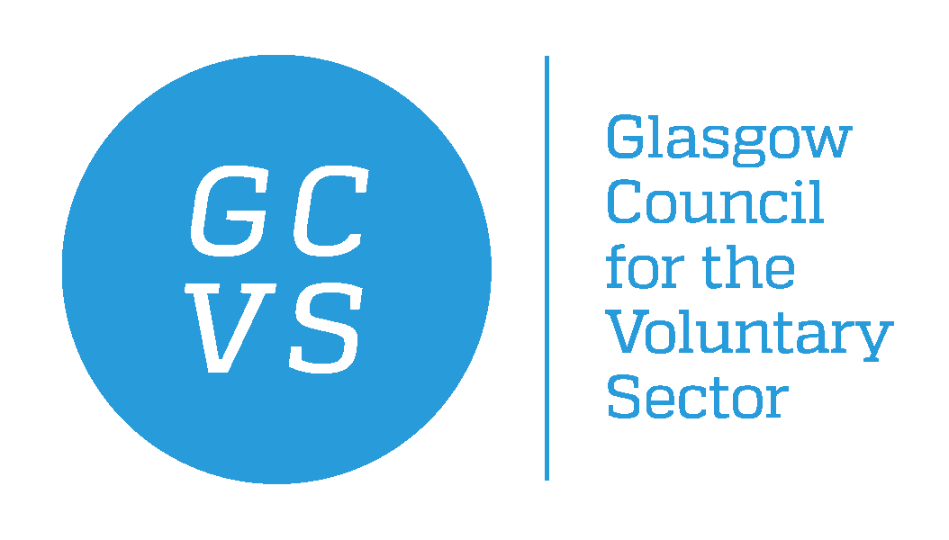

PERSON SPECIFICATION

POST TITLE: Gambling Harms Development Worker

Essential skills for this post

- Excellent organisational and planning skills.
- Excellent oral and written communication skills.
- Experience of general office administration, including use of IT
- Up-to-date, IT skills in the use of Microsoft Office suite, including Word, Outlook, PowerPoint, Excel and experience of using database software.
- Willingness to learn new skills and a flexible approach.
- An excellent ability to build rapport and work with people from a wide range of backgrounds
- Ability to prioritise workload and competing demands
- Flexible approach to working hours with occasional additional hours
- Ability to work effectively as part of a team.
- Ability to work unsupervised and on own initiative.
- Ability to use online resources to research and problem solve.

Desirable

- Experience of project administration.
- Experience of working in the voluntary sector.
- Knowledge of gambling related harm and its impact.
- Experience of using social media in a professional capacity.
- Experience of using Mail Chimp, Survey Monkey and Salesforce CRM systems.

