**Job Description – Lang Toun Cycles Shop Assistant** 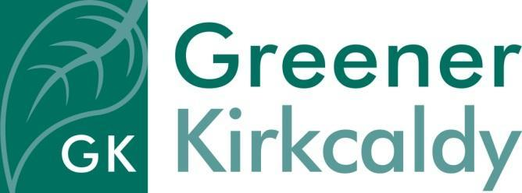

**Responsible to** Cycle Workshop and Retail Coordinator

**Salary** £18,018 per annum pro rata + 6% contribution to pension scheme

**Hours of work** 17.5 hours per week on a flexible basis (0.5 full-time equivalent), must be able to work Friday & Saturday with occasional evening work*

**Place of work** Lang Toun Cycles premises & community locations

**Contract** Fixed term for 1 year initially, with possibility of permanent post thereafter

**Holiday** 33 days inclusive of public holidays per annum pro rata

**Requirements** The post-holder will be subject to a Disclosure Scotland check

**Job purpose**

Greener Kirkcaldy is a community-led charity and social enterprise, working on a local scale to benefit people and our environment. We run a wide range of projects: tackling climate change and social injustice, and bringing our community together. We have delivered cycling activities, including training and group rides, since 2017.

The Cycle Shop Assistant will be part of the social enterprise community bike shop, Lang Toun Cycles, offering bike servicing and repairs, sales of refurbished bikes, and a small range of accessories. You will be part of a small team, taking on customer service and admin role helping to manage cycle servicing and repairs, upcycling donated bikes for sale, Dr Bike events on and off site and workshop training events. The team consists of the Cycle Workshop and Retail Coordinator (who will be your line manager), Cycle Mechanic plus volunteers who will assist in activities.

There will also be the opportunity to be trained in cycle mechanics to assist with servicing and repair of bikes

Our aim is to develop a thriving social enterprise that is part of a wider project to promote cycling in Kirkcaldy and help people reduce their car use.

**Specific responsibilities**

* Be first point of contact and carry out retail operations and meet customer needs including helping customers to choose the correct bike and accessories
* Support regular practical activities as described above with a wide range of participants
* Coordinate the Greener Kirkcaldy ebike library loan scheme
* Work closely with project team to plan workshops and resources required
* Ensure shop premises are clean, presentable and welcoming to customers
* Cash handling and point of sale operation
* Helping with regular stock checks

**General responsibilities**

* To work as part of the Greener Kirkcaldy team to promote and encourage understanding of environmental issues in the local area
* To promote the work of Greener Kirkcaldy when working in the local community
* To engage with members of the public in a positive and constructive way and ensure their needs are met
* To provide excellent customer service
* To communicate effectively with the team
* To work with team members to achieve goals
* To work constructively with project partners
* To report on the success of allocated tasks
* To comply fully with the organisation ethos, policies and procedures and relevant legislation
* To attend team meetings as required
* To undertake other duties in line with the job purpose

*Greener Kirkcaldy operates a 'time off in lieu' policy for any work outwith office hours.