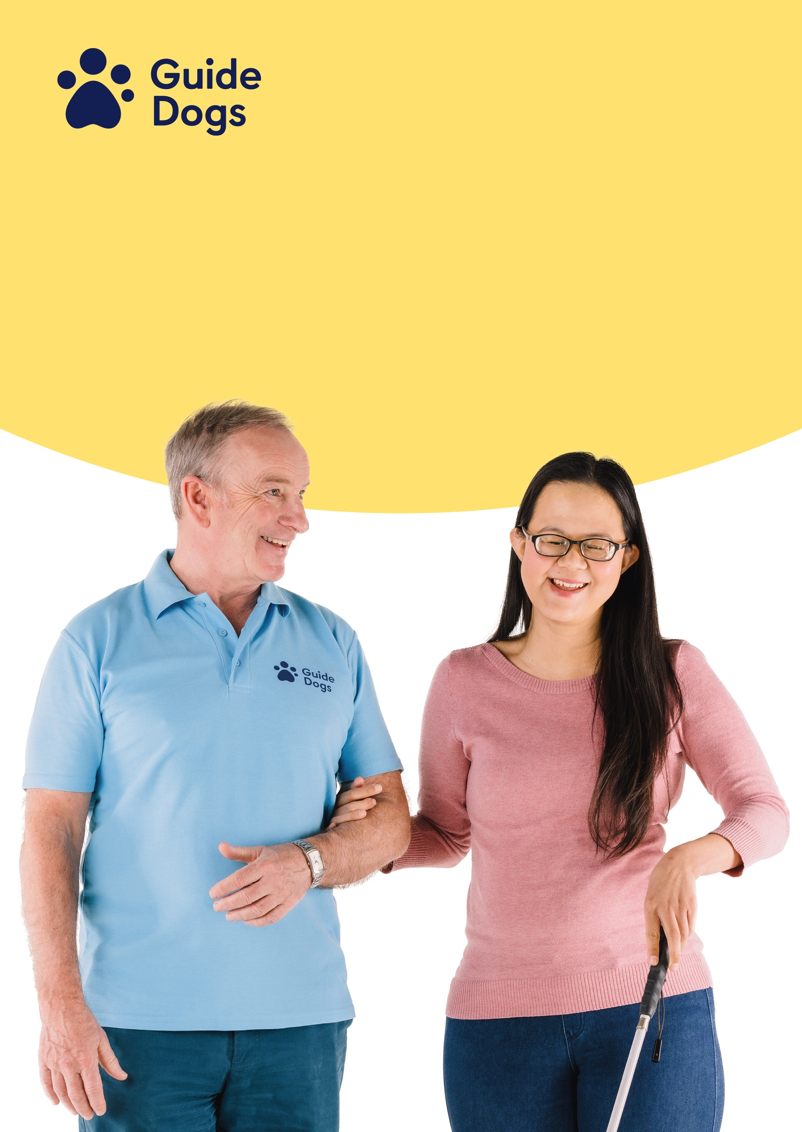

Candidate Pack

Trainee Orientation and Mobility Specialists

## **Table of contents**

**Table of contents** 2

**Introduction** 3

**Overview of the role** 4

**Overview of the training course & University** 4

**Case Study** 5

**Application** 7

**Shortlisting & Assessment** 7

**Job Offer** 8

**Onboarding** 8

**Feedback** 8

**Reasonable adjustments** 8

**Contact Details** 8

**End of document.** 8

## **Introduction**

Thank you for your interest in working for Guide Dogs! It is an exciting time with our refreshed 2023 Strategy, By My Side, to be joining the charity as it is doing more now than ever before to help people who are blind or partially sighted gain freedom and independence.

Guide Dogs is one of the UK’s best known and best loved charities. It is listed in the top 20 of the Charity Brand Index recognising our positive reputation and trustworthiness. Since our first guide dog partnerships were formed in 1931, we have transformed the lives of so many people with sight loss, helping them to get out of their homes and to live independent lives.

More than 80 years later, our work is even more relevant. Every hour, someone in the UK starts to lose their sight. Today, there are almost two million people in the UK living with sight loss and by 2050, this figure could have doubled. We know we can do more to reach more children and adults for them to walk with us as we embark on our new strategy.

We hope that this information pack will give you everything you need to know about us and about the role!

Best wishes,

The People Service Centre team

## 

## **Overview of the role**

The Orientation and Mobility Specialist (OMSp) helps people with sight loss to live the life they choose by delivering orientation and mobility services which support Guide Dogs strategic objectives and promote independence and choice to people who are blind and partially sighted. Through personalisation, you will provide specialist holistic assessment of customer needs that will improve their wellbeing.

The role is critical in enabling and empowering people to live the lives they want and is a fascinating and rewarding profession. You will be working with adults (including offering support and advice to their families, friends, and carers) across a range of ages and environments.

You will join a Guide Dog Community Team who offer a range of services and gain experience and support from existing and qualified OMSps through mentoring and Technical Supervision.

As a qualified OMSp you will use your core Rehab skills to be a person-centred problem solver and to respond to an individual’s unique situation, supporting and empowering them to achieve their mobility and other goals. You will develop individual training programmes based on the person's needs and aspirations.

Visual impairment is a life changing experience and very often you will be working with people who are at a crisis point in their lives supporting them to make the best use of their strengths and any remaining vision.

The Orientation and Mobility Specialist facilitates a person to increase their choices, support their independence and assist them in building confidence through a holistic approach.

This is a rewarding role based on person centred skills, working in partnership with people, developing their confidence and independence to achieve their goals.

## **Overview of the training course & University**

To become an OMSp and enable people who are blind or partially sighted to be as independent as possible in their day to day lives, you will be studying and completing a 2-year foundation degree in Rehabilitation Work (Visual Impairment) provided by Birmingham City University (BCU).

The course is designed as a blended learning experience. You will be based within a Community Team and attending the University’s Campus for block learning weeks that are spread throughout each academic year. During these weeks you be involved in lectures, simulation sessions and a range of hands-on group activities on this practical course. With the team you will be putting your learning into practice and developing your skills and experience through shadowing, reflective learning and supported delivery of core skills all supported and supervised by your mentor.

<https://www.bcu.ac.uk/courses/rehabilitation-work-visual-impairment-fdsc-2021-22>

You will develop core skills through assignments and practical learning. The core skills are:

**Assessment:** specialist assessment of a person’s current situation, needs and desired goals. This includes identifying strengths, needs and possible solutions; agreeing goals and an ‘action plan’ to achieve those goals.

**Eye conditions:** non-medical knowledge of eye conditions that can cause sight loss, to understand how those conditions may affect how a person uses their sight and the implications of their diagnosis for the future.

**Orientation and mobility:** working with people to increase their confidence to move around safely both indoors and outdoors; providing training in the use of mobility aids, such as white canes; technology to support orientation, route training in specific areas e.g. teaching the route to the shops or work; learning orientation skills to know where you are in your environment and to be able to interpret what the environment can tell you

**Low vision:** specialist knowledge and skills in using low vision devices such as optical magnifiers, high-tech video magnifiers, computers and close circuit TV; the use of non-optical devices and training a person to make the most of their vision by using specific sight strategies.

**Independent living skills:** developing a person’s activities of daily living e.g. preparing and cooking meals and drinks; managing household tasks, such as laundry, cleaning, personal finances and money transactions; personal care, such as applying make-up, shaving, cutting nails and dressing; identifying and taking medication appropriately.

**Communication skills**: developing communication and information skills for a visually impaired person may involve using many formats such as print, audio or tactile systems like Moon or Braille. It may also encompass many platforms or settings including computer, tablet, or smart phone with or without specialist access-software. Communication-skill development is of importance when working with someone who has dual-sensory loss.

**Entry Requirements**

To successfully apply for the course, you will need to evidence that you have a qualification of level 2 English and maths. Qualifications such as GCSE at grade 4 or above at English Language (or equivalent e.g. GCSE grade C, key skills level 2, adult literacy level 2 or CSE grade 1 will be accepted). Level 3 qualifications and an NVQ, diploma or A-level of two D’s or higher or, evidence that you are able to study at level 4 on the FdSc. Please visit the BCU website for more information.

<https://www.bcu.ac.uk/courses/rehabilitation-work-visual-impairment-fdsc-2021-22>

The course is a blend of face-to-face teaching blocks, independent study and work-based learning placements all supported by your Community Team peer group.

## **Case Study**

It took me ages to decide to call Guide Dogs as I didn’t know what to expect and I felt really nervous. I was so surprised as I enjoyed the relaxed conversation and felt that I was actually being listened to. I felt cared about as got to talk about the things that were important to me. I am now getting some help and receiving cane training. I used to dread going to local supermarket at lunchtime as often found it difficult. Bumping into shoppers and staff. I was also finding busy streets and station a challenge. I am now much more confident and as a result of the help I have been referred to the guide dog service and I am on the waiting list. I have also been signposted to my local voluntary association for more help around the home.

**Benefits we offer our employees**

We believe that wellbeing at work is about creating an environment to promote a state of contentment which allows all employees to flourish and achieve their full potential for the benefit of themselves and for Guide Dogs. As a member of staff, we offer you a wide range of benefits to suit your individual needs:

• 26 days holiday plus Bank holidays (rising to 28 days after 3 years’ service).

• Defined Contribution Personal Pension Plan – New employees, who meet the eligibility criteria, will be automatically enrolled into the DC Plan upon their third month of employment. The pension contribution level for automatic enrolment is 3% employee and 5% employer. However, once you are a member you may wish to increase your level of pension contribution and Guide Dogs will match your contribution plus 2%, up to a maximum of 9%.

• A choice of Flexible Benefits – An amount equivalent to 3% of salary is given to employees to purchase benefits though an on-line portal. There are a range of options to suit personal circumstances and preferences. These include: Gym Membership, Travel Insurance, Healthcare and Hospital Treatment Plan, Dental Insurance, Additional Life Assurance, Health Screening, buying and selling annual leave (up to 3 days), Cashback to salary (up to 2% of salary equivalent).

• Discounts and Cashback Scheme – Access to discounts on goods and retail vouchers and cashback on purchases for supermarkets, clothing, electrical goods, travel, eating out, insurance and much more.

• Employee Assistance Programme – A free-phone confidential helpline to provide unlimited access to advice, information, and face to face counselling support, where appropriate.

• Occupational Sick pay – Enhanced above the statutory minimum, after probation.

• Occupational Maternity, Paternity and Adoption pay – Enhanced above the statutory minimum.

• Life Assurance – A core benefit of 4 times salary.

• Childcare Vouchers – Enabling National Insurance savings to be made on child care costs.

• Eye Care Vouchers – Free eyes tests and, if needed specifically for VDU work, a contribution towards glasses.

• Dogalogue 10% Discount – All employees are entitled to a 10 percent discount on orders from the Guide Dogs charity catalogue

**Standard Recruitment Process**

### **Application**

Due to the nature of the work Guide Dogs does, the individuals we support can be children, young people, or vulnerable adults. In order to ensure we protect them to the best of our ability; we follow Safer Recruitment practices. This is the same recruitment practice used by schools.

A requirement of this practice is that we only accept completed application forms for candidates wishing to be considered for a role. The application form can be completed online via our job board. We do request that a current CV is also attached to support an application providing details of a full work history to ensure all gaps are accounted for.

Application forms should be used to clearly highlight how your skills and experience meet the requirements for the role. These are laid out within the person specification of the role description within this document. When addressing each criterion, ensure you use specific examples to evidence the specific skill or experience you are referring to.

### **Shortlisting & Assessment**

Applications will be reviewed by the recruiting manager as they come in. This will initially be a longlist against the essential criteria for the role. The applications that make it through the longlist, will then be reviewed in more detail against all the criteria (essential & desirable) to identify the highest scoring applications that will be shortlisted for invitation to interview.

Guide Dogs are a Disability Confident Employer. This means that any applicant that has declared a disability, and meets the essential criteria, will be offered an invite to interview. This will be irrelevant of how they rank in the shortlisting.

Once shortlisting is complete, all applicants will receive communication from Guide Dogs, usually by email, to advise of the outcome of their application.

All roles will involve a face-to-face interview, in person or virtually; however, some may be proceeded by a telephone interview. Some roles will involve other assessment exercises as well. The assessment process followed varies role by role. The assessment exercises used are tailored to be able to find the most suitable candidate for the job role. They are also designed to give applicants more insight into the role requirements to ensure they have realistic expectations of the position and that it is suitable for them as well.

Dependant on the reasons behind the assessment process design, shortlisted candidates may complete all exercises before being informed of an outcome, or they may be reviewed after each stage and only some individuals progress to the next exercise.

As with the long and shortlisting exercise, all applicants will receive communication from Guide Dogs, usually by email, to advise of the outcome of their assessment.

### **Job Offer**

Once all assessments have been completed, results for all applicants in consideration will be reviewed by the recruitment panel and a decision will be made about the most suitable person for the role. If successful, the recruiting manager will be in contact to congratulate you and discuss the offer details. Once accepted, pre-employment checks will be carried out, including a full 5-year professional reference history and a disclosure check if applicable for the role.

### **Onboarding**

The successful candidate will be provided with an official offer letter, and their terms of employment for review, signing and return. This will be subject to all pre-employment checks being completed, returned, and deemed satisfactory.

Once a signed contract has been returned, the successful candidate will be advised further of their onboarding process and start date if this was not included in the contract.

### **Feedback**

All candidates are welcome to request feedback on their application or interview/assessment. To do so, please use the contact details below, specifying the role to which the request relates.

If there is a large volume of candidates, feedback on application may take us a while to provide, especially if the recruitment process is ongoing.

To support career development, candidates that have declared a disability, or are internal, will be contacted by the recruiting manager to offer the provision of feedback. Please advise if you would like this, and in what format would be most helpful.

### **Reasonable adjustments**

At any stage in the recruitment process, if you any require reasonable adjustments please contact the recruiting manager, or the People Service Centre on the details below, and this can be discussed in more detail to identify the most suitable way to support you.

### **Contact Details**

People Service Centre

Phone – 01189838837 ext.3 for the Resourcing Team, or ext. 1 for general enquiries.

Email – [peopleservicecentre@guidedogs.org.uk](mailto:peopleservicecentre@guidedogs.org.uk).

To enable us to help you as efficiently as possible, please include the vacancy ID number, job title & location in your communication as well as your full name, as used in your application.

## **End of document.**