Engagement Officer (Scotland) at Re-engage

- Full time post - permanent with occasional weekend and evening work. This post will be home based in Scotland.
- Re-engage is committed to flexible working and will consider all requests for flexibility.
- Salary £22,725 pa
- Holidays 26 days per year plus public holidays.
- Reporting to head of partnerships and engagement.
- Working as part of a team of engagement officers all with responsibility for engagement in different parts of the UK.
- Collaborating across our resource hub of finance, IT systems, admin, communications, and fundraising staff.

Re-engage, the national charity working with older people to combat loneliness and social isolation, is pleased to announce that we’re recruiting a new member of our partnerships and engagement team to drive forward our work in Scotland. This role is at the heart of ensuring Re-engage’s lasting impact.

In line with the charity’s mission, the engagement officer will set up and manage referral routes and pathways across the country, along with recruiting loyal volunteers to support our services. Your role will be to recruit older people and volunteers, and also to raise awareness amongst the public and voluntary sectors and to identify key partners and referral agencies across Scotland.

As an engagement officer, you’ll
- contribute to the delivery of Re-engage’s objectives by creating new partnership working opportunities and developing existing ones.
- generate older people referrals into Re-engage services and represent our core services of call companions, tea parties, and community Christmas and pass on to the relevant teams. You will also generate older people referrals into our other projects, such as the LGBT+ programme.
- look for new opportunities for service delivery partnerships.

You’ll need to:
- have a good standard of IT skills, including use of databases and MS Office
- personally value the voluntary sector and volunteering.
- be committed to an environment which promotes equality of opportunity and recognises and values diversity.
- be energised by flexible interactive teamwork.
- commit to Re-engage's ethos and values which are respectful, determined, warm, local, and pioneering.
- Recruit volunteers remotely throughout Scotland.
- Raisie awareness of Re-engage amongst the public, voluntary sector and referrers and promote other Re-engage services.
- Support outreach volunteers by arranging regular supervisions

Main tasks and responsibilities
  - Promote volunteering opportunities through recruitment and publicity strategies and campaigns.
  - Recruit volunteers (group coordinators, call companions coordinators/call companions, hosts, drivers, etc) and identify tea party guests as required to create and sustain groups across Scotland.
  - Adhere to Re-engage’s volunteer recruitment procedure, ensuring that all new volunteers understand the work and ethos of the charity and that processes and systems are followed.
  - Provide regular and appropriate communication with your volunteers.
  - Provide project support by undertaking monitoring and evaluation activities including, collation of case studies and presentation of appropriate statistics.
  - Ensure Re-engage processes and systems are followed e.g., seeking references, DBS checks, maintaining databases, reporting and capturing data in line with projects aims.
  - Liaise with referral agencies across Scotland to recruit genuinely isolated activity guests e.g., Social Services, NHS, and other public, private, and voluntary sector organisations working with older people.
  - Research and participate in volunteer recognition initiatives, e.g., awards schemes and Volunteers’ Week to celebrate the work of our volunteers.

- (ii) Promotion & Publicity
- Liaise with the Re-engage communications team to secure and follow through media opportunities to increase awareness of Re-engage through local press, radio, TV, magazines, use of the exhibition stands etc.
  - Distribute promotional materials within local communities, for example, community spaces, libraries, notice boards, churches etc.
  - Liaise with Re-engage communications team to use Re-engage social media and communication platforms to promote activities.

- (iii) Finance and Fundraising
  - Make regular, documented expense claims to finance team.
  - Manage a budget, should a diversification project/programme be delivered.
  - Inform fundraising team of any fundraising needs or opportunities – such as local authority grants, companies, trusts or individuals.

- (iv) National Office Procedures (the resource hub)
  - Prepare regular reports for management, including accurate statistics.
  - Provide material including photographs and quotes for newsletters, annual reports and social media.
  - Attend virtual and face-to-face staff meetings and training courses as required.
  - Share ‘good practice’ in working with volunteers and activity guests.
  - Carry out any other reasonable tasks assigned to you by your line manager.

- (v) Monitoring and evaluation
  - Carry out regular questionnaires with tea party guests, call companions and volunteers etc.
  - Gather and collate measurements on outputs and impacts to aid continuous development.
  - Gather and collate case studies to support reports for funders

About Re-engage
Re-engage is a charity that is positive about older age and committed to fighting loneliness so that people can have social lives and friendship groups however old they are. We inspire and enable meaningful connections and shared experiences within communities across the UK for people over 75 facing loneliness and social isolation.

Our volunteers work together to create better communities and help to enrich the lives of our members by giving them something to look forward to. Older people who may have felt very alone, now feel valued as individuals, continue to form friendships, and have groups and call companions that give support. We make sure that people know they are important well into old age. Respectful, determined, warm, pioneering, and local: we are Re-engage and we are bringing generations together.

Our volunteers
We couldn’t do anything without our volunteers, and we are committed to empowering them through implementing our new volunteer management pathways
- 92% of our volunteers feel that they are giving something back
- 89% feel happier as a result of being involved
- 77% have made friends with the older guests in their group

Our goals, values, and objectives
We take very seriously our commitment to deliver against the strategy and want everyone at Re-engage to believe passionately in the importance of keeping our strategic goals and objectives front and centre of our work.
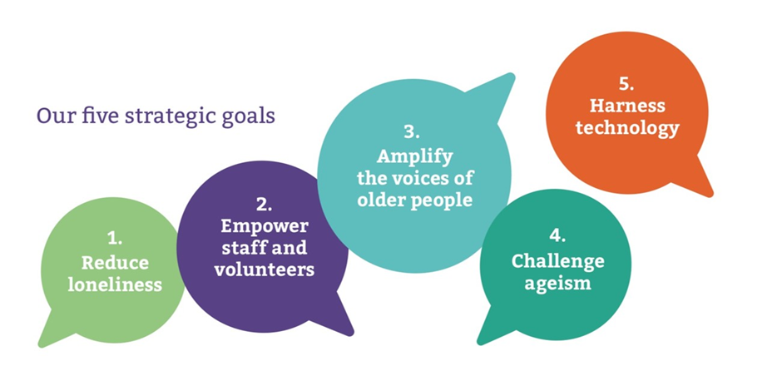

Our values guide how each of us work and behave in our role on a daily basis:

Our strategic objectives:

The ten strategic objectives are shared by every member of our team and help everyone to focus on their part in delivering against all these goals.
- Increase the number of older people we help by 15% year on year with a target of reaching 13,000 in the year 2022-23.
- Grow and diversify our client base of older people and include more men, members of BAME communities and LGBTQ+ groups
- Develop a scalable volunteer management model that will allow us to grow our volunteer base year on year, develop fresh volunteer roles, and provide a consistent volunteer experience
- Develop our senior volunteer roles to diversify and​ increase our impact, recruiting and training four new Area Coordinators each year
- Put in place professional policies, processes, and practices for staff management to ensure we are a great place to work​. ​
- Put in place a monitoring, evaluation, and learning (MEL) programme which will demonstrate our impact. ​
- Grow our brand in support of our service and our beneficiaries: ​
- Develop IT systems that will allow us to deliver on our service delivery and people management goals:
- Grow our income in line with our growth in numbers and diversify our income streams
- Amplify the voices of older people

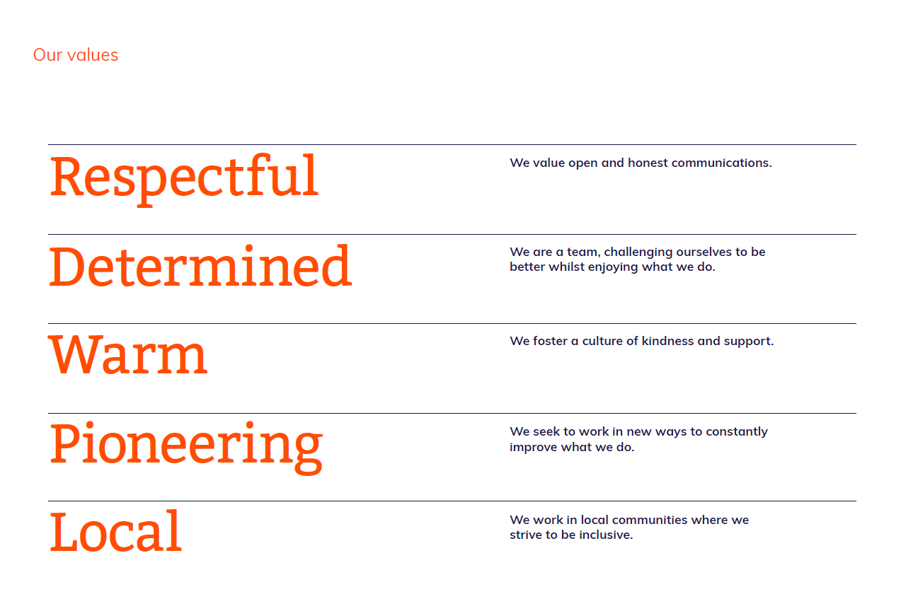

Person specification:
Job title: Engagement officer

- Skills/attributes
- Essential
  - Excellent interpersonal skills with a proven ability to work collaboratively with staff, volunteers, and older people.
  - Able to lead a dispersed group of volunteers.
  - Able to engage with new guests and attend groups (where needed) across Scotland, when required.
  - Regularly communicate with volunteers to share news, progress, and gather feedback from groups.
  - Able to lead and motivate others, to give constructive feedback on their performance and to provide ongoing support, guidance and development and mentoring
  - Able to maintain a database with up-to-date information for volunteers and activity guests.
  - Able to engage with, and communicate appropriately with, activity guests and generally with people from all walks of life.
  - Organised and methodical approach to work.
  - Self-motivated, able to work remotely with minimal supervision.
  - Able to work on one’s own initiative as well as part of a team.
  - Understanding of, and empathy with, the issues affecting older people who are isolated, and lonely.

- Knowledge/experience
- Essential
  - Knowledge of the Scottish charity sector.
  - Experience of organising regular catch ups with volunteers.
  - Experience of working with and supporting volunteers and older people in group environments.
  - Able and competent administrator with experience using various Microsoft packages.
  - Proven ability to lead and motivate people, provide ongoing support, guidance, development, and mentoring
  - Administrative and IT skills, and an ability to maintain records and produce clear written and oral reports.
  - Experience of working across different sectors and developing links with other organisations.
  - Experience of working to project deadlines and managing project KPIs.
- Desirable
  - Experience of delivering and implementing community projects.
  - Full driving license and own car preferred as this post will require travel throughout Scotland, as and when required

Demonstrable commitment to the following personal values and attitudes is essential:

A positive attitude towards all age-related issues.
The value of the voluntary sector and volunteer activity.
An environment which promotes equality of opportunity, recognising and valuing diversity.
Flexible interactive teamwork.
Provision of excellent customer service to all volunteers and older members.
Promotion of a positive image of Re-engage at all times.

This role also requires:
A dedicated place to work in your home.
Sufficient broadband for permanent Wi-Fi access to multiple cloud-based systems.
An enhanced Disclosure and Barring Service/Protecting Vulnerable Groups check.

