

**STAFF JOB DESCRIPTION & PERSON SPECIFICATION**

|  |
| --- |
| **1. JOB DETAILS** |
| **Job Title:** Operations Manager  **Salary Scale**: £33,146 - £35,441  **Pension:** 6% Employer Contribution  **Holiday Entitlement:** **(i)** 20 Days Annual Leave with an additional Day for each completed Year of Service to 25, and rising to 28 Days when achieving 10 Years Reckonable Service; **and** **(ii) 12**.5 Public Holiday Days  **Other Benefits:** Employee Group Life Assurance (Death in Service Benefit – 3 x Annual Salary); **and**  Company Sick Pay scheme that increases with length of service as per:   |  |  |  | | --- | --- | --- | | **Reckonable Service on Commencing Absence Owing to Sickness and/or Injury** | **Full Allowance**  **for up to:** | **Half Allowance**  **for up to:** | | Less than 26 Weeks  26 weeks or more but less than 1 Year  1 Year but less than 2 Years  2 Years but less than 3 Years  3 Years but less than 5 years  5 Years and over | N/A  3 Weeks  9 Weeks  18 Weeks  22 Weeks  26 Weeks | N/A  3 Weeks  9 Weeks  18 Weeks  22 Weeks  26 Weeks |   **Responsible to**: Operations Director  **Direct Reports**: 4 - 5 Advocacy Workers  **Location:** Glasgow (With a requirement to travel across operational service delivery areas)  **Hours:** 35 Hours per Week (Flexible Working System in Operation: Variable 07:00 – 21:00) |
| **2. JOB PURPOSE & OVERVIEW** |
| The Operations Manager role is crucial in terms of The Advocacy Project’s Leadership Team. Working collaboratively with the CEO, Operations Director, Business Director, fellow Operations Managers and allied to organisations Strategic Action Plan, the postholder will have responsibility for the day-to-day management of a small team of Advocacy Workers’, therefore, contributing to the seamless delivery of our ‘Independent Advocacy’ provision across the East Renfrewshire, Glasgow City and South Lanarkshire Heath & Social Care Partnerships (HSCP’s) to the benefit of our service users and key stakeholders.  Reporting to the Operations Director, the postholder will lead of a small team of Advocacy Workers, whom, are deployed across the entirety of our HSCP and locality orientated provision, contractual obligations and service level agreements. Furthermore, each of the organisations 5 Operations Manager will bear the day-to-day responsibility for a defined aspect of our service delivery, with the expectation you will also lead on certain thematic aspects of the organisations work such as Quality Assurance, whilst also, ensuring the best use of organisational resources and contributing to the continuous improvement of our ‘Independent Advocacy’ provision. |

|  |
| --- |
| **3. ORGANISATIONAL POSITION** |

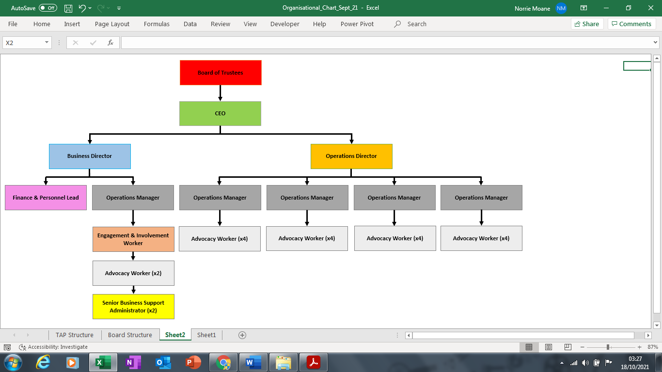

**VACANCY**

|  |
| --- |
| **4. KEY DUTIES AND RESPONSIBILITIES** |

**Role Specific Responsibilities - Management:**

* To take responsibility for your both your own and your teams up-to-date knowledge of, and adherence too, The Advocacy Projects’ practice standards, policies, procedures and protocols whilst also being alert to more strategic developments in ‘Independent Advocacy’, management best practice, employment matters and to legislative changes and/or emergent case law – Equalities, Mental Health, Health & Safety, Human Resources etc.
* Providing line management, supervision, and support to a designated Team of Advocacy Workers, and others, as may be required.
* Responsible for managing, and where appropriate – auditing and improving, the daily flow of work within the context of your Team ensuring that Quality Assurance Standards (KPI’s) are achieved and maintained.
* Responsible for ensuring that day-to-day operational ways of working adhere to the required internal and external policies, procedures, systems and service level agreements.
* Make day-day operational decision about service issues demonstrating an ability to prioritise, use your own initiative and the effective use of problem-solving skills and abilities.
* Ensuring the effective use of the CROCUS Case Management Systems.
* Responsible for supporting the gathering and analysis of the relevant organisational performance, quality and outcomes data to enable both contractual and organisation service reporting frameworks.
* Timeous escalation of issues to the Operations Director and involvement in the planning of and then the implementation of necessary changes and improvement work.
* Support the recruitment and induction of staff, students and volunteers as required.
* To ensure The Advocacy Projects’ human resources are managed in accordance with the organisations policies and procedures i.e. Recruitment & Selection, Discipline, Grievance, Support & Supervision and Annual Appraisal.
* To ensure you have an appropriate first line manager understanding of, whilst, at all times complying with The Advocacy Projects procedures for promoting and protecting the welfare of vulnerable adults, and where relevant, children ensuring policies and procedures are followed and the timeous escalation and communication of any issues to the Operations Director or CEO.
* In times of organisational need and/or in accordance with the exigencies of the service, carry a proportionate client caseload.
* To be a partner in the organisation’s leadership team in the writing and development of re-tender exercises, new tender opportunities and/or funding proposals in line with contract schedules and emergent opportunities; **and**
* Provide contingency type support to the Operations Director as requested and/or appropriate.

**Service Development:**

* Working in close collaboration with the Operations Director and in an innovative, creative and enterprising way, the postholder will contribute to the development of our ‘Independent Advocacy’ services.
* Assist with service evaluations through gathering and analysing both service user and stakeholder feedback so as to understand whether needs are being met before then helping to plan and implement any necessary adjustments and improvement strategies.
* Raise awareness of The Advocacy Projects work by the means of bespoke promotions and networking opportunities.
* Identify and report on system, process and practice issues whilst highlighting gaps in policy, provision or training that are impacting upon service delivery.
* Support the Operations Director with the development and implementation of new services, projects and service improvements including the creation of any systems required to report upon targets, key performance indicators (KPI’s) etc.
* Working with the Operations Director to increase the reach of the services we currently offer. Liaise with other Operations Managers in order to provide a distinct and person-centred ‘Independent Advocacy’ service and in a manner that facilitates inclusion, equalities and diversity.
* Organise and administer your own work and that of your direct reports to ensure that it is accurate and meets organisational Quality Assurance standards, targets, KPIs, reporting deadlines and stakeholder requirements.
* Participate in organisational development activities continually sharing your knowledge in respect of the relevant legislation, appeals/redress mechanisms, social policy and best practice in relation to ‘Independent Advocacy’.
* Operate within a Performance Review & Personal Development (PRDP) System through your ongoing participation in working groups/ committees/forums as requested by the Operations Director; **and**
* Chair, co-ordinate, attend and manage a range of meetings both internally and externally as required.
* **Training and Development:**
* Act as your Teams day-to-day practice lead in terms of any strands of The Advocacy Projects’ L&OD which are relevant to your staff.
* Ensure that lessons, case studies and outcomes from your Teams delivery activities are captured in appropriate and effective ways, and that the impact of these are considered and communicated in the context of the wider organisations practice and reporting activities.
* To attend essential training – both internal and external as required by the Operations Director; thus; ensuring your own CPD whilst also working to the objectives stipulated within your PDRP; **and**
* To encourage and support your Team of Advocacy Workers with a view to helping their progress, shaping their development and facilitating their ongoing learning in line with both organisational and personal ambitions.

**General:**

* Working in collaboration with your Team and allied to the guidance provided by the relevant line manager, the postholder will make a role appropriate contribution to the ongoing development of our services and that of The Advocacy Projects’ service evaluation work by helping to garner both service user and stakeholder feedback to allow us to accurately apprise outcomes, quality standards and satisfaction levels.
* Attendance at internal forums such as line management defined one-to-ones, Leadership Meetings, Team Meetings, ‘TeamTalk’ and external meetings, forums, statutory conferences and tribunals.
* Identify and report on any emergent process and/or practice issues that are impacting upon your day-to-day caseload management and service user facing type duties before assisting the Operations Manager improvement activities either at Team or Organisational level. You will contribute to a culture which is, at all times, supportive, reflective and open to change whilst also fostering positive working relationships with a wide range of external professionals and/or stakeholders.
* Promote a Team culture which is, at all times, supportive, reflective and open to change.
* To undertake any other duties or projects equal with the nature and grade of this post as required.
* Provide contingency and/or ad-hoc type support to the Operations Director, your Team and/or fellow Operations Managers’ as required and/or requested; **and**
* To undertake any other duties or tasks as deemed proportionate and appropriate by your Operations Manager and/or the Senior Management Team (SMT).

|  |
| --- |
| **5. COMMUNICATIONS AND WORKING RELATIONSHIPS** |

As an Operations Manager, and therefore, representative of The Advocacy Project, and in the daily course of your work, you will be expected to, at all times, conduct yourself in a professional manner whilst consistently demonstrating effective communication and interpersonal skills with regards to your interactions with others e.g. staff within the relevant Health & Social Care Partnership’s (HSCP’s). Moreover, this role will require you to deploy a combination of professional and collaborative skills in order to maintain, and indeed, to help enhance relationships with HSCP representatives, referrers, partner agencies and wider stakeholders.

You will work collegiately with the Senior Management Team (SMT), the other Operations Managers and staff from across the organisation to enable the day-to-day delivery of high-quality services that are conducive to the organisational aspirations of our Board, CEO, SMT and the Strategic Action Plan. The Operations Director serves as the designated line manager for this post and will monitor, support and supervise your work and will be your direct point of contact with regard to any matters and/or issues arising from your work.

|  |
| --- |
| **6. PERSON SPECIFICATION** |

| **ATTRIBUTES** | **ESSENTIAL** | **DESIRABLE** |
| --- | --- | --- |
| **Qualifications & Experience** | - Educated to Diploma level or equivalent in a relevant subject matter.  - Experience of operating at first line manager and/or senior practitioner level within a similar environment i.e. the field of ‘Independent Advocacy’ and/or having significant experience with the Advocacy, Advice & Information or a relevant Third Sector domain(s).  - Direct experience of collaborative working and contributing to the delivery of an organisations Strategic Action Plan.  - Demonstratable experience of leading a group of staff.  - Previous people management experience in a related environment. | - A recognised management qualification; |
| **Knowledge** | - Good awareness of legislation and policy drivers inc. the Adults with Incapacity (Scotland) Act 2000 – AWI, Mental Health Care & Treatment (Scotland) Act 2003 and the Adult Support and Protection (Scotland) Act 2007 – ASP.  - Relationship and partnership building strategies;  - Awareness of tools and techniques for service development.  - Problem solving strategies. | - Experience of both National and local policies and strategies in relation to Independent Advocacy. |
| **Skills** | - Good relationship building and networking abilities.  - Effective communicator, with an understanding of internal and external communication techniques.  - Proven time and change management skills.  - Demonstratable one-to-one conflict resolution and de-escalation abilities.  - The ability to lead, develop and influence practitioner staff to achieve positive results and organisational change.  - Communicating overarching objectives to staff in a straightforward and practical manner.  - Effective numeracy/data interpretation skills.  - Ability to work on own initiative as well as part of a wider management team. | - Facilitating training. |
| **Other (Specify)** | * Evidence of Continuous Professional Development (CPD); * Experienced in the use of Information Technology (IT); * Possession of a full UK Driving Licence. |  |

|  |
| --- |
| **7. CONDITIONS & OTHER RELEVANT INFORMATION** |

Our policy and practice when recruiting staff has been to make new appointments at the lowest Spinal Column Point (SCP) in respect of the Job’s grading profile. However, should the Board of Trustees warrant it necessary to pay a higher starting salary in order to attract the right candidate, a successful candidate may be placed on a higher SCP on the job’s grade range.

The Advocacy Project intends that our renumeration remains competitive but must do so in accordance with charitable objects and fiscal governance. The Board of Trustees bears strategic responsibility for a periodic review of pay and benefits which also tries to take factors such as the Consumer Price Index and sector comparisons into account. Pay award’s, other recompense or additional benefits are subject to affordability and sustainability.

|  |
| --- |
| **8. PVG / DISCLOSURE INFORMATION** |

The Advocacy Project complies fully with the Disclosure Scotland Code of Practice, as issued by Scottish

Ministers, for the use of information provided to registered persons and other recipients of the information issued by Disclosure Scotland under Part V of the Police Act 1997, or the Protection of Vulnerable Groups (Scotland) Act 2007 for the purposes of assessing applicants' suitability for positions of trust. The **Operations Director** post has met the threshold test for being classed as role whereby the staff member is undertaking restricted work with protected adults. Therefore, membership of the **PVG Scheme - Restricted Work with Protected Adults** is a requirement for this post.

|  |
| --- |
| **9. JOB DESCRIPTION & PERSON SPECIFICATION – T.B.A BY THE PROSPECTIVE POST HOLDER** |

The above duties and responsibilities are intended to represent current priorities and are not meant to be a conclusive list. The post holder may, from time to time, be asked to undertake other reasonable duties.

Any changes will be made in discussion with the post holder and in the light of service needs.