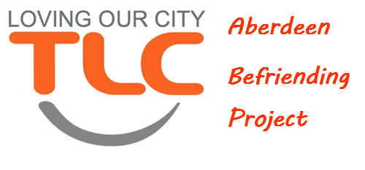
ROLE DESCRIPTION

Role: Coordinator
Department: TLC Befriending Project
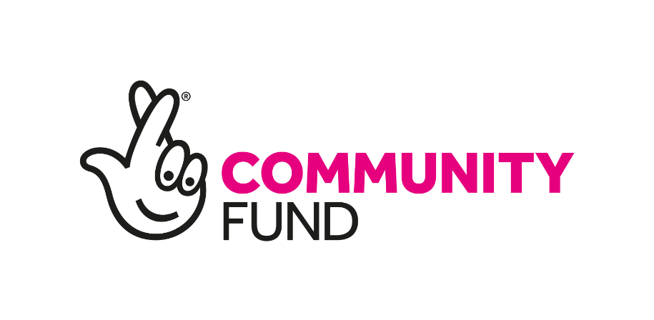
Responsible to: Senior Coordinator
Hours: Part-time (25 hours a week)
Salary: £24,000 pro-rata
Based: Home & Office
Contract: Temporary – 2 Year

(This post is funded by The National
Lottery Community Fund)

Role Outline & Purpose:
The Coordinator is accountable for part of the operational management of the project, as assigned by the Senior Coordinator.
Key roles include working alongside the senior coordinator in managing the referral process, the monitoring and reviewing of befriending placements, volunteer recruitment and training.

Responsibilitys:
- Working at the direction of the Senior Coordinator on the management of referrals, befriendee visits and associated administration.
- Resonsibility for managing the volunteer recruitment process, including volunteer enquiries, application and reference request, interviews and criminal record checks (PVGs).
- To work alongside and at the direction of the senior coordinator on the management of our volunteers, including holding Volunteer Supervision.

Note: As the project develops, there will be an increased number of referrals and volunteers that will require management. It is the expection that the Coordinator will work closely with the Senior Coordinator in sharing the case load.

PERSON SPECIFICATION

Technical skills and minimum knowledge:
- A proven track record in motivating and developing people or volunteers.
- Educated to degree level and/or significant relevant professional experience working with people and teams.
- Excellent communication skills (written and verbal) with the ability to present information clearly to share both internally and externally.
- Skilled in using Microsoft Office applications.
- Strong organisational and administrative skills.

Behaviours and competencies:

- Demonstrate dedication to the values of TLC
- Demonstrates empathy for people from disadvantaged, marginalised or socially- excluded backgrounds.
- Demonstrates resilience, resourcefulness, flexibility, and perseverance.
- Analyses and communicates complex information effectively to different internal and external stakeholders.
- Works with others as one team, actively listening and collaborating to achieve the shared vision.
- Building strong internal relationships, sharing information and expertise.
- Role models inclusive behaviour, values, and leadership

Our Values

TLCs core values are compassion, community and purposefulness and are central to all that we do.

