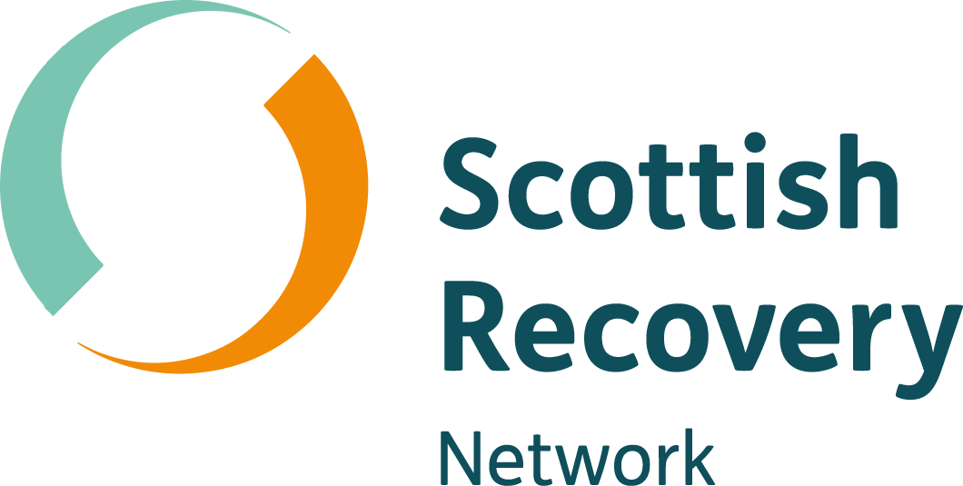

Applicant information for the post of

Network Manager

Scottish Recovery Network


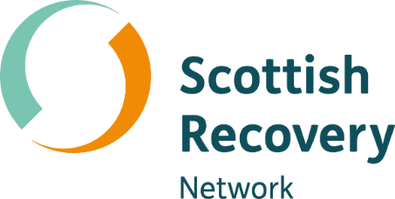

Dear Applicant

Thank you for your interest in the post of Network Manager, Scottish Recovery Network.

Since being established in 2004, Scottish Recovery Network has made a significant impact on mental health policy and practice across Scotland.

With a team of 8, Scottish Recovery Network delivers a number of exciting and innovative programmes to support recovery approaches in Scotland. The voice of people with lived experience of mental health problems has always been central to the development of our work and we take a collaborative approach bringing lived experience and other key stakeholders together.

Please note we require all applicants to complete and submit an application form. In order to assist you with your application we enclose a job description and person specification.

You can find out more about Scottish Recovery Network at our website www.scottishrecovery.net.

Scottish Recovery Network’s strategic plan 2021-2024 can be found here

If you would like an informal discussion about the post please contact Louise Christie, Director at louise.christie@scottishrecovery.net

Closing date for applications is Friday 25th February 2022 at 7pm.

Interviews will be held on Thursday 17th March 2022

Please see https://isw.changeworknow.co.uk/penumbra/vms/e/careers/search/new for more details and how to apply.

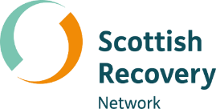

Introduction

Scottish Recovery Network has been promoting and supporting mental health recovery since 2004. Over the past 16 years there have been a wide range of activities with many successes. For example:

- Mental health recovery is accepted as a concept and reality in policy and practice

- People with lived experience of mental health problems have more opportunities to speak out and share their skills and learning

- Many services, organisations and communities have good examples of recovery focused practice

- Good connections have been made with those supporting recovery in other parts of the UK, Europe and further afield

However, our recent engagement on the future of mental health recovery in Scotland identified there is still a lot to do. Examples of good practice are far from universal. Mental health recovery is still not a day-to-day part of the development and delivery of mental health support.

A recovery focused mental health system should be powered by lived experience. There needs to be visible leadership and buy in from decision makers at all levels. We need to work together to create a system that:

- Takes a whole person approach

- Champions and values lived experience by integrating it into all parts of the system

- Embeds peer support approaches and roles in mental health services and supports

- Offers more community-based supports and choices so everyone can be supported when and where they need it

- Works with others to create a more equal society where good mental health and wellbeing can flourish

The Scottish Recovery Network strategic plan 2021-2024 sets out our vision, mission, values and strategic aims. It sets out how we will work with others to bring about the changes needed to transform Scotland’s mental health system.

About the role

Scottish Recovery Network are seeking an experienced manager with great people skills. You will have a passion for delivering work programmes which bring people, services and organisations across sectors together to create a mental health system powered by lived experience which supports everyone’s recovery journey. You will be committed to values-based practice, mental health recovery and excited by the opportunity to work with others to bring about much needed change in our mental health system.

Network Manager Job Description

Role | Network Manager – Scottish Recovery Network
Accountable to | Scottish Recovery Network Director
Responsible for | Line management of a team of 4 Network Officers
Location | Home based. Regular travel for work purposes and attendance at team meetings/supervision in office based in central Glasgow will be required.
Conditions | - Full time post (37.5 hours per week)  - Permanent contract  - Annual leave total (including public holidays) of 33 days per annum  - Contributory money purchase pension scheme available  - Evening and weekend work may be required, as will some travel throughout Scotland
Salary | £39,445 - £41,528 per annum
Closing date | Friday 25th February 2022 at 7pm.

Purpose | To support the work of Scottish Recovery Network, both locally and nationally by leading a team of Network Officers to deliver our programmes and achieve agreed objectives and outcomes. The post will have responsibility for delivering Scottish Recovery Network’s strategic plan by developing, sustaining and managing programmes and projects.
Key responsibilities | Strategic planning  - Contribute to the development and implementation of Scottish Recovery Network’s strategic plans  - Support colleagues in the development of outcomes focused workplans which meet strategic objectives  Programme management  - Oversee the operation of Scottish Recovery Network work programme including planning, delivery, monitoring and evaluation  - Manage the contribution of team members and external contractors  - Ensure appropriate data recording, information gathering and reporting of activities and impacts  - Contribute to financial planning and management  People management  - Lead and line manage a team of 4 Network Officers  - Contribute to and support the development of an enabling culture within the organisation  - Ensure that our organisational values and procedures are adhered to in all activities  External relations  - Maintain awareness of local and national mental health and recovery related developments and opportunities  - Represent Scottish Recovery Network at a strategic level as required with wider stakeholders at meetings and events  - Develop and maintain positive relationships with relevant partners and stakeholders  - Identify and develop opportunities for collaborative projects with a range of partners across Scotland.

Person specification

I am…..

Educated to degree level or equivalent

An experienced manager who inspires, motivates and enables others to perform at their best, both individually and collectively, and in keeping with our organisational values

Experienced in managing and overseeing a range of different projects, reviewing progress towards goals to successfully meet strategic objectives

A good verbal and written communicator who can produce structured, accurate and concise plans and reports that inform and enable others to take action

A great relationship builder and manager who can bring people from different sectors and perspectives together to recognise, design and deliver sustainable recovery approaches

Someone who recognises and values new ideas and facilitates new approaches which may depart from conventional thinking

Well-informed about mental health recovery and the recovery approach and committed to values based practice, recovery and rights

Familiar with and have experience of community development approaches

Someone who thrives in a fast-paced, changing work environment and can adapt their working approach and methods to meet strategic aims whilst maintaining organisational values and team performance

Scottish Recovery Network is hosted by Penumbra which is a charity (SC010387) and a company limited by guarantee (SC091542) registered in Scotland.
Scottish Recovery Network is hosted by Penumbra. We therefore comply with Penumbra’s policies and financial management systems and staff are subject to Penumbra terms and conditions of employment.

