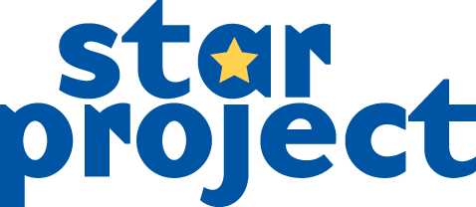Support Worker (18 hours)

Application Form

This form constitutes your application for the above post. We ask you, however, to support it with a C.V. (curriculum vitae) including the following details:

* Education – school and further/higher education, other qualifications and relevant training (most recent first)
* Career – employment, unemployment and voluntary work. Please state posts held, work involved and reasons for changes (most recent first)
* Personal – For example, interests and hobbies.
* Two references of which at least one should be from your employer

Do not expand beyond 4 pages. Use minimum size 11 font.

**Deadline: Wednesday 23rd February at 12 noon**

Full Name:

Current address:

E-mail:

Telephone: (Day) (Eve)

How would the training or qualifications you bring to this role be relevant?

What personal skills or qualities would you bring to this role and how would they be relevant?

How would the experience you bring to this role be relevant, for example work in a context of social deprivation and the different needs that may arise?

STAR places great value on our relationship-based approach and the use of creativity as a tool for change. What would you see as the key benefits of each of these?

The STAR Project places great importance on creating a sense of safety – detail your understanding of the benefits of this and also some of the barriers to achieving this.

I apply for the above post and enclose my C.V. I declare that, to the best of my knowledge, the information on this form and any attachments to it is true and correct. I also confirm that I *do not require / have the appropriate\** United Kingdom Work Permit. I understand that any false statement may disqualify me from appointment or, if employed, may render me liable for dismissal.

Signed: …….......................................................... Date: .......................................

* Delete as applicable

For postal submissions send to STAR Project, 12-14 Wallace St, Paisley, PA3 2BU or email to

[enquiries@star-project.org.uk](mailto:enquiries@star-project.org.uk) [Email submissions will need to be signed if invited to interview]

I apply for the above post and enclose my C.V. I declare that, to the best of my knowledge, the information on this form and any attachments to it is true and correct. I also confirm that I *do not require / have the appropriate\** United Kingdom Work Permit. I understand that any false statement may disqualify me from appointment or, if employed, may render me liable for dismissal.

Signed: …….......................................................... Date: .......................................

* Delete as applicable

Use this space to tell us anything else that might help us to consider your application: