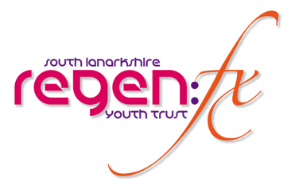

JOB OVERVIEW
Post: ADMIN WORKERS x 2 (THE GIVIT)
Organisations: Regen:fx Youth Trust
Salary: | £19,619 pro rata
Salary Info: | 17.5hrs per week
Job Type | Fixed Term 3yrs (potential further 2yrs)
Location | Base Larkhall/Hamilton – throughout South Lanarkshire
Closing Dates: | 21st Feb 2022, Interviews 7th March.  Interviews

Job Role
Regenfx Youth Trust are establishing a brand new dedicated young person’s intensive support outreach service for 13 – 25yr olds affected by alcohol & substance use.

The new service called The GIVIT will be ground-breaking and the first of its kind in Scotland. We will use early intervention with blend of Youth Work, CBT Counselling, and a fully supported Recovery Model.

We need to recruit an amazing staff team of nine to make this 7-day a week service that includes evening & weekends a reality. We need people who would be motivated and daring enough to help us build the service from scratch with LLE young people, that in time could change the face of recovery services for this target group in the future.

We are looking to build our A-Team with experience in Youth Work and or the Recovery Field, but most importantly, people who are driven, genuinely interested in young people and who would relish a challenge like no other.

We need two efficient, approachable, and welcoming ADMIN WORKERS to provide the smooth running of the offices. You must be able to work with and direct young volunteers and colleagues on the necessary office systems. Have extensive experience with Microsoft 365, Word, Excel, Databases etc.

You will help establish the first ever dedicated Youth Recovery Community based in South Lanarkshire.

It is important to us that we find the right people for the new posts. We acknowledge we might not find someone with everything we are looking for, but if you think it could be you and are hesitant on whether to apply or not, just give us a call for an informal discussion about the post.

JOB INFORMATION
Organisation Profile: | Regen:fx Youth Trust is a registered charity formerly established in 2007. We work in partnership to develop and deliver Youth Work Programmes throughout South Lanarkshire for disadvantaged young people between the ages of 8 – 25yrs. Please check out our website www.regenfxyouthtrust.org.
Application Notes: | If you prefer an application pack to be sent to you please call Esther on 01698 552101 or e-mail recruitment@regenfxyouthtrust.org
Additional Information: | Interviews will take place on 7th March 2022  Driving Licence and access to a car is required.
Downloads: | - Job Description  - Person Specification  - Application Form  - Equal Opportunities Form  - Criminal Convictions Declaration Form

