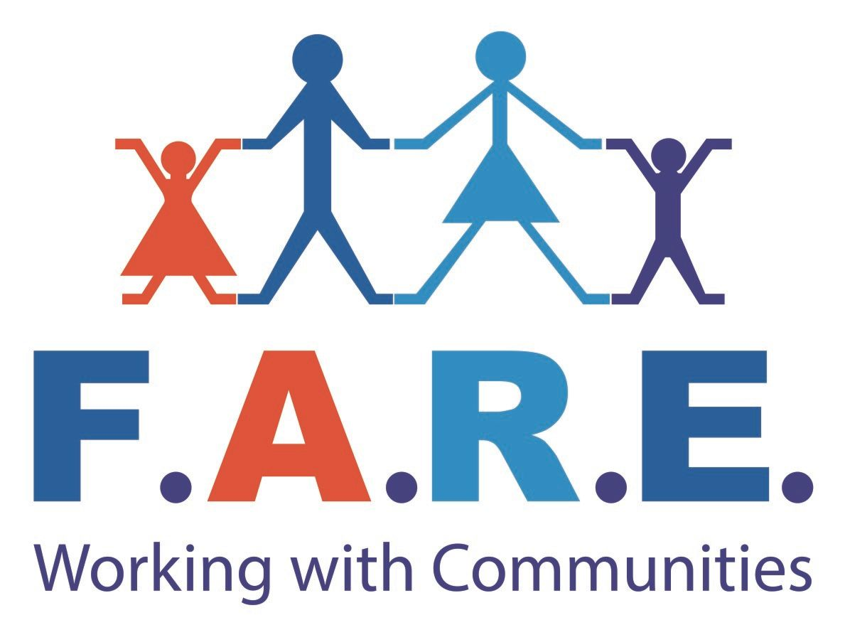
f.a.r.e Scotland
Bannatyne House,
31 Drumlanrig Avenue,
Glasgow, G34 0JF

Tel no. 0141 771 9151

Email: recruitment@fare-scotland.org
Website: www.fare-scotland.org

Position: Family Liaison Officer:

Reporting to: Community Support & Development Manager

Contractual status: Full Time, 35 hours per week

Salary: £22,000 - £24,000

Annual Leave: 25 days & 9 Public holidays

Job Description
Working alongside the wider FARE team, the Family Liaison Officer (school based) will maximise the potential of local facilities to meet the needs of school pupils and local people of all ages. S/he will develop and participate in the delivery of a range of joint and needs identified activities. The post holder will have a sound knowledge of the issues faced by children, young people, adults and families. While also having experience in developing interventions to tackle poverty, its symptoms and close the attainment gap through educational and social activities including volunteering and mentoring opportunities.
S/he will have experience of planning and delivering needs led programmes by working alongside the school, local people and other organisations in a strategic working group to meet the needs of the pupils and their families with the School catchment area. The post holder will be based in the school and therefore should have good oral and written communication skills s/he must have the ability to communicate with people at all levels.

Key Responsibilities
- Ensure the collection and collation of statistics as required to ensure continued funding and for progress reports to the schools SLT (Senior Leadership Team) FAREs board of directors and various funding bodies.
- Work closely with FARE SMT and school staff to develop, promote and organise Family Liaison Services.
- Raise attendance issues with parents; meet with both pupils and parents in order to support them to improve attendance and/or attainment.

- Attend meetings with the schools Senior Leadership Team and other agencies that can support students that are a concern in order to successfully improve their attendance and/or qualifications.
- On-going monitoring of attendance of pupils identified as non-attenders and\or those at risk of falling out of the academic structure.
- To establish activities which will promote the personal, social, educational and material welfare of young people and their families.
- Ensure the collection and collation of statistics as required to evaluate the projects impact and for progress reports.
- Assist with the planning and delivery of FARE’s attainment programme for at risk young people.
- Establish and maintain contact with relevant outside agencies.
- Maintain all records in accordance with guidelines from FARE and the school.
- Comply with all relevant legislation and FARE/school policies.
- Promote the objectives of FARE as stated in its constitution.
- Write reports, as requested.
- Participate in fund raising activities and the development of funding applications.
- Attend training opportunities.
- Attend meetings, as requested.
- Undertake any other duties as specified by the SMT

Person Specification
- Excellent communication and presentation skills
- Ability to motivate individuals facing barriers
- Organised and systematic approach to monitoring and reporting
- Ability to work with people at all levels internally and externally
- The drive and initiative to work independently
- Ability to share learning and develop practice through feedback
- Ability to challenge, in a constructive manner, negative attitudes
- Excellent IT skills in Word, Excel, Outlook, Access, particularly for database-related work
- Educated to HNC/HND level or minimum of 2 years relevant experience.
- Driving License (desirable) (Maximum 6 penalty points)
- Good knowledge of CSD/Family Support initiatives
- Knowledge of statutory organisations
- Experience of providing outcomes-focussed programmes to individuals excluded from mainstream society
- Experience of delivering Family Support/CSD programmes
- Experience of providing in-work support

