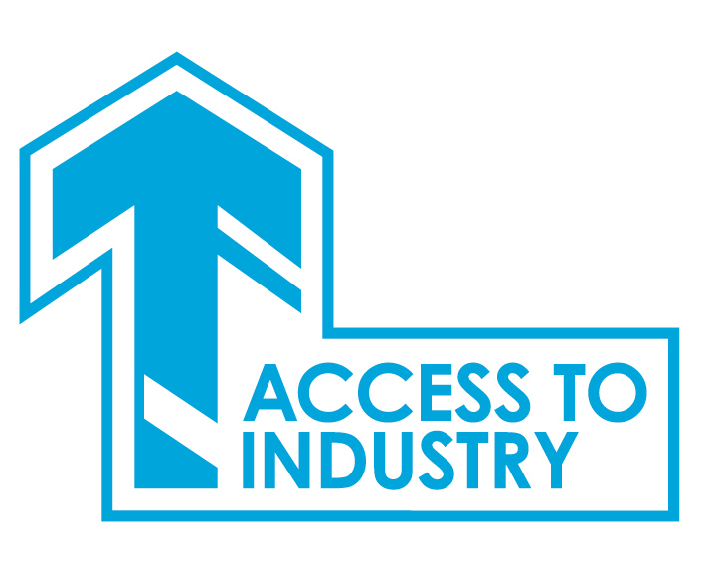

Access to Industry Application Pack
Post: Access to Industry Caseworker
Project: MELDAP

Enclosed in this pack is:
Job Description 2
Person Specification 4
About Access to Industry 5
How to Apply 6
Terms and Conditions of Employment 7
Recruitment Privacy Statement 8

Thank you for your interest in applying for a position with Access to Industry.

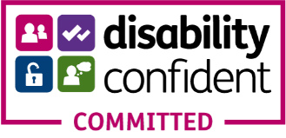

Job Description
Job Title | Caseworker | Accountable to | AI Management Team
Working Hours | 35 Hours Per Week | Location | Midlothian and East Lothian
Salary Scale | £23,000 - £26,000 | Length of Post | March 2023
Programme | MELDAP  (Mid and East Lothian Drug and Alcohol Project) | Project | Mid and East Recovery Project

About the Role: An opportunity has arisen for AI to recruit a dynamic, enthusiastic individual who is able to work creatively within our Recovery Project Team in Mid and East Lothian. You will manage a caseload of clients within an outreach setting and be operational contact for our Edinburgh College partnership in Mid and East Lothian. You will have the opportunity to develop meaningful activity for clients working with colleagues and external partners.

Key responsibility areas will include:
Case Management - Providing education, training and employability support to people who have a history with substances, offending, and homelessness, focusing on engagement and building positive relationships with clients. Working with them to create an action plan that focusses on building confidence, resilience and supports progression into positive destinations. Offering support and guidance around CV and mock interviews. Creating opportunities for your clients to progress into training programmes, employment, and education. This element is offered both face to face and over digital platforms.

One-to-one support - You will work holistically with clients. This means that you will provide, or source, support that is impeding their progression and devise an Action Plan to address this. This could include welfare advice; financial planning & budgeting; wellbeing support; and motivational support. One-to-one sessions take place in a place of safety for the clients – it will be flexible to accommodate the needs of the client. You will have the support of AI’s wider services.

Skills based activity -You will motivate and support clients to achieve qualifications, that can be delivered in outreach both individually and in small skill-based group settings across Midlothian and East Lothian. Clients will be able to progress into AI’s Community College offering accredited learning. Skill based learning will be offered through AI’s in-house training programme including CSCS training; Driving theory; First Aid; digital skills and Smart facilitators training.

College Link - This will involve operational responsibility for our classes delivered within Edinburgh College Midlothian Campus and Musselburgh East Learning Centre. You will be responsible for liaising with the College, in the timetabling of classes; working with lecturers; supporting the registration & enrolment of AI clients as students, and, with the College, evidencing their outcomes. This will involve a high level of communication skills both written and verbal. It will require digital literacy as classes are currently blended, involving lecturers in a mixture of face-to-face and online teaching. You will have

responsibility for coordinating the online digital classes with the College - ensuring details are communicated to AI clients who are students, and you will support their attendance, as AI students, in the digital classes. You will have the opportunity to develop and timetable additional class opportunities with your colleagues, and you could have the opportunity to develop your own class delivery.

Supervision - as part of developing client’s digital skills, you will supervise and support our peer digital Champion who is in place and who works across East Lothian offering digital support to our clients of East Lothian. You may be responsible for volunteers recruited to support delivery.

Digital Communication - AI is building our digital presence using social media, website, and digital video platforms. You contribute to this ensuring our social media presence is current on our Facebook page, website, and other digital platforms.

AI Team - You will play a part in the wider team of AI through attendance at internal meetings and participation in shared services across the teams.

Administration - You will administer all aspects of the project from referrals, training, progression routes and employer engagement.

Quality Assurance & Management Systems- You will maintain excellent records and will maintain case management through use of the Management Information System, Caselink. You will demonstrate client’s progression through gathering relevant evidence required by funders.

Health & Safety and Property Management - You will ensure a healthy and safe environment and the protection and best use of property and equipment by implementing and observing AI policies and procedures.

Communications - You will be an effective communicator as you will be working with external agencies, specialist providers and employers and attending meetings on AI’s behalf. You will contribute to internal reporting procedures both through writing and verbally. You will market the project externally. You will always ensure client confidentiality.

Other Requirements - The post holder will be expected to manage their own caseload and work with minimum supervision partly in an outreach capacity.

Person Specification
Key Areas | Essential | Desirable
Qualifications and attainment. | Qualified to degree level or relevant experience. | A relevant qualification in a subject such as Community Education, Careers Guidance, Social Policy, Social Care or Addiction
Knowledge, Skills and Experience | Experience of client case management within a supportive setting and of client barrier removal. | Experience of working in a supportive role with clients in recovery.  Knowledge and understanding of a trauma-informed approach to service delivery.  Knowledge of the impact addiction can have on mental health and emotional wellbeing  Experience of working in an outreach setting.  Supervision skills having supported volunteers or staff members.
Knowledge, Skills and Experience | Experience of employability support  for individuals, including those who may have additional compounding needs
Knowledge, Skills and Experience | Experience in putting in place support for individuals to build their personal resilience.
Knowledge, Skills and Experience | Skilled in developing, recruiting and delivery of a programme of learning activity.
Knowledge, Skills and Experience | Strong time management skills: ability to work on own initiative; and able to prioritise own workload.
Knowledge, Skills and Experience | Knowledge of education and support services in Midlothian and East Lothian.
Knowledge, Skills and Experience | Experience of monitoring projects to ensure outcomes are being achieved and gathering evidence to verify outcomes.
Knowledge, Skills and Experience | Confident using Microsoft Office suite and digital platforms.
Knowledge, Skills and Experience | Excellent written and verbal communication skills.
Additional Requirements | Empathetic and non-judgemental in your approach to working with individuals and groups and an ability to easily build a positive rapport.  Patient, passionate and committed to delivering the best service possible.  A team player, you will be determined and flexible to achieve your own and your team’s goals.

About Access to Industry
MELDAP Recovery College
Access to Industry (AI) has been delivering an education, training, and employability service to unemployed people with complex health and social care needs across Midlothian and East Lothian since 2014.

The project will engage with clients in a trauma informed way, offering an outreach service enables the caseworker to meet with the client in their own town or village, reducing the need for travel or initial engagement within an unfamiliar space.

Assessment will be carried out with each client one-to-one, identifying key areas that are posing barriers to progression and creating an action plan that will form key milestone to be achieved during their time on the project.

Caseworkers will provide one-to-one support and skills-based activity. The project will link with the wider initiatives within AI, including our community college.

As we ease out of COVID-19 restrictions, delivery will be in groups in local community centres offering teamwork; communication; CV preparation; mock interviews and digital up skilling on using zoom; online applications; online interviews.

Staff Development
Access to Industry supports individuals who can have complex needs that act as a barrier to progression. We are constantly reviewing the skills of our employees and developing these so we can best support our staff to meet the needs of our clients.

On joining Access to Industry, as part of your initial induction your training may include:

- Mental Health First Aid
- Motivational Interviewing
- ASIST – Applied Suicide Intervention Skills Training
- Living Life to the Full – training in course delivery
- Conflict resolution – de-escalation

COVID-19 information
Access to Industry remains committed to ensuring the safety and wellbeing of our staff, volunteers, and those we support. We are following guidelines and we are supporting people remotely and in person. Our Edinburgh College courses are currently being delivered through blended learning with some in-person and some online classes. We constantly review our practices in view of government guidance.

How to Apply
Access to Industry Caseworker

Application is through a CV and a Supporting Statement.

- All applications should be marked ‘CONFIDENTIAL: Mid and East Caseworker.

- CVs should include two referees one of whom should be your most recent employer. We will not contact referees prior to interview.

- The supporting statement should demonstrate your experience and how this matches with our requirements. This additional information should be confined to a maximum of two sides of A4 in minimum font size 11. Additional information over this limit will not be considered. Generic statements not contextualised for the post will be discarded.

- Closing date for applications is Midnight on Monday 21 February 2022

- Interviews will be held on Wednesday 2 March 2022

Applications should be sent to:
Email: admin@accesstoindustry.co.uk
Postal: Access to Industry, 156 Cowgate, Edinburgh EH1 1RP

Terms and Conditions of Employment
Access to Industry
Caseworker
Salary
Salary for this post will be £23,000-£26,000. Appointment usually at start of scale.
AI operates an auto enrolment pension. AI contribution is 6%; employee contribution is 2%
Annual leave
Entitlement is 25 days per annum. Public holiday entitlement is 10 days per annum.

Working Hours
35 hours a week Monday to Friday. Some evening and weekend work may be required.

Equality and Diversity
Access to Industry work towards the three aims of The Equality Duty in order to:
- eliminate unlawful direct or indirect discrimination, harassment and victimisation and other conduct prohibited by The Equality Act 2010;
- advance equality of opportunity between people who share a protected characteristic as set out in the Equalities Act 2010 and those who do not; and
- foster good relations between people who share a protected characteristic and those who do not.
Performance Review
A three-month probation review period will be in operation.

Disclosure
Successful candidates will be required to complete an enhanced PVG

Appointment is subject to satisfactory references, disclosure and right to work.

Recruitment Privacy Statement
How We Use Your Data for Recruitment

Background
This privacy policy covers how we Access to Industry collect, use, store and protect the data that is supplied to us by job applicants and agencies.

Our Commitment to Job applicants
We believe completely in equal opportunities and will treat all applicants fairly with no discrimination.

We never knowingly provide misleading information about the nature of the role. We would never charge a job seeker a fee for the purpose of finding them a role.

We are committed to managing your personal information securely and with respect in accordance with the General Data Protection requirements.

The information we collect may cover the following:
- Contact information (name address, phone number and email address)
- Information from CV or application form or covering letter (education, skills and qualifications)
- Health records (Night Worker assessment forms, Health questionnaires) where required as part of the role.
- Occupational health report (Higher level screening required for role) with Access to medical Records consent being given by the applicant
- criminal convictions/offences/protecting vulnerable groups information from Disclosure Scotland where a requirement for the role
- References from the names referees that the applicant provides and only with the applicants’ consent.
- Visa and proof of the right to work in the UK documents
- Employment records (including job titles, work history, working hours, training records and professional memberships).
- Salary, annual leave, pension, and benefits information.
- Access to your DVLA portal.

We may also collect, store and use “special categories” of more sensitive personal data which require a higher level of protection such as Information about your race or ethnicity, religious beliefs, sexual orientation, and political opinions. Also, information about criminal convictions and offences.

Purpose of collection
The purpose of collecting this information is to find suitable candidates to fulfil a specific role within our Organisation, and to check that you are legally entitled to legally work in the UK.

To enable us to make recruitment decisions and assess suitability for particular work, we will process information about criminal convictions and offences (including alleged offences).
We will process this information to enter a contract with you, to comply with a legal obligation, for our legitimate interests and to exercise or perform employment law rights or obligations.

Any offer of work from us will be subject to a satisfactory criminal record check to allow us to perform our public task and comply with our statutory obligation.

Processing criminal conviction data requires the same safeguards as ‘special categories’ data.

How the information is held.
Most information is transmitted by email and is stored on our computers, and paper-based filing.

All this information can only be accessed by authorised staff within our Organisation. Our staff are trained to understand the importance of keeping personal data secure.
Our computers are safeguarded by anti-virus software and the regular changing of security passwords.

The information on candidates for specific roles will be held for 6 months in line with CIPD recommended best practice. After which paper files will be securely shredded and computer records deleted. Only if we have asked, and you have given your consent for the data to be held will this not apply.

Disclosure
We may disclose the information for the purpose of obtaining referees. Where additional information is required, the information may be obtained from Disclosure Scotland, your G.P or an Occupational Health professional only after you have given your consent.

You have specific rights in connection with personal information: request access to your personal information; request correction of the personal information that we hold about you; request erasure of your personal information; object to processing of your personal information where we are relying on a legitimate interest; request the restriction of processing of your personal information; request the transfer of your personal information to another party and the right to withdraw consent.

Complaints
Privacy complaints are taken very seriously and if you believe that we have breached your privacy you should in the first instance write to the Finance Administrator who has responsibility for Data Protection within our Organisation stating the details of your complaint (finance@accesstoindustry.co.uk). We would ask that you provide us with as much detail as possible to allow a thorough investigation. Your complaint will be acknowledged within 24 hours, and we aim to resolve any complaint within 5 working days. However, depending on the complexity of the complaint and availability of external agencies it may on occasions take longer.

Should your complaint show that we have breached our duty of care we will report the breach to the Information Commissioner’s Office. If you are not satisfied by our response you may complain to the ICO.

