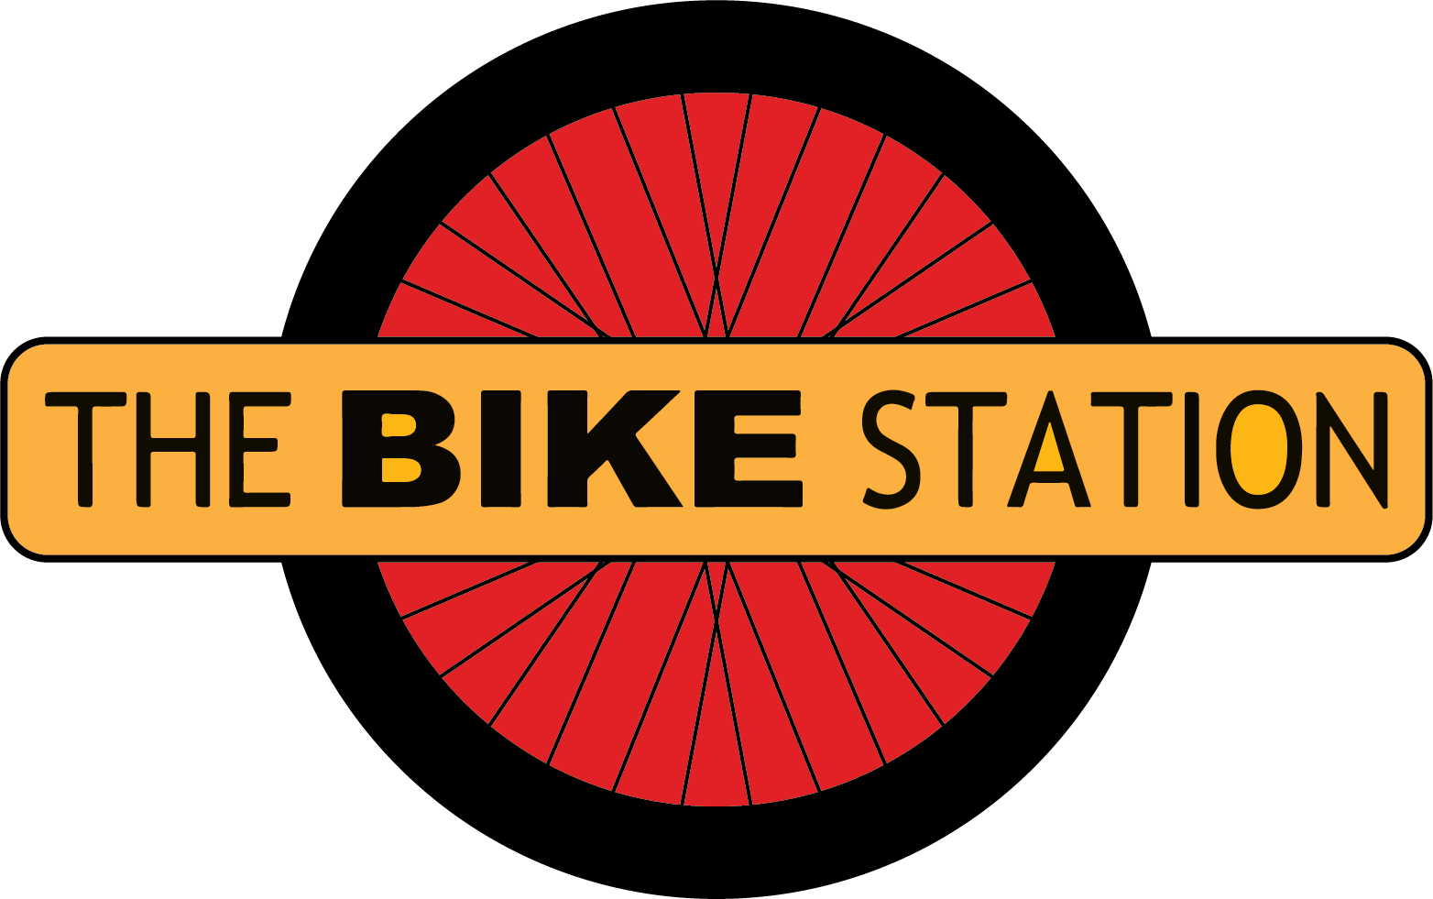

The Bike Station
Communities Manager

Salary 28K (FTE)
Hours 28hours (however flexible options are available)
Fixed Term Contract until 31st March 2023 (With the expectation to be extended subject to funding)

Location Perth/Edinburgh/Flexible/Home working

Reports
The Communities Manager Reports to CEO.

Purpose of the Role

As part of the Senior Management team you will be responsible for the successful development, coordination and delivery of our communities based programmes.

You will develop and maintain strategic partnerships across health, education and third sector organisations to ensure The Bike Station activity compliments and adds value to other community based activity.

You will be responsible for continually reviewing and developing our activity, demonstrating quality and impact.

In collaboration with the Senior Management team, provide direction and support to the on-site Community Outreach Officers to ensure the effective coordination of day to day activities.

Key Responsibilities

- Responsible for the success of our Communities programme including Shifting Gears & Skills Development

- Oversight of all communities based activities, ensuring a consistently high quality offering

- Provide direction and support to our Community Outreach & Skills Development team

- Develop and regularly review project delivery plans & project spend

- Develop and implement robust evaluation frameworks to demonstrate the impact of our communities based activity

- Report on progress of programme including recommendations for refinement and improvement.

- Develop compelling community led evidence base for future programme delivery.

- Produce strong community led and full costed proposals for future community based activity.

- Secure resource for our communities activity, creating compelling and evidence based funding applications.

- Foster strong strategic relationships with our stakeholders, ensuring trust and credibility.

- Engage with partners across sectors including active travel, health, third sector and social enterprise

Experience

Essential
- Project development and coordination, including development and implementation of project plans, evaluation frameworks and improvement plans.

- Significant experience of developing community based programs within climate change and/or social justice and equalities.

- Demonstrable experience of furthering the principles of community engagement and empowerment.

- Developing evidence based community led proposals and credible business cases.

- Securing funds from diverse income streams and maintaining excellent relationships with funders .

- Producing impact reports and strong communications for a diverse range of stakeholders.

- Line management and fostering cooperative and thriving teams.

- Strong partnership development across sectors including public and third sector organisatio.

Desirable
- Programme delivery across multiple locations.

- Managing budgets and financial reporting.

- Training programme development and delivery.

- Experience of risk management.

Skills
- Strong verbal and written communication skills.

- Ability to innovate, motivate and persuade.

- Strong ability to prioritise.

- Excellent interpersonal skills needed to maintain and develop partnerships.

- Ability to work independently.

- Efficient time management is essential to effectively carry out the role.

