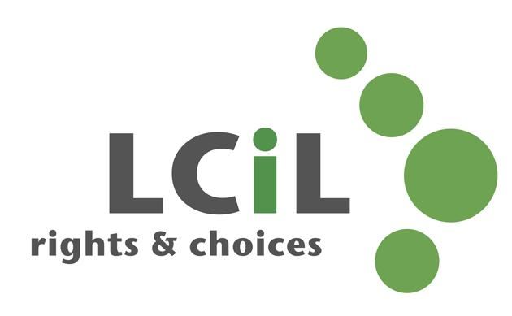
Lothian Centre for Inclusive Living
Job description

Job Title: Administrator/HR Administrator (Part time 25hrs)

Salary scale: £18,625 - £20,000 pro rata

Responsible to: Office Manager

Job Purpose: The Administrator will be the key administrative and organisational resource within the operations team of the organisation. They will also assist the Office Manager with HR tasks.

Location: Edinburgh, office based

Main Responsibilities

- taking telephone calls and passing enquiries to the appropriate member of staff
- opening and logging incoming mail and franking outgoing mail
- typing of various correspondence
- printing, collating and circulating information pack, newsletters etc
- management of Personal Assistant recruitment service and PA database
- filing, photocopying and shredding confidential papers
- assisting with room bookings or events as required
- assisting the Office Manager to ensure effective processing of HR and recruitment information
- database data cleansing, input and retrieval (statistics/reports)
- preparing distribution lists/labels/envelopes for mail shots etc.
- assisting with annual renewal of organisation membership
- scanning and uploading of paper files to cloud storage
- destruction of paper files in line with GDPR
- tasks relating to monitoring and evaluation for all services
- collating and writing of annual organisation surveys and subsequent reports
- converting information into formats suitable and accessible to service users, i.e. braille, large print, audio tape, computer disc.

Any other duties as required.

Contacts:
- Disabled people, people with long term conditions and parent carers
- LCiL’s Board, staff and members
- Disability organisations and other voluntary organisations
- Schools and colleges
- Local authority and National Government officials and elected members

Supervision Received:
The post holder will receive regular supervision from the Office Manager in accordance with the terms and conditions of service. The post holder will be expected to attend staff meetings, team meetings, training courses, LCiL events and other meetings as appropriate to the functioning of the organisation.

Complexity and Creativity:
Lothian Centre for Inclusive Living is an innovative and demanding initiative which has a significant impact on the lives of disabled people, their families and the statutory authorities.

The provision of support which enables disabled people to increase their level of self-control in all aspects of their lives is highly complex. It requires sensitivity, a knowledge of services which are available to disabled people, up-to-date knowledge of relevant legislation, an understanding of the concerns of disabled people, a commitment to the Social Model of Disability, and an understanding of the Independent Living philosophy.

The post holder is required to take initiative on a wide range of tasks and work as part of a team to ensure LCiL maintains an integrated approach. They must be able to work under pressure within a challenging and sometimes uncertain social, political and financial climate.

It is essential that the post holder is able to work within an organisation which is led and managed by disabled people.

 | Essential | Desirable
Experience:
The post holder will have experience of working in an HR department. |  | x
The post holder will have experience of working in a busy office. | x
Experience of website and social media | x
Knowledge:
Knowledge and understanding of employment law |  | x
Demonstrate Intermediate level office software, word-processing, spreadsheets and personal information management tools. | x
Knowledge of health & safety provisions and procedures |  | x
Skills:
Demonstrate good written and verbal communication and interpersonal skills. | x
Demonstrate accurate data entry. | x
Demonstrate ability to organise own work and prioritise often conflicting requirements. | x
Proficient IT skills with a willingness to adopt and learn new technologies and systems – this includes communication, collaboration, recording and office applications. | x
Demonstrate ability to proof, format and present documents. | x
Demonstrate effective time management skills. | x
Good working knowledge of mailchimp, canva and Youtube |  | X
Other requirements
Commitment to LCiL’s mission and values with a desire to make a difference | x
Open-minded, values equality and diversity, acts with care and is supportive of others. | x
Thoughtful and committed to learning, forward looking and solution-focused. | x
Proactive, flexible and collaborative | x

January 2022

