Job Description

Title | Service & Volunteer Development Officer
Line Manager | Service Manager
Line Manages | No line management. Will supervise volunteers.
Salary | Band 3: £23,370 - £25,277
Location | This role will offer flexible, blended working opportunities. Office based in Calman Centre, outreach covers Greater Glasgow and Clyde.
Contract | July 2024 (part funded by the National Lottery Communities Fund)
Hours | 35 Hrs per week
Annual Leave | 35 days annual leave (including bank holidays)

About Cancer Support Scotland:
For more than forty years, Cancer Support Scotland have helped people live well with cancer. Our purpose has always been to improve the wellbeing of those affected by cancer.
We are here for anyone affected by cancer, whether they are a person with cancer, a carer or loved one. Our wellbeing services range from professional one-to-one and digital counselling, stress management, ‘Here for You’ phone calls and Self-help tools, to simply offering a tranquil place to collect your thoughts with a cup of tea.
In the last year Cancer Support Scotland has offered over 7,000 appointments and demand for our services is continuing to rise.

Our Values:

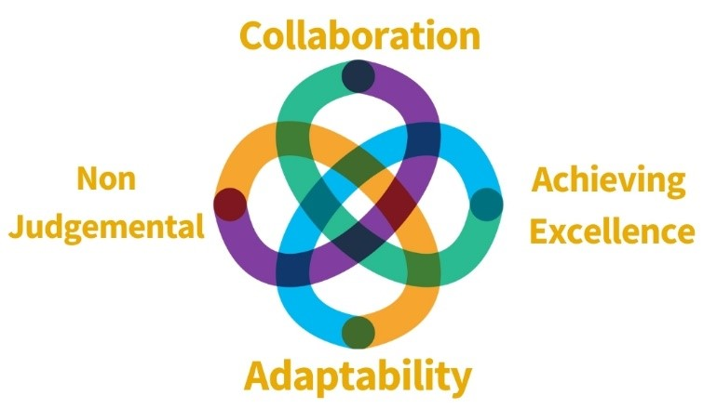

The Post:
We are looking for an exceptional Service & Volunteer Development Officer to take up a new post supporting our Stress Management & ‘Here for You’ Service, focused on expanding and developing both programmes to best meet the needs of people affected by cancer. In this role you will be highly proactive, empathetic and driven to support our services through:

- Development and coordination of Peer Support Groups; supporting Stress Management programme participants to set up, facilitate and maintain their own Peer Support Groups Offering support, signposting and referrals where appropriate.
- Development, recruitment, training and support of Stress Management & ‘Here for You’ volunteers, providing opportunities for those we support to participate in service development and delivery.
- Taking part in networking opportunities including reaching out to local communities, businesses and groups helping Cancer Support Scotland reach people affected by cancer.
- Opportunities to support improvement in our long-term evaluation methods for both services.

You will report to the Service Manager, working closely with the Wellbeing Facilitators, ‘Here for You’ Befriender Volunteers and those we support to deliver a highly effective Stress Management and ‘Here for You’ befriending service to help more people live well with cancer.
This post is generously part funded by the National Lottery Community Fund.

Key Responsibilities
Stress Management Development
- To recruit, develop and train participants in service-specific volunteer roles.
- To develop, implement and facilitate Peer Support Groups for stress management participants.
- To participate in inclusive monitoring and evaluation processes, involving programme participants in reviews and implementing a participant steering group.
- To represent and raise awareness of the programme at external events, presentations and on social media.
- To work collaboratively across teams to support effective progress reporting and communications content.
- To develop and maintain links with contacts in relevant charities, public bodies and community groups.
- To support improvement in our long-term evaluation methods for this service.
- To source local venues to host Stress Management workshops across Greater Glasgow.

Volunteer recruitment, training and support
- To develop and maintain links with local and national volunteer recruitment agencies.
- To attend relevant events, such as volunteer fairs and community events to promote volunteer opportunities within the whole Charity.
- To support the development of a volunteer strategy in partnership with other staff members.

- Production of Monthly and Quarterly Volunteer Stats for the Leadership Team.
- Responsible for the recruitment and training of befrienders and ongoing support of the existing 5 ‘Here for You’ volunteers.
- To provide ongoing support and review meetings for Stress Management and ‘Here for You’ volunteers, encourage their personal development and if appropriate, direction towards relevant and additional support.
- Liaising with the Administrator and other relevant staff to ensure volunteers are fully supported to deliver their volunteering effectively.
- To assist the Service Manager with support and review meetings for other service volunteers where appropriate and workload permitting.

General Responsibilities
- Ensure all activity complies with GDPR legislation.
- To attend internal and external meetings representing Cancer Support Scotland as required.
- To attend occasional out of hours’ meetings or events.
- Work effectively and collaboratively with colleagues across the departments.
- To operate within the policies and procedures set out by the organisation.

Personal Specification
 | Essential (E) / Desirable (D) | Assessment Method
Qualifications | - Full Clean Driver’s licence (D)  - Evidence of continuing professional development (E) | • Application
Experience | - Experience of working in a community development role (D)  - Experience of working with volunteers (E)  - Experience of using online content management systems Customer Relationship Management Systems–  (E)  - Experience of meeting and measuring key performance indicators. (D)  - Experience of working effectively in a team and leading on own initiative (E)  - Knowledge of the charity sector (E)  - Experience of multi-agency working (D)  - Experience of responding to people with sensitive and complex needs (D)  - Ability to use website tools (D)  - Knowledge of relevant policy and procedures for volunteering roles (D) | - Application  - Interview
Skills | - Excellent organisations skills, including ability to manage multiple tasks and projects (E)  - Excellent communication skills with people from all backgrounds (E)  - A proactive approach to identify opportunities and make connections (E)  - Ability to work on own initiative and to meet deadlines (E)  - Ability to problem solve and find creative solutions (E)  - Attention to detail and to seek the highest standards (E) | - Application  - Interview

Benefits
- Access to learning and development opportunities.
- Company sick leave policy.
- Mental Health Benefits: access to supervision for all staff.
- 35 Days Annual Leave, increasing 1 day after year of service (to 40days).
- Flexible working options.
- Modern workplace environment.
- Competitive salaries with incremental progression.
- Access to pension scheme.

Requirements of this role are;
- PVG Check (Paid for by Cancer Support Scotland).
- Two Professional references.
- 6 Month probationary period.
- Participation in all staff training & meetings.
- Requirement to wear relevant PPE and adhere to social distancing guidelines as appropriate and in line with guidance from the Scottish Government.
- Adhere to all of Cancer Support Scotland’s guidance, policies and procedures.

Structure of Cancer Support Scotland
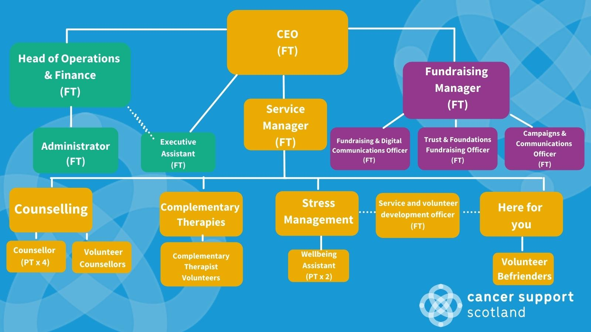

How to apply
You can apply by submitting a tailored covering letter and two-page C.V to: recruitment@cancersupportscotland.org by 12noon on 25 Feb 2022.

