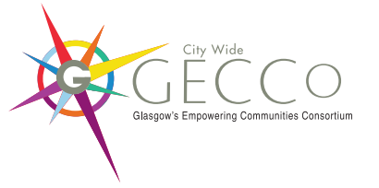



JOB DESCRIPTION

JOB TITLE  EMPLOYMENT ADVISOR | CONTRACT  To 31st March 2023 (ext. subject to funding)
SALARY £24,500

Responsible to: GECCo Steering Group & Host Employer

Base: Connect Community Trust (Easterhouse) & Community Central Halls (Maryhill)

Hours: 35 hours
(Flexible working to be confirmed with Manager)

Job Summary
As one of three Personal Advisors across the city, you will be responsible for helping local people remove barriers to employment, education, volunteering and training and move into or closer to work. You will engage and manage a caseload of clients to address barriers by providing core employability support, helping to identify opportunities and supporting each individual through their personal journey.
The post holder will be required to deliver provision both remotely and face to face working as a team across the city to best support local people.
This position is key to the launch of this transformational partnership across the city and a core part of our organisations continued vision to provide quality employability provision and increase opportunities for local people and ultimately, move people into work.

1. KEY RESPONSIBILITIES

Key Responsibilities:

- Undertake an assessment of, and with, each individual to identify individual needs and develop an appropriate plan of support and interventions in response.
- Provide local people with tailored core employability support including CV writing, application help, jobsearching, creating email, digital skills for work, interview preparation.
- Provide support to local people to develop and further their engagement with volunteering, employment opportunities and educational providers.
- Establish a supportive relationship with each individual, enabling them to maximise their own resources to improve their potential.
- Work alongside the GECCo staff team, provide training and guidance to team members in developing suitable training and workshops.
- Work co-operatively as part of GECCo and the wider Connect/SWAMP/Community Central Halls team including attending and contributing to team meetings and wider community engagement.
- Update client database with outcomes and interventions as required (Hanlon).
- Liaise with local jobcentres, housing associations and other partners
- Ensure the views and wishes of local people are central to your work and encourage participation across all services and activities.

Development

- Actively engage with local people to ensure services are evolving and new ideas are heard.
- Attendance/Represent the company at external and internal meetings to promote, share information and develop the contracts.
- Work in partnership with other local organisations to maximise the opportunities available to local people.
- Support the creation and development of employability and training opportunities.
- Organise recruitment and/or information events and sessions for promotion of opportunities.

Administration & Monitoring Duties

- Monitor time and attendance of individuals
- Ensure all necessary paperwork for each individual is completed
- Maintain Client Management database (Hanlon)
- Produce statistical information on the level of participation and facilitate evaluation
- To undertake administrative duties including word processing and report writing

Other General Duties

- Be an active team member by highlighting any achievements and any areas for improvement
- To attend company meetings to report on progress of activities
- To undertake any other reasonable duties as delegated by your employer

The successful applicant will be subject to a PVG Check

