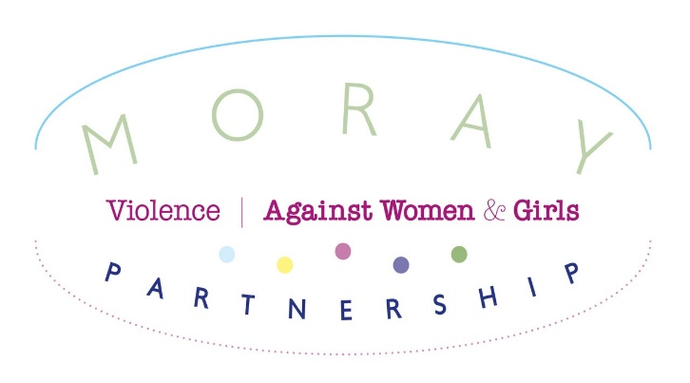

Dear Applicant,
Vacancy: Equally Safe and Together Development Co-Ordinator. Fixed term contract to 30th Sept 2023.
Thank you for your interest in working with Moray Violence Against Women and Girls Partnership VAWGP as the Equally Safe Development Co-Ordinator.
To enable the partnership to achieve its aim we have successful secured funding from the Scottish Government through the Delivering Equally Safe funding stream to employ a Development Co-ordinator to support the work of the partnership. You will oversee the co-ordination of Equally Safe Moray Project, plan, implement and deliver a training plan for Safe and Together and wider workforce training requirement.
Please note that we do not accept CVs. The full application form should be completed and emailed to recruitment@mwaelgin.co.uk by 9am Tuesday 15th March. Interviews will be held on Tuesday 29th or Wednesday 30th Match at Marleon House, Elgin
We look forward to receiving your application. In the meantime, if you have any queries, please contact me on 01343 548561 or email melaie.wood@mwaelgin.co.uk
Best wishes,

Melanie Wood
Melanie Wood
Business Development and Funding Manager,
Moray Women’s Aid
On behalf of Moray Violence Against Women and Girls Partnership

Background Information
Moray Violence Against Women and Girls Partnership (VAWGP). The VAWGP is dedicated to tackling violence against women in all its forms and coordinating services from voluntary and statutory agencies to ensure appropriate support is provided to those affected by it.
The partnership recognises that partnership working is essential for providing a comprehensive response to violence against women, and that by working together agencies can intervene more effectively with the men who perpetrate violence, therefore safeguard the women and children affected by it and take steps to prevent it happening in the first place.
The VAWGP has adopted the Scottish Government definition of Violence Against Women and Girls and will develop an outcomes-based approach to its work, in line with the national ‘Equally Safe’ Strategy.
Violence against women and girls is not confined to any particular political or economic system, but it is prevalent in every society in the world. It cuts across boundaries of wealth, race and culture. It is an expression of historically and culturally specific values and standards which are today still executed through many social and political institutions that foster women’s subservience and discrimination against women and girls.
The Partnership, has also adopted the Scottish Government definition which identifies violence against women as follows:
“Gender based violence is a function of gender inequality, and an abuse of male power and privilege. It takes the form of actions that result in physical, sexual and psychological harm or suffering to women and children, or affront to their human dignity, including threats of such acts, coercion or arbitrary deprivation of their liberty, whether occurring in public or private life. It is men who predominantly carry out such violence, and women who are predominantly the victims of such violence. By referring to violence as ‘gender based’ this definition highlights the need to understand violence within the context of women’s and girls’ subordinate status in society. Such violence cannot be understood, therefore, in isolation from the norms, social structure and gender roles within the community, which greatly influence women’s vulnerability to violence”

It is recognised that the abuse perpetrated against women is much wider than physical violence so the word “violence” encompasses, but is not limited to:
- Physical, sexual and psychological abuse occurring in the family, within the general community or institutions, including: domestic violence, coercive and controlling behaviours, rape, incest and child sexual abuse.
- Sexual harassment and intimidation at work and in the public sphere; commercial sexual exploitation, including prostitution, pornography and trafficking
- Dowry related violence
- Female genital mutilation
- Forced and child marriages
- Honour crimes
- Child Sexual Exploitation
- Other sexual crime including cyber enabled crime

