JOB DESCRIPTION
(1) JOB IDENTITY
POST TITLE: Equally Safe Development Co-ordinator
LOCATION: Home Working / Public Protection Office Moray Council
REPORT TO: Violence Against Women & Girls Partnership
SALARY: £30,326.40 (£36,644.40 FTE) + 10% employer pension
HOURS: 30 hours per week. Fixed Term Contact ending 31st September 2023

(2) JOB PURPOSE AND WAY OF WORKING
To play a key role in the delivery and implementation of agreed project outcomes relating to Equally Safe Moray. Supporting the Violence Against Women & Girls Partnership (VAWGP) to increase workforce development and community awareness on gender-based violence.

(3) MAJOR TASK, JOB OBJECTIVES & RESPONSIBILITIES
3.1 Oversee the co-ordination and implementation of Equally Safe Moray Project and provide regular updates to the Violence Against Women & Girls Partnership. Monitor ongoing impact of project and produce project reports.

3.1.1 Support the development of a partnership wide development plan based on a workforce training needs assessment. This plan will be inter-agency both in design and delivery and will be inclusive of a partnership wide Safe and Together implementation plan.

3.1.2 Assisting VAWGP agencies in the implementation of Safe and Together approach, including update of policies, practice, staff training programmes, monitoring and evaluation frameworks, participation plans and service user involvement strategies.

3.1.3 To coordinate, plan, implement and deliver a training programme that will support work force development and increase community awareness on the causes and consequences of gender-based violence

3.1.4 Collaborate with the VAWGP to develop and deliver training to the workforce and community on local multiagency guidance for: How to identify women and children affected by gender-based violence; Safe responses and referral pathways; The role of MARAC and the Risk Indication Checklist

3.1.5 To contribute to the development of a communication and engagement plan to raise awareness of VAWGP using a range of mediums to disseminate key messages, learning and available resources, e.g., campaigns, events, social media etc.

3.1.6 Work with the partnership and raise awareness of VAWG across the public and specific groups, including the planning and delivery of the Moray Equally Safe Conference.

3.1.7 Offer of high-quality development opportunities for community groups and private sector organisations on gender equality and VAWGP issues.
3.2 To work with other members of the team to implement key elements of the project plan, ensuring improvement to service delivery/operational practice. Lead on designated action plans arising from the overall project plan/project brief ensuring agreed milestones and timescales are achieved.
3.2.1 Be a key member of the project team delivering the Equally Safe Moray project. Work with members of the VAWGP and the Public Protection Team to implement key elements of the project/plan ensuring improvement to service delivery/operational practice.
3.2.2 Support the completion of Domestic Abuse Informed Practice Self-Assessment Tool and Implement the Safe & Together Model across the partnership.
3.2.3 Contribute to the preparation of action plans as required. Lead and collaborate on some action plans arising from the overall project plan/project brief ensuring agreed milestones and timescales are achieved.
3.2.4 Contribute/prepare reports as required by the project for Moray VAWGP and Inspiring Scotland.
3.2.5 Collate data to understand people’s attitudes in relation to VAWGP to inform the development of awareness raising activities.
3.2.6 Conduct a final evaluation of the Equally Safe project, learning from the experiences of women and children to assess the success of project.
3.3 To assist the senior officer(s) in the project in the communication and dialogue within the partnership, as appropriate, in order to establish requirements, update on project progress and delivery of agreed outcomes.
3.3.1 Support VAWGP and the Lead Officer for Public Protection in providing communication regarding the project to relevant stakeholders in accordance with the agreed communications plan.
3.3.3 Organise and control operational delivery of the action plans as assigned to you.
3.3.4 Guide and support other project team members in the requirements of the action plan and what is required.
3.3.5 Liaise with relevant stakeholders, when required, to ensure the action plan can be delivered on time.
3.3.6 Monitor the progress of completing the assigned actions plans.
3.3.7 Ensure legislative and procedural compliance on all work produced relating to the project.
3.3.8 Ensure clear and accurate project records are maintained to meet audit requirements.
3.4 Draw on the experiences of women and girls through questionnaires and focus groups to identify what development professionals need to fully understand their situation and provide effective support.

3.4.1 Engage with women and girls to ensure that the improvement actions of the VAWG Partnership are informed by their views and lived experience.

3.4.2 Enable women and children to have their stories heard through the platforms of awareness raising, workforce training and partnership evaluation activities.

3.4.3 Set up focus groups, 1 to 1 conversations, online polls and questionnaires to enable women and children to safely take part in projects.

The above is intended to provide a clear but concise statement of the MAJOR TASKS and ACTIVITIES of the job. It is not an exhaustive list of all its detailed duties.

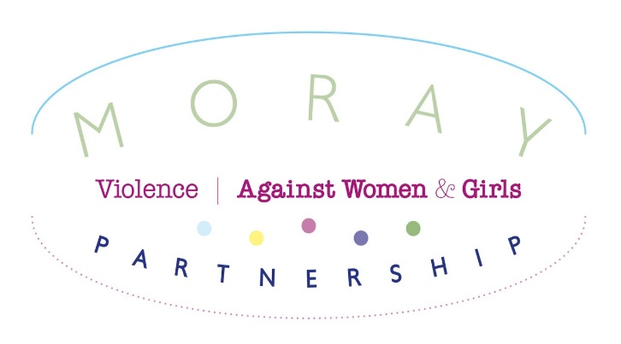
PERSON SPECIFICATION
Post: Equally Safe Development Co-ordinator
Salary: £30,326.40 (£36,644.40 FTE)
Hours: 30 per week
ATTRIBUTES | ESSENTIAL  The minimum acceptable levels for safe and effective job performance | DESIRABLE  The attributes of the ideal  candidate
- Experience | Proven experience in working on projects and delivering outcomes successfully within set time frames.  Proven experience of analysing complex information in order to identify opportunities for improvements  Experience of working on a project with multiple partners and stakeholders | Experience of working with survivors of domestic abuse and understanding the gendered dynamics and broad ranging impacts of Violence Against Women and Girls  Experience of delivering workforce training  Experience of facilitating group work/focus groups,
- Education & qualifications* | Degree or equivalent in a related subject (Social Work, Health, Education) or the ability to demonstrate the equivalent relevant work experience  Awareness of Equally Safe: Scotland's strategy to eradicate violence against women 2018 and the Equally Safe Quality Standards and Performance Framework. | Certification in the delivery of accredited training  Training in improvement methodologies
- Skills/abilities (general) | Self-confident, self-motivated and able to work independently  Good organisational skills and analytical skills  Appreciation, acceptance of and a commitment to the importance of confidentiality  Ability to use Microsoft Office inc. Word, Teams, Excel and Access or equivalent
- Skills/abilities specific to post* | Ability to prepare detailed reports and project/budget plans  You will be expected to travel efficiently and effectively between various work locations within Moray to meet the operational requirements of the Service. Due to the rural nature of Moray this is normally undertaken by use of a car. | Ability to deliver presentations to stakeholders
- Inter-personal & social skills | Strong communication skills with ability to engage with colleagues, partners and the public to build productive relationships with key stakeholders.
- Working environment & physical demands | Must be able to work flexibly to meet the demands of the project.  Work will primarily be undertaken in the home, with sometime in the office in Elgin and some time in other locations across Moray, dependent on the demands of the project.

* Candidates will be required to show these documents if invited for interview.
Membership of Protecting Vulnerable Groups Scheme (Working with Vulnerable Adults) YES/NO
Membership of Protecting Vulnerable Groups Scheme (Working with Children) YES/NO
Access to car and clean driving licence YES/NO
Satisfactory pre-employment medical screening required? YES/NO

