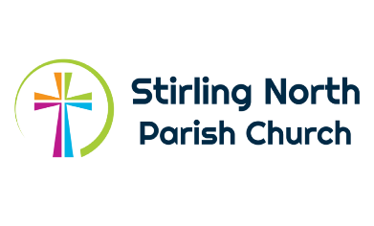

Stirling North Parish Church
Parish Worker (Children, Youth & Families)
Please fill in the application form and submit it, along with a CV and a covering letter, outlining where you think your experiences match the requirements of the job description.
References: In addition, can you please, with their consent, give the names and contact details of two appropriate referees we can contact? ALL APPLICATIONS SHOULD BE RECEIVED ON OR BEFORE 1st April 2022.

Name:
Address:

Email:
Telephone number:

Contact details of Referee 1:
Name:
Address:

Email:
Telephone number:

Contact details of Referee 2:
Name:
Address:

Email:
Telephone number:

Applications should be sent, either by post or by email, to:
Sheena Rennie
Office Admin
Stirling North Parish Church
Springfield Road
Stirling
FK7 7QW
Email: info@stirlingnorth.org

NB Please remember to submit your CV and covering letter.

Stirling North Parish Church
Charity No: SC011795

