

Role Profile – Marketing Co-ordinator
Reports To: Marketing Manager
Role Purpose:
The Marketing Co-ordinator delivers targeted marketing campaigns and activities driving customer acquisition, retention and brand awareness, via multiple channels.
The post is responsible for co-ordinating campaigns aligned with our organisational strategy to reach everyone in Scotland with sight loss and implement marketing activity across all channels. The role also manages our website and is responsible for producing marketing collateral.
You’ll have an analytical mindset able to optimise campaigns, planning and providing post-campaign reporting and insights.
The Marketing Co-ordinator works as part of a team within the Marketing and Communications department.
All roles within Sight Scotland and Sight Scotland Veterans are expected to work to our values and Our Ways of Working framework:
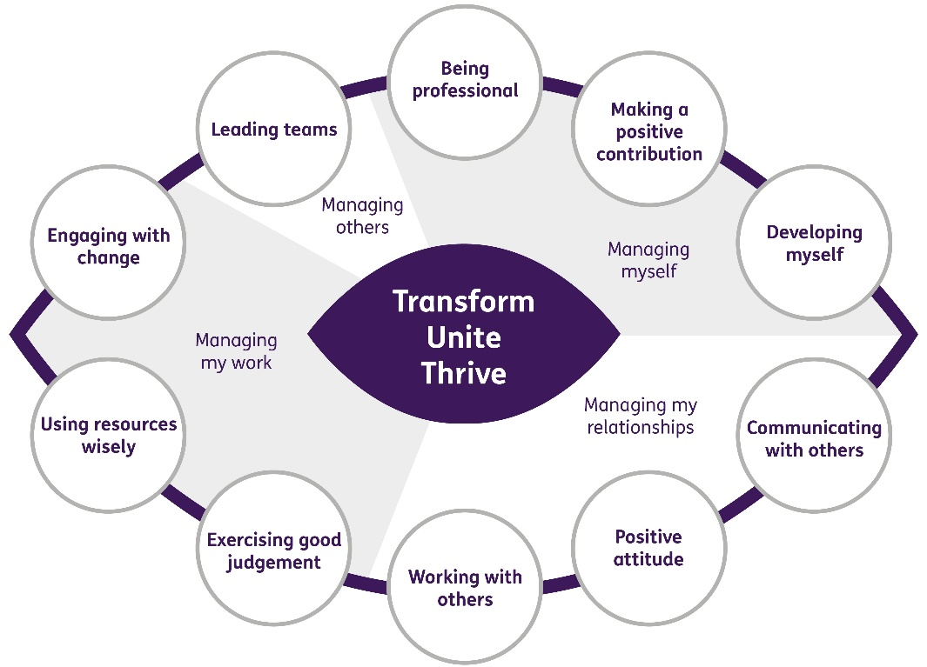

The main responsibilities and accountabilities of this role are:
Marketing and brand
- Work closely with, and under the supervision of, the Marketing Manager to deliver marketing campaigns to attract enquiries and customers to the charities and to promote the brand. Campaigns can target potential service users, volunteers, donors and new staff
- Research advertising opportunities, answer enquiries from advertisers and work with media buyers on planning
- Monitor progress of marketing campaigns, gather and report on outcomes including digital analysis
- Act as internal and external brand ambassador
- Populate listings websites relevant to services
- Liaise and build relationships with external stakeholders who can support marketing to new service users
- Ensure marketing activities cross sell services to appropriate audiences
- Research and book profile raising opportunities at conferences and events (exhibition stands, sponsorship, branding and speaker opportunities)
- Assist the Marketing Manager in organising profile raising events
- Work in collaboration with others in marketing department to ensure campaigns are aligned across all channels (eg social media, press, publications)
Website
- Ensure website is kept up to date with regularly reviewed engaging content and images
- Content writing including for SEO
- Analysis performance of website with Google analytics and advise on changes and new content as required
- Give day to day direction on behalf of the department to digital marketing agency for SEO and Facebook ads that drive traffic to the website and are in line with campaigns for marketing, brand, fundraising, policy and information resources
- Interview people for case studies
Marketing automation
- Manage contract with marketing automation company, Adestra.
- Design and write marketing automation journeys for customers.
- Ensure templates used by all colleagues meet brand guidelines.
- Support and train colleagues with using Adestra and ensure it is being used to maximum effect across all departmental email marketing.
Customer journeys and service
- Work with Marketing Manager to ensure delivery of cohesion and strong customer journey for all service marketing related campaigns
- Write and design materials and letters to support service user acquisition and retention strategies
- Co-ordinate and design customer service user feedback surveys and mystery shopping as required
- Develop improved standards of customer experience through the user journey
- Support customer service roles in delivering high standards of care and stewardship
Marketing collateral
- Write and commission design of marketing materials This can include brochures, leaflets, merchandise, banners etc
- Create branded materials (eg. posters) for use in-house using tools like Canva
- Manage photo library
- Commission photographers
Contribute to the work of the Marketing and Communications department
- Support cross team projects and events
- Work effectively and collaboratively with colleagues across the department
- Proof read brochures, magazines and leaflets written by other colleagues
- Represent the organisation at conferences, exhibition stands and events
To do this role, you will have:

Professional experience of:

- Running multi channel marketing campaigns
- Commissioning work from agencies, photographers and graphic designers
- Writing and producing marketing collateral to a high standard
- Writing for different audiences and across off line and online channels
- Brand management
Skills:
- High level of writing skills with an excellent grasp of grammar
- Working with a wide range of stakeholders, internal and external, at all levels
- Working independently and as part of a team
- Experience of using content management systems and photo editing software
Knowledge and Understanding of:
- SEO strategy and delivery
- The use of Google analytics to produce website improvements
- Development of offline and digital customer journeys
- Customer service processes and journeys
Other:

- Ability to work out of hours, for which TOIL will be granted
- Full clean driving license
It is desirable that you will have:

- Degree or professional qualification in marketing
- Membership of the Chartered Institute of Marketing
- Market research and analysis
- Experience of using in-house graphic design tools such as Canva and video editing software

On a day to day basis you will work with different people and teams, these could be:
- Staff within services and head office departments
- Service users
- Families of service users
- External stakeholders

Requirements of this role are:
- You are a member of the PVG scheme (paid for by Sight Scotland and Sight Scotland Veterans)
- You will have a 6 month probation period
- You participate in all staff training and development and maintain your own professional development
- You will follow Sight Scotland’s guidance, policies and procedures relating to your own health and safety and that of colleagues and service users at all times.
- You will uphold the principles of Sight Scotland’s Dignity at Work and Equal Opportunities policies at all times, working in a way which supports an inclusive work environment that is respectful of differences.

What we can offer you:
- Generous annual leave entitlement
- Generous pension scheme
- Access to learning and development opportunities
- Employee Assistance Programme
- Cycle to Work scheme
- And many more, please visit our website for more information

This job profile is not exhaustive. The duties of the post holder may be reviewed from time to time and the employee may be called upon to work in other locations within Sight Scotland and Sight Scotland Veterans.

