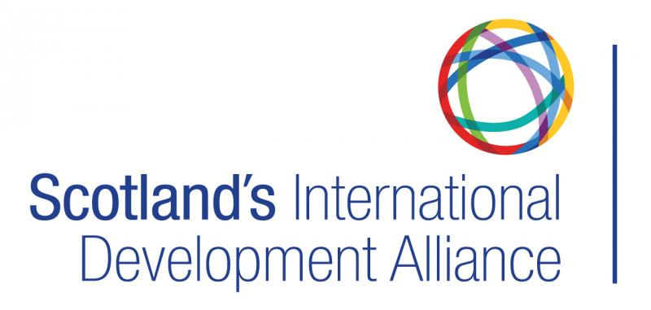
Humanitarian Action & Global Citizenship Engagement Officer
Hours: 35 hours a week, full time
Location: Flexible/hybrid (with at least one day a week in Edinburgh/Glasgow)
Contract type: 2 years fixed-term, with possible extension
Salary: £32 000-35 000
Annual Leave: 31 days plus 6 public holidays
Reports to: Chief Executive

About Scotland's International Development Alliance
Scotland’s International Development Alliance is the membership body for everyone committed to creating a fairer world, free from poverty, injustice and environmental threats.
Our work facilitates connections in global development to improve impact and effectiveness for a range of actors including public sector bodies, third sector and international NGOs, private companies, universities and charitable trusts.
Our network has a uniquely global reach, with members working in more than 100 countries with a wide range of specialisms. We exist to improve the capacity, influence and effectiveness of those working on global development connected to Scotland through providing opportunities for networking, debate, training and promotion of good practice. We help members share their skills and learn from each other’s best practice to boost effectiveness of our members and their partners
About the role
Working closely with the small team at the Alliance, this new post will support the development and coordination of civil society driven humanitarian action out of Scotland. A key aim is to raise public awareness of, and engagement with, the most effective ways to support international humanitarian causes.
Through direct outreach activities, with NGOs, diaspora and grassroots community groups in particular, the Scottish Government and public authorities such as NHS Scotland (including NHS NSS Procurement), and the private sector, the role will facilitate joined up thinking, communications and action and promote Scotland’s collective global citizenship.
The Humanitarian Action, Diaspora, & Global Citizenship Engagement Officer will support and develop new communities of interest and practice in response to humanitarian crises across the world, with a focus on legacy work to build lasting connections.
Using and developing the Alliance’s digital platforms, the post will also support participation, outreach and communications activities to enhance global citizenship in Scotland.
The post holder will be required to contribute to a variety of projects and initiatives, and a willingness to collaborate and work closely with colleagues is essential.
Responsibilities
- Facilitate and host regular coordination meetings for Scottish based NGOs, diaspora, grassroot groups and other organisations/private sector companies providing support and/or sponsorship for ongoing humanitarian crises.
- Promote humanitarian action in Scotland, including work of Scottish Government funded Humanitarian Emergency Fund (HEF) panel and promote outreach to Scottish public on best ways to support humanitarian action including regular updates on how/where support is being delivered.
- Establish and maintain strong relationships with key organisations and networks that support humanitarian action in other countries, including Scottish-based diaspora and grassroots groups e.g. Glasgow Afghan United, Ukrainian groups, official consular representatives and others.
- Establish and maintain strong relationships with global citizenship champions in education, health and other public sector bodies by supporting, developing and amplifying their work on Active Global Citizenship.
- Develop outreach programmes reiterating key responsibilities of global citizens in responding to humanitarian crises, the climate and nature emergency and broader sustainable development objectives in solidarity with global communities.
- Provide guidance, learning material and advice for communities which will enable them to play an active and effective part in international humanitarian responses.
- Develop and support structures and processes which enable Scotland’s international humanitarian organisations to collaborate effectively with the broader voluntary and community sectors.

Person Specification
Skills, knowledge, experience

- People skills
- Strong facilitation skills
- Strong interpersonal and intercultural skills with an ability to listen and accommodate different views
- Experience of organising events, chairing meetings, and building networks in a range of online and in person contexts
- Experience and knowledge of humanitarian delivery in crisis contexts

- Communication
- Creativity - an ability to tell compelling stories using a range of formats and media
- Excellent writing skills using a range of formats and styles
- Strong attention to detail, with an ability to synthesise specialist information into clear, readable copy
- Relevant experience in the development and delivery of communications and marketing strategies to build support and interest in global solidarity

- Digital
- Excellent computer and IT skills and demonstrable ability to learn new software quickly
- Experience of promoting engagement via social media, utilising scheduling software and creating multimedia content using basic graphic design software
- Experience in producing and uploading digital content relevant for a range of audiences on websites and other online platforms

- General
- At least 4 years relevant experience in a coordination/facilitation role, in a humanitarian or other related context.
- Ability to learn, reflect and respond to new issues quickly
- Ability to work with minimal supervision and to deadlines, including carrying out research where required.
- Ability to multi-task and prioritise workload effectively

