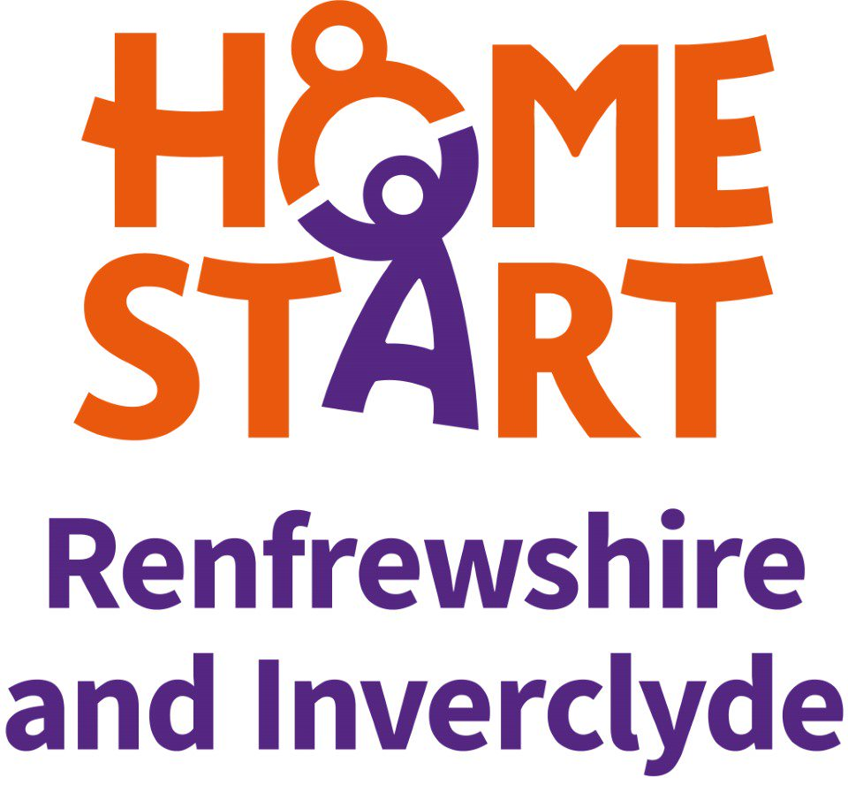
Person Specification – Wellbeing Group Worker

This form also indicates how the different requirements may be assessed during the selection process:

A = Application Form, I = Interview, E = Exercise

Person Specification – Wellbeing Group Worker

ESSENTIAL | Method of Assessment
 | A | I | E
Education and Qualifications
Good standard of general education | ✓
Employment History
Relevant previous or current employment/volunteering | ✓ | ✓
Experience of Planning & Running a Group
Experience of running a similar group | ✓ | ✓
Knowledge of the roles of agencies providing services for improved mental health and wellbeing | ✓ | ✓
Knowledge of current legislation and policies relating to children and families | ✓ | ✓
Understanding of challenges individual face as a result of the pandemic | ✓ | ✓
Understanding of the needs of families with young children | ✓ | ✓
Understanding of the need for professional confidentiality | ✓ | ✓
Ability to assess individual needs and plan to meet these through Group activities. |  | ✓
Ability to organise appropriate activities and programmes |  | ✓
Ability to maintain accurate records and provide reports from them |  | ✓
Ability to organise volunteers and parents to provide support to the Group |  | ✓
Ability to promote and develop the service |  | ✓
 | Method of Assessment
 | A | I | E
Personal Qualities
Non judgemental attitude. |  | ✓
Ability to work on own initiative within clear guidelines |  | ✓
Knowledge of and commitment to equal opportunities and anti-discriminatory practice | ✓ | ✓
Commitment to personal and professional development | ✓ | ✓
Eligibility to work in the UK | ✓
Open, friendly disposition: warmth, creativity. |  | ✓
Good written and verbal communication skills | ✓ | ✓
DESIRABLE
Parenting experience | ✓
First Aid certificate. | ✓
Knowledge of the local community | ✓ | ✓
Experience of work in the voluntary sector or as a volunteer | ✓ | ✓

