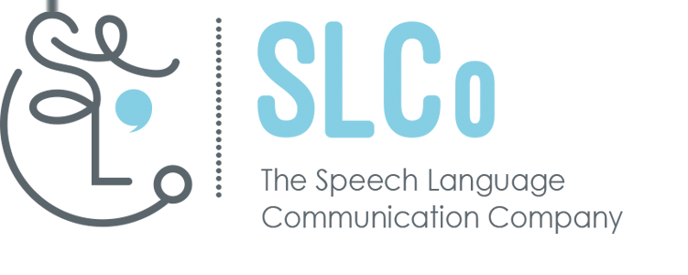

The Speech Language Communication Company (SLCo)
Background information and Job Description: Volunteer Co-ordinator
Term of appointment: Fixed-term: until March 2024
Location: Home-based; (Dundee) and other locations when required.
Hours per week: circa 10 per week home based with travel as required
Salary: negotiable
Background information
The Volunteer Co-ordinator role demands a pro-active approach and the ability to work independently and on own initiative to achieve agreed objectives. The current team works very flexibly to maximise the impact of this small organisation across Scotland, raise awareness of the impact of speech, language and communication disabilities and improve services for families and their children. This position will be best suited to someone who can work flexibly, enjoys a challenge and does not need a highly structured framework to manage their own, and other people’s work effectively.
SLCo provides information, supports local parent groups, develops resources and offers a programme of training, workshops and conferences to support parents and CYP (and professionals). We are a registered provider of C.P.D. in Scotland. SLCo seeks to develop a small team of volunteers who will engage with our services and local authority community planning partnerships and develop volunteer networks for parents and families across multiple geographic areas.

Job description

Fixed-term post, funded by Scottish Government through Volunteering Support Fund.
This role is ideal for a self-starter with a range of key skills; a dynamic individual who is able to work independently within the communities covered by our project. You must demonstrate experience in volunteer management and possess disability and equalities awareness, have excellent communication and interpersonal skills and evidence considerable experience in person-centred working. You will value the people you engage with as the experts and be familiar with community engagement principles and local authority partnerships.
You will be responsible for supporting and developing a new volunteer programme to help build a volunteer base to support service delivery and act as a local voice for children and their families.
The post-holder must be proficient in the use of internet and social media, and wider I.C.T. is desirable. This is an exciting, new opportunity for someone with the relevant experience who can make a considerable impact. We welcome applications from all sections of the community and actively seek to promote equality and diversity within the organisation. The Volunteer Co-ordinator will be responsible to the Director. The post is pensionable in line with Automatic Enrolment.

SPECIFIC DUTIES
- In conjunction with the Director, develop a Volunteer Programme in line with recognised standards.
- Identify adult volunteers to work to promote SLCo’s work within local community settings.
- Identify parents and carers willing to become involved in ‘promoting the ‘parent voice’ within their local authorities.
- Recruit, train, engage and support the volunteers and manage the application process (and PVG checks where appropriate). Be creative in working with a range of individuals with different needs and aspirations in different locations.
- Promote volunteering within local communities as a means of building confidence and offering peer support and networking opportunities for a range of families and carers.
- Induct and train volunteers to ensure that they have the skills, knowledge and support to be able to carry out their roles effectively.
- Develop and maintain links with local statutory services, NHS, local volunteer centres and other agencies.
- Promote and market events; encouraging collaboration and developing partnership opportunities.
- Link in with leisure centres, day centres and schools to make use of venues across the geographic areas.
- Co-ordinate social media and online information and ensure communication principles applied.
- Monitor and regularly review the volunteer programme and support being provided.
- Ensure that adequate and appropriate digital records are kept of all voluntary work.
- Manage a database of contacts and provide content for a quarterly e-newsletter.
- Provide regular updates to IT officer to ensure website has up to date information; use a range of social media in order to share information and build links with stakeholders.
- Provide regular updates to Director and team members.
- Attend meetings and prepare progress reports when required.
- Collect and evaluate data about the service in order to inform future development and delivery.
Other Duties:
- Attend local meetings
- Attend relevant training sessions
- Deliver awareness presentations
- Contribute to reports for Management, funding opportunities etc
- Participate in other SLCo activities as required

This job description is not intended to be exhaustive. The post-holder will be expected to adopt a flexible attitude to duties, which may have to be varied subject to the needs of the service and in keeping with the general profile of the post. It is recognised that the time constraints of the post (10hr) will require SLCo and post-holder to prioritise duties from within the above range of duties.

Knowledge/Skills / Experience
Essential
- Experience of co-ordinating volunteers
- Excellent written communication and presentation skills
- Ability to develop and manage small projects
- Exceptional organisational and time management skills
- An understanding of the relationship between national and local government
- An understanding of the role of the Third Sector
- Ability to work on your own initiative
- Comprehensive knowledge and experience of using IT and social media
- Comprehensive understanding of Equalities, Disability and any other relevant legislation
- Full, clean driving licence and use of car

The post will require travel across Scotland and the successful candidate must be able and willing to work anti-social hours as necessary.

Desirable

- A qualification in volunteering, community education or similar.
- Knowledge of speech, language and communication impairments.
- An understanding of the Scottish Government’s ‘Inclusive Communication’ agenda.

