Candidate Information
Senior Project Officer, Active Travel Strategy

Salary: | Grade G: £28,499 per annum (pro rata for part time hours)
Hours: | Full time hours are 37.5 hours per week  We are very happy to discuss working hours to suit individual circumstances which could include job share / compressed hours.
Contract: | Permanent
Disclosure: | Protecting Vulnerable Groups scheme is not required for this position as the post holder will not be working with children in educational settings
Base: | Fife Council offices in Roads and Transportation Services, Bankhead Central, Bankhead Park, Glenrothes KY7 6GH (at least 4 days per week) with possible flexibility to work from home a proportion of the time.
Travel: | This role will involve regular travel most weeks. The focus of this role is the Fife Council area; we may occasionally need you travel further during the course of your work including occasional visits to Sustrans Offices and overnights stays.
 | A key part of being the Charity that makes it easier to walk and cycle is that most colleagues cycle, walk, wheel or use public transport for the majority of their work journeys. We support this with National Standards Cycling Training payment of bicycle mileage and covering the cost of public transport.

Job Specific Information:
The post holder will be based within Fife Council and facilitate a strategic approach to active travel infrastructure development and delivery in Fife, working to shared priorities agreed between Fife Council and Sustrans. The post holder will be line managed by Sustrans and task managed on a day to day basis by a key contact in Fife Council. The post holder will provide support in the development and delivery of active travel policies and proposals as set out within Fife Council’s Local Transport Strategy and developing Active Travel Strategy and related documents. The post-holder will work across Council departments and in partnership with external organisations to identify and develop opportunities for investment in active travel. The post-holder may also assist with research to demonstrate demand for investment in active travel infrastructure.
Where this role sits in the Sustrans structure:
Where this role sits in the Fife Council structure

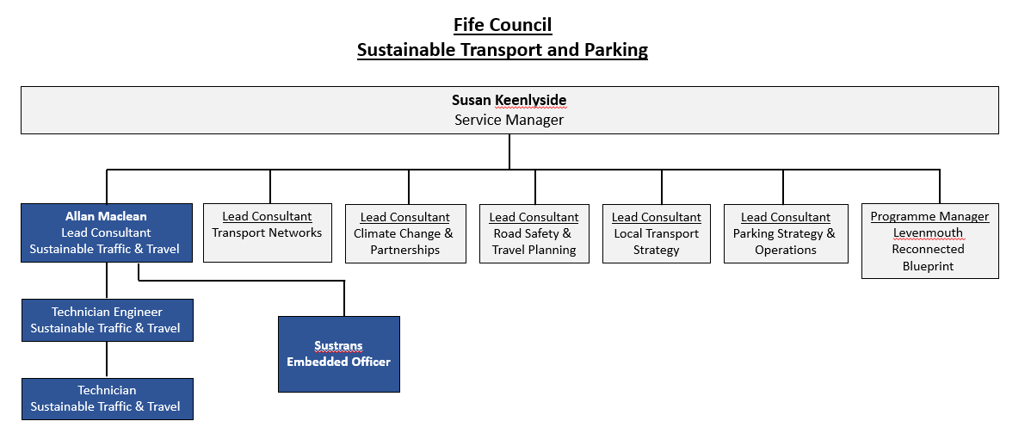
Job Description - About the Role
Overview:
To work within Fife Council to help deliver our shared priorities for active travel.
The post holder will support the development and delivery of active travel policies and proposals as set out within Local Transport Strategy and developing Fife Council Active Travel Strategy and related documents for an average of 4 days per week. They will work on Sustrans-specific tasks related to the Strategic Partnership’s Team objectives for an average of 1 day per week.
Where this role sits in the structure | Reporting into a Partnerships Manager in Sustrans Scotland  The role will work closely with our key contact(s) in Fife Council (who will be the task manager for the role), with other Local Authority staff and also Sustrans Senior Project Officers who have a similar role, based in other Local Authorities across Scotland.  This role does not have line management responsibility.
Key Responsibilities:
This role is a Senior Project Officer, Active Travel Strategy. Responsibilities may include:
Delivery of the Project:
- To work strategically to develop active travel initiatives in Fife, for example assisting the development of active travel strategies/ development plans/ project delivery processes to direct council investment into active travel (e.g. network development and prioritisation)
- To plan and deliver high quality active travel projects, including initiating and supporting delivery of new/improved infrastructure
- Identify and develop funding opportunities for active travel projects, including liaising with funders to discuss potential projects and submitting funding applications
- To assist with Bike Life research to demonstrate demand for investment in active travel infrastructure
- To facilitate community / public engagement to ensure a collaborative approach to projects and their communication and engage with promotional campaigns to encourage active and sustainable travel.
- To work across council departments and in partnership with external organisations to identify opportunities to align policy aims and increase investment in active travel
- To influence through sharing knowledge, expertise and evidence, including facilitating access to opportunities for support, training and knowledge from other teams within Sustrans
- To prepare reports and present project updates and outcomes to a variety of audiences, which may include funders, local authority and Sustrans staff, elected members, as well as to wider audiences (e.g. conference presentations)
We don’t expect anyone to be an expert in all these areas and as long as you meet the person specification we can train you in any gaps.
Person Specification
The following criteria sets out the method by which the skills, knowledge and experience will be assessed against. Our website has a useful guide about how to make a great job application.
 | Application Form | Interview
Specific experience required
Experience in at least one of the following; transport planning, land use planning, urban design, traffic engineering, sustainable transport project delivery or similar.
Project management
Partnership working and relationship-building
Working with or in local authorities
Behaviour change work
Community engagement
Skills and Abilities
Excellent verbal and written communication skills and presentation skills
Excellent interpersonal skills and the ability to build relationships with partners, key stakeholders and communities
Ability to work independently and make decisions with minimal supervision
Ability to be a team player
Ability to develop concept designs for active travel infrastructure projects either individually or as part of a design team
Strong analytical skills
Excellent report writing skills
Effective time management skills
Proficient in Microsoft Office
Competent in using GIS (geographic information system) mapping
Strategic thinking
Ability to persuade others to try out a new approach or idea
Specific qualifications/ training required
Educated as appropriate to person specification
Specific knowledge required
National and international best practice in design and promotion of cycling, walking and wheeling
Knowledge of the funding context for active travel in Scotland

This document does not form part of the contract of employment but does outline our expectations. If we need to amend this document in the future we will consult with the post holder before doing so.
Everyone at Sustrans
Our values guide us in everything we do:
- Including everyone
- Having the courage to question
- Acting local, thinking big
- Getting things done, together
- Always learning.
- Sustrans has clear health and safety policies and it is essential that all our colleagues follow these. Very often our teams come into contact with young people through schools work or community engagement so it is everyone’s responsibility at Sustrans to comply with our Safeguarding policies.
- One of our key strategic goals is to be a charity “for everyone”, building a more diverse and inclusive Sustrans. We recognise there is much more we can do to bring together diverse life experiences and voices to enable us to more fully understand, access and represent the communities we work in. Everyone at Sustrans should support this goal and follow our Equality, Diversity and Inclusion policies and procedures.
- Sustrans asks that all our employees develop their skills, knowledge and experience through training and personal development activities. Sustrans will support you with clear objectives and a supportive management culture - our teams tell us that one of the great things about working for Sustrans is the learning and knowledge sharing opportunities.
- It is very important that our colleagues are happy and able to work with IT systems - we use Microsoft programmes and other databases every day (we will train you on our bespoke systems)
- It is also important that everyone at Sustrans supports and follows with the charity’s guidance on branding/key messages and contributes towards raising Sustrans’ profile.
- Everyone at Sustrans is required to work their contracted hours and record their time – if extra hours are worked then we can take time off in lieu.
- We ask that everyone in Sustrans helps us to develop new opportunities for funded work and builds excellent relationships with our delivery partners and stakeholders.
Two of our values are we get things done, together and we’re always learning. Managers often require their teams to get involved in activities that are outside of their job descriptions as we feel this is one of the ways you can learn on the job, develop new skills, make new contacts and progress your career with Sustrans.

