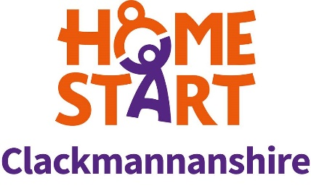
Home-Start Clackmannanshire is committed to safer recruitment practice as an important part of safeguarding and protecting children and vulnerable adults

Home-Start Clackmannanshire

Job Description - Family Support Worker

Job Title: Family Support Worker

Employer: Home-Start Clackmannanshire, 92-94 Alloa Business Centre,
Whins Road, Alloa, FK10 3SA

Hours of work: 20 hours per week

Contract type: Fixed term Contract for 1 year – expect to source funding for continuation of post
Salary: £22,000 pa full time (pro rata, 20 hours per week £12,571)
Responsible to: CEO (line-managed by Assistant Manager)

Purposes of the job

To work directly with young children (5years+) and their families, providing them with direct emotional and practical support within their homes, and the wider community, in order to promote, strengthen, and develop their ability to manage their lives and thrive.

To contribute to the effective day to day operation of the scheme in accordance with the Home-Start Governing documents, Standards and Methods of Practice, Home-Start Agreement and Quality Assurance Standards.

To maintain high standards of practice in supporting families within the ethos of Home-Start. To ensure inclusion and diversity in all aspects of the scheme’s operation and work.

Main Responsibilities:

Support for families
- Provide families with support, friendship and practical help at a time that suits them best ie mornings/evenings
- Ensure adequate and up-to-date records are kept of support offered to each family, in line with case management system (Charity Log)
- To undertake the designated responsibilities for safeguarding and promoting children’s welfare
- Prepare for and attend multi-agency meetings as appropriate
- Actively review families’ needs as well as referring families to appropriate additional supports
- Work collaboratively with our team, assisting Family Support Co-ordinators, to deliver a package of support to families

Working in Partnership
- Liaising with referrers
- Networking appropriately within the community

Home-Start is committed to safer recruitment practice as an important part of safeguarding and protecting children and vulnerable adults

Managing the Wider Context
- Promoting the scheme its profile, ethos and practice.
- Contributing to the development of Home-Start locally, regionally and nationally.
- Contribute to generating volunteer enquiries

Managing the scheme
- Supporting the implementation and review of all Home-Start policies and procedures.

The post holder may be required to undertake any other duties that fall within the nature of the role and responsibilities of the post as detailed above.

