Candidate Information

Job Title Service and Performance Improvement Manager (Business Change)

Salary: | Grade J: £43, 132 - £51,228 per annum (pro rata for part time hours)
Hours: | 37.5 hours per week  This job is proposed to be full-time but we are happy to discuss working hours and patterns to suit individual circumstances. Job share options may be considered.
Contract: | Permanent
Disclosure: | PVG Scheme is not required for this position
Base: | Sustrans office in Edinburgh or Glasgow with the flexibility to work from home, or home-based within reasonable travelling distance from Edinburgh or Glasgow.
Travel: | This role may involve travel across Scotland during the course of your work including occasional overnights stays.
 | A key part of being the Charity that makes it easier to walk and cycle is that most colleagues cycle, walk, wheel or use public transport for the majority of their work journeys. We support this with access to a Sustrans pool bicycle and National Standards Cycling Training.

Job or Project Specific Information

The purpose of this post is to drive and deliver key high profile and strategic internal change projects across Sustrans Scotland with a focus on improvements in processes, systems, and ways of working to improve organizational effectiveness which will drive improved performance. The postholder will be required to undertake end to end project management and steer projects including handling issues, interdependencies and communicating project status at regular intervals.

Specific Role

The post-holder will work across Programmes and Functions initially supporting the bedding in of the new structure before moving on to developing an overarching approach to continuous improvement within the organization with demonstrable impact on performance. This role is about business change and is not about business as usual performance management.

To achieve this the post-holder will be required to work collaboratively with colleagues at Director and Head level in particular, as well as using learning and support from UK colleagues.

Where this role sits in the structure: | 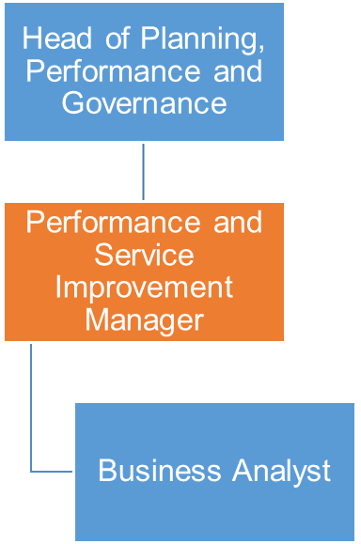

Job Description - About the Role

Overview

The Service and Performance Improvement Manager is responsible for business change across the Sustrans in Scotland, driving a consistent approach to continuous improvement.
You will be expected to work collaboratively with other Heads, Managers and Directors in Scotland and UK.

Where this role sits in the structure | Reporting to Head of Planning, Performance and Governance  Working relationship with Directors, Heads and Managers in Scotland and colleagues across the UK.  This role will have line management responsibility for the Business Analyst
Key Responsibilities

Responsibilities may include:

- To manage the delivery of end-to-end internal business change projects working closely with senior internal and external stakeholders to ensure benefits are delivered
- To scope and create project plans, ensuring these are well resourced and monitored throughout the lifecycle of the project.
- To implement and maintain a project schedule, project documents, highlight reports and meeting notes
- To proactively manage risks and issue logs, ensuring that appropriate mitigation and actions are in place.
- To coach and support colleagues leading workstreams to develop skills and experience in project management.
- To liaise with key stakeholders in order to identify document and agree the project objectives, success factors and scope at outset and manage accordingly.
- To build relationships with all stakeholders, through regular, on-going communications and engagement, proactively searching for solutions to challenges and understanding opportunities to maintain delivery.
- To manage project scope, quality, schedule, costs and resources ensuring the projects meet the business objectives
- To balance and challenge the influence of constraints, for example, scope creep across resource and schedule.
- To transparently report on overall project and individual workstream status to key stakeholders.
- To work with the PMO, Strategic Planning Manager and other key posts as required.
- To monitor and log lessons learnt with a continuous improvement approach across the organisation.
- To facilitate meetings (and produce related documents such as agendas and minutes)
- To keep up to date with best practice on business change.

Provide reports, analysis and insight for briefings to Directors, Heads and other colleagues on emerging strategic and performance themes which may impact Sustrans.

We don’t expect anyone to be an expert in all these areas and as long as you meet the person specification we can train you in any gaps.

Person Specification
The following criteria sets out the method by which the skills, knowledge and experience will be assessed against. Our website has a useful guide about how to make a great job application.

 | Application Form | Interview
Specific experience required
Experience of internal project management | ✓ | ✓
Proven experience of delivering business change in an organisation to promote continuous improvement |  | ✓
A proven track record in delivery of change which impacts on the organisation’s effectiveness and efficiency | ✓ | ✓
Experience of collaborating internally and externally to understand best practice | ✓ | ✓
Skills and Abilities
Excellent analytical, verbal and written communication skills | ✓ | ✓
Ability to work collaboratively across an organisation | ✓ | ✓
Ability to plan and prioritise workload, ensuring all given deadlines are met | ✓ | ✓
Ability to understand and challenge expert opinions |  | ✓
Excellent organisational and interpersonal skills |  | ✓
Ability to take a proactive approach to completing tasks and resolving enquiries, anticipating problems and finding solutions |  | ✓
Specific qualifications/ training required
Educated to degree level or equivalent | ✓
Specific knowledge required
Knowledge of best practice in project management, business change and/or process management | ✓ | ✓
Understanding and of dependency management
Understanding of portfolio/programme management

This document does not form part of the contract of employment but does outline our expectations.
If we need to amend this document in the future we will consult with the post holder before doing so.
Everyone at Sustrans

Our values guide us in everything we do:
- Including everyone
- Having the courage to question
- Acting local, thinking big
- Getting things done, together
- Always learning.

- Sustrans has clear health and safety policies and it is essential that all our colleagues follow these. Very often our teams come into contact with young people through schools work or community engagement so it is everyone’s responsibility at Sustrans to comply with our Safeguarding policies.

- One of our key strategic goals is to be a charity “for everyone”, building a more diverse and inclusive Sustrans. We recognise there is much more we can do to bring together diverse life experiences and voices to enable us to more fully understand, access and represent the communities we work in. Everyone at Sustrans should support this goal and follow our Equality, Diversity and Inclusion policies and procedures.

- Sustrans asks that all our employees develop their skills, knowledge and experience through training and personal development activities. Sustrans will support you with clear objectives and a supportive management culture - our teams tell us that one of the great things about working for Sustrans is the learning and knowledge sharing opportunities.

- It is very important that our colleagues are happy and able to work with IT systems - we use Microsoft programmes and other databases every day (we will train you on our bespoke systems).

- It is also important that everyone at Sustrans supports and follows with the charity’s guidance on branding/key messages and contributes towards raising Sustrans’ profile.

- Everyone at Sustrans is required to work their contracted hours and record their time – if extra hours are worked then we can take time off in lieu.

- We ask that everyone in Sustrans helps us to develop new opportunities for funded work and builds excellent relationships with our delivery partners and stakeholders.

- Two of our values are we get things done, together and we’re always learning. Managers often require their teams to get involved in activities that are outside of their job descriptions as we feel this is one of the ways you can learn on the job, develop new skills, make new contacts and progress your career with Sustrans.

