Membership & Engagement Officer (maternity cover)

Post | Membership & Engagement Officer (maternity cover)
Location | Office-based, Edinburgh with the potential for some home working.  Travel throughout the country will also be required.
Salary | £30,302 + pension (currently 11.5% employer contribution)
Length of contract | Fixed term, 12 months from July 2022
Hours | Full-time, 35 hours per week (excluding meal breaks). No overtime paid, but time off in lieu may be taken as appropriate.
Leave entitlement | 25 days p/a, plus 10 public holidays
Probationary period | 3 months
Closing Date | 12 noon on Monday 16th May
Interviews | Interviews will be held on Wednesday 1st and Thursday 2nd June

Purpose of post:

We are looking for a dynamic and committed individual to support communities on their journey towards setting up development trusts. Working as part of the Development Officers’ team, this role will provide advice and information to early-stage development trusts, contribute to the development of resources and communications for established DTA Scotland members, and coordinate a programme of in-person and online networking and learning events.

Summary of main tasks

Help interested communities and organisations explore the development trust approach:

- Respond to enquiries by email and telephone
- Provide information, advice and resources, as appropriate, including on appropriate governance arrangements
- Signpost to other agencies and support programmes
- Attend and contribute to relevant community meetings and events
- Make presentations and deliver / co-deliver training
- Arrange learning / study visits to other development trusts
- Assist organisations with DTA Scotland membership applications

Promote the development trust approach, DTA Scotland and the wider development trust movement:

- Contribute to the development of information, resources and promotional materials
- Support the Development Officer team to manage the members’ area of the website
- Support the Development Officer team to with the delivery of member benefits
- Contribute to the planning of a programme of DTA Scotland member network events
- Organise and promote DTA Scotland member events online and face-to-face
- Facilitate and coordinate peer learning opportunities for DTA Scotland members such as the closed member Facebook group
- Support the delivery of DTA Scotland annual conference
- Contribute to DTA Scotland communications including member mailings, e-bulletins, website and social media content
- Update the membership database
- Contribute to the work of the Development Officer team as appropriate
- Carry out any other duties relevant to the post.

Please note that the post-holder is required to travel throughout the country and as such, hold a full driving licence. There is evening work on a fairly regular basis, with occasional overnight stays and weekend work. No overtime paid, but time off in lieu may be taken as appropriate.

Person Specification

Skills & experience
You will have
- Experience of working with communities and an understanding of grassroots community-led approaches to regeneration
- Experience of providing advice and support to individuals and organisations, ideally in a community context
- Understanding / knowledge of organisational governance
- Experience of delivering training or providing information in a public setting
- Skilled in producing written communication across different platforms and for diverse audiences
- Experience of community development, community enterprise and community ownership (desirable)
- Experience / knowledge of community consultation (desirable)

Personal attributes
You will be:
- Strongly committed to development trusts, community-led regeneration and placemaking
- Friendly, approachable and an effective communicator
- Highly organised with excellent attention to detail
- Able to manage a varied and busy workload
- A problem-solver, able to use initiative and be proactive
- Digitally confident, skilled in using IT systems, software and databases
- Able to work flexible hours when required (including some evenings and weekends) to meet the needs of organisation

To Apply for the Post:

If you are keen to be considered for this opportunity, please email kay@dtascot.org.uk with your CV and a covering letter detailing your reasons for applying and specific experience to match the criteria above by no later than 12 noon on Monday 16th May.

If you have any questions regarding your application, please contact kay@dtascot.org.uk.

DTAS is committed to a policy of equality & diversity.
We take the collection and use of your data seriously, please see link to the DTAS Recruitment Privacy Statement

This position is funded by:

 | 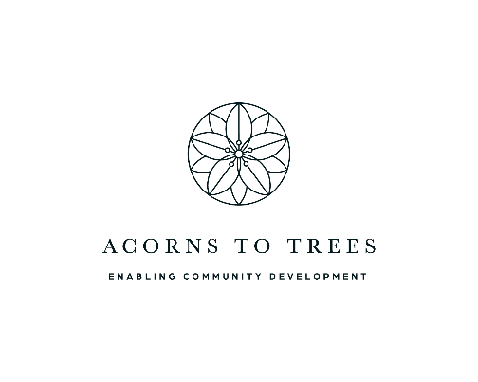

Background information:

Development Trusts Association Scotland (DTA Scotland) is an independent, member-led organisation which aims to promote, support and represent development trusts in Scotland. Established in 2003, DTA Scotland now has over 330 development trust members, which makes it one of Scotland’s largest and most dynamic community-led regeneration networks.

A development trust is a community-owned and led organisation, working to combine community-led action with an enterprising approach to address and tackle local needs and issues. The aim of a development trust is to create social, economic and environmental renewal in a defined geographical area, creating wealth within that area and keeping it there. Across the country, in city, town, rural and island locations, development trusts are enabling communities to make their own plans and aspirations a reality.

Through the provision of information, advice and support, and the effective facilitation of our inspiring development trust network, DTA Scotland seeks to contribute to the building of independent, enterprising and resilient communities. This work includes an annual conference which regularly attracts over 200 delegates, a wide range of publications and resources, and a suite of training and support interventions.

As well as providing core support to DTAS members, we also operates two specific services: our Community Ownership Support Service which promotes and supports the transfer of public assets to community organisations and Community Shares Scotland, a national programme to raise awareness and support the use of community shares to finance a range of community enterprises.

Our office is based in the Dalry area of Edinburgh, a short walk from Haymarket Station.

