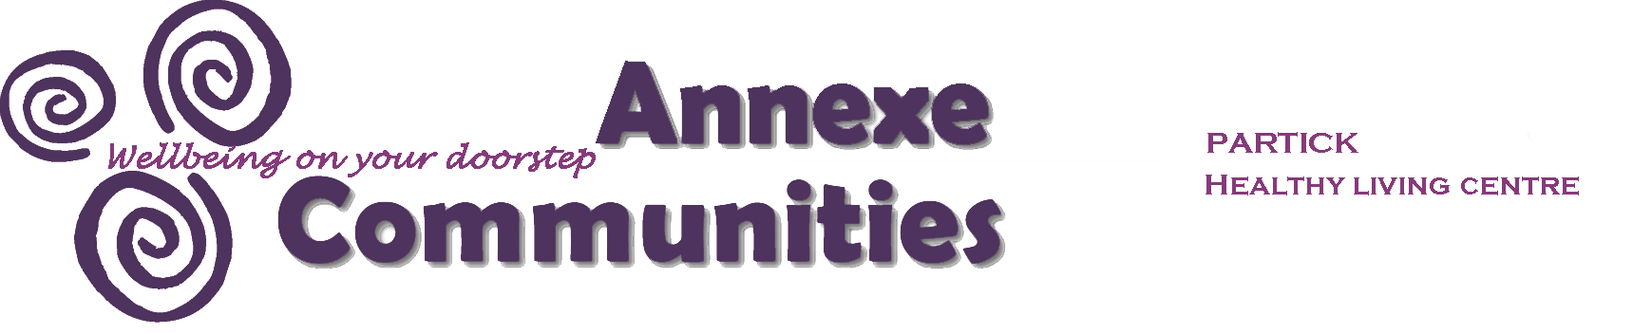

April 2022

Dear Applicant

Post of Social Prescribing Development Worker

Thank you for expressing interest in coming to work with us at Annexe Communities.

The following documents with this information pack include:

- Application Form
- Equal Opportunities Monitoring Form
- Job Description and Person Specification.

Once you have completed your application and equal opportunities monitoring form, please email to kashif.anwar@annexecommunities.org.uk or post to The Administrator, Annexe Communities, 9a Stewartville Street, Glasgow G11 5PE.

Applications should arrive no later than 5pm Tuesday 3rd May 2022.

Only those applicants short listed for interview will be contacted and this will be by Monday 9th May 2022.

Face to face Interviews will be held week commencing 16th May 2022.

Yours sincerely

Julie Fox
General Manager

About Annexe Communities
We are a local community anchor organisation with a focus on community-led health and wellbeing. We operate from our Healthy Living Centre base in Partick, Glasgow and have over 30 years’ experience working with the local community to develop and deliver community development initiatives and wellbeing activities.

Our aim:
To work continuously to engage with local people and to maintain our position as a leading provider of cost-effective, wellbeing initiatives resulting in fitter, more resilient and more active communities.

Our current priorities support:
- Local groups to build their capacity to make a positive difference in the lives of individuals and communities;
- People with poor mental or physical health to raise their aspirations, make informed choices, and improve their life chances;
- Older people and those facing social isolation to enable them to reconnect with their local communities, participate in positive activities, and improve their life chances;
- Families, carers, to counter disadvantage and influence decisions that affect them, their relations and neighbourhoods

We work together with local people, community groups, the local authority, housing associations, businesses and other voluntary and community organisations. We are governed by a volunteer board of directors, elected by our members. Directors are local residents, services users or people who work locally. We currently have 10 employees; 12 sessional tutors and 30 volunteers working to achieve our mission and engage with around 1000 individuals each year.

Currents services include:
- Healthy Eating Community Cafe: including affordable lunch clubs for vulnerable and older people.
- Personal and social wellbeing activities: knit & natter group, a range of exercise classes, Lipreading class, community singing group, ukulele group, art class, walking groups, meditation group, craft class, cooking workshops and community film nights.
- Supporting volunteers: providing appropriate training and mentoring to build their capacity to volunteer in their community
- A social prescribing initiative taking referrals from local health care professionals to enable patients to access personal and social development activities and follow personal health pathways to reduce isolation and improve wellbeing..
- Participatory budgeting initiative – supporting local people to get involved in determining priorities for their neighbourhood and to access local funds to develop ideas.
- Developing local groups: to build their capacity to make a positive difference in the lives of individuals and communities
- Working collaboratively with a range of local partners to identify and develop initiatives to benefit residents and the local community
- Operating as a community enterprise: offering facilities rental and healthy living services to generate income
- Responding to and supporting community needs in an emergency e.g. Covid pandemic

