14th April 2022

Dear Applicant

Advocacy Worker Role

Thank you for your interest in the above vacancy with Govan Community Project.
Enclosed with this letter is a copy of the job description, and a copy of our application form. The application form can be completed electronically, however we are also happy to receive paper applications.
The closing date for applications is midnight on Tuesday 3rd May 2022. No late applications can be considered.
To enable us to monitor diversity within our recruitment processes, we would be grateful if you could complete our anonymous diversity survey which can be accessed here: http://bit.ly/GCPHReqmonitoring, however this is not mandatory and opting out of this will have no impact on your application.
Completed applications being submitted by email should be sent to recruitment@govancommunityproject.org.uk. Paper applications should be sent to:
Traci Kirkland, Head of Charity
Govan Community Project
Pearce Institute, 840-860 Govan Road
Glasgow G51 3UU

We look forward to receiving your application.
Kind Regards
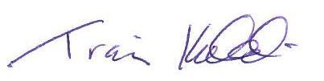
Traci Kirkland
Head of Charity

