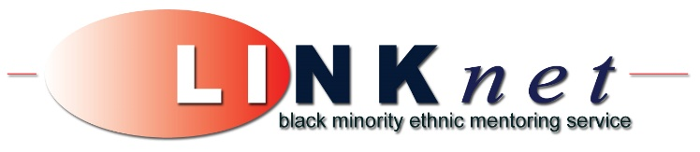

**Ethnic Monitoring Form**

The information requested is helpful in monitoring the effectiveness of our services and is required by our funders. Any information given is kept confidential

1. **Name:**
2. **Postcode :**

**3. Your area - Please tick a box below**

|  |  |  |  |  |  |
| --- | --- | --- | --- | --- | --- |
| North | South | Craigmillar | Wester Hailes | Leith | Other/Don’t know |
|  |  |  |  |  |  |

**4. Gender**  *Male Female*

**5. Current employment status** Full-time Part-time Unemployed Student

**6. Length unemployed**

0-6 months 7-12 months 13-24 months 25+ months

**7. Your qualification**

No qualifications less than SVQ/NVQ level 1

SVQ/NVQ level 1 or equivalent SVQ/NVQ level 2 or equivalent

SVQ/NVQ level 3 or equivalent SVQ/NVQ level 4 or equivalent

SVQ/NVQ level 5 or equivalent

Other/Don’t know___________________

**8. Age Range:**

16-18 19-25 26-35 36-45 46-59 60+

**9. How long have you been in the UK?**

Less than 3 years □ More than 3 years □

***\* Please turn over***

**10. Do you fit any of the following?**

Jobseekers allowance claimant Lone parent

In low waged employment Care Leaver

Homeless Ex-Prisoner

History of Substance abuse Mental health issues

Have learning disability Employed

Have physical disability or ill health

Other disability *(If yes, please describe)*

**11.** **Which of the following categories do you consider that you belong to?** *(Please tick)*

|  |  |  |  |  |  |  |  |
| --- | --- | --- | --- | --- | --- | --- | --- |
|  | Asian - British |  | Indian |  | Black - African |  | White - African |
|  |  |  |  |  |  |  |  |
|  | Black - British |  | Pakistani |  | Caribbean |  | White |
|  |  |  |  |  |  |  |  |
|  | White - British |  | Bangladeshi |  | Black - Other |  | Arabic |
|  |  |  |  |  |  |  |  |
|  | Mixed - British |  | Chinese |  |  |  | Mixed |
|  |  |  |  |  |  |  |  |
|  | Any other Asian |  | Any other black |  | Any other white |  | Any other ethnic identity: |
|  | ethnic identity:  *(please give details)* |  | ethnic identity:  *(please give details)* |  | ethnic identity: *(please give details)* |  | *(please give details)* |

**12. How did you hear about LINKnet Mentoring?**

Friends Family Work place

School College / University Jobcentre

Volunteer Recruitment Fair The Welcoming Self referral

LINKnet Presentation LINKnet Outreach worker

Intermediary organisations Employment academies

Edinburgh Volunteer Centre

Other organisation *(please give details)*

Other *(please give details)*