Sands
Application Information

National Bereavement Care Pathway Manager- Scotland

April 2022

About Sands
Every day in the UK, 13 babies are stillborn or die shortly after birth.

Sands is the leading stillbirth and neonatal death charity and exists to reduce the number of babies dying and to support anyone affected by the death of a baby, before, during or shortly after birth.

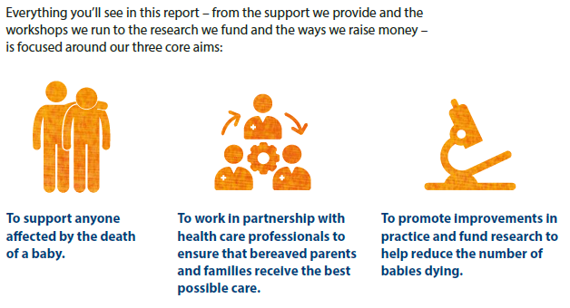 | Sands provides bereavement support services both nationally through its Freephone helpline, mobile app, online community and resources, as well as locally through a network of around 100 regional support groups based across the UK and run by trained befrienders.
 | Sands works in partnership with professionals, trusts and health boards and offers a range of training programmes and bereavement care resources to ensure that every bereaved parent and family receives the best possible care wherever they are in the UK.
Sands promotes improvements in practice and supports research to better understand the causes of baby deaths and save babies’ lives.
Sands raises awareness of baby loss and works with governments, key influencers and other stakeholders to make reducing the number of babies dying a priority nationally and locally.
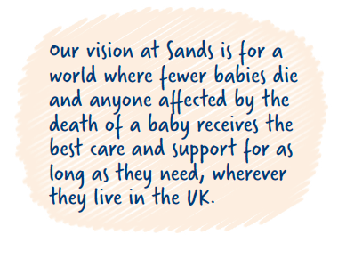
Over the past 44 years, Sands has grown into a national charity with a powerful vision shared by dedicated volunteers, fundraisers, members, donors, healthcare professionals, partners, staff and bereaved parents and families.

Sands has grown its income by over 40% since 2012 and, as part of our strategic plan, is focusing on how we can make the biggest difference to the lives of bereaved families and save babies’ lives. To find out more, visit www.sands.org.uk
Join us and help create a world where fewer babies die.
Sands Staff Benefits

Annual Leave
Staff receive 28 days annual leave per annum pro rata, plus bank holidays. Staff will be required to take 3 days annual leave during the period between Christmas & New Year.
Employee Assistance Service
As part of its commitment to employee wellbeing, Sands offers all Staff access to the Bupa Employee Assistance service which offers free and confidential counselling and wellbeing support. Support is available on a range of issues including legal, financial, emotional, health and work-related concerns.
Sand Cycle to Work Scheme
Sands has teamed up with Cycle Solutions to provide a Cycle to Work Scheme, which you can join to make considerable savings on the cost of a new bike and equipment.
Sands Pension Scheme
Subject to eligibility, you will be automatically enrolled into the Aegon Personal Pension scheme as soon as your employment commences. You can decide whether to remain in the scheme and/or make additional voluntary contributions if you wish.
Flexible Working
All Staff can apply for flexible working with effect from their first date of employment.
Maternity Pay
Staff on maternity leave are paid their full salary for the first 26 weeks of their period of leave.
Leave for the Death of a Baby or Pregnancy Loss
Any member of Staff affected by the death of baby or pregnancy loss will be granted leave paid at their normal salary, regardless of the type of loss.
Sands is a vibrant, growing charity!
With a clear strategy, Sands is repositioning as a learning, developing organisation which aims to achieve excellence through people and offers a collegiate, collaborative working environment – making it an especially exciting time to join the charity!
Sands is an inclusive and diversity-friendly employer. We are committed to promoting equality, valuing diversity and working inclusively. We welcome and encourage applications from people of all backgrounds and do not discriminate on the basis of disability, race, colour, ethnicity, gender, religion, sexual orientation, age or any other category protected by law.

About the role
Sands is looking for an experienced project manager to manage the development, delivery and review of the National Bereavement Care Pathway (NBCP) partnership project and embed it across Scotland to drive up standards of care. This pathway addresses the inequity of bereavement care offered to, and experienced by parents when a baby dies - see www.nbcpscotland.org.uk for more details.

This is a high-profile and rewarding role which will involve delivering a NBCP in Scotland which is parent-centred and drives up standards of care. The project is being trialled in four early adopter NHS boards in Scotland. The post-holder will engage with bereaved parents, senior decision makers and clinicians at both an operational and strategic level to ensure successful delivery of a sustainable pathway

With demonstrable experience of leading project groups comprising a diverse range of stakeholders, you will have excellent people management skills and be able to reach-out, engage with and enthuse key stakeholders across Scotland.
You will be able to establish and maintain high level, productive relationships with senior external stakeholders and organisations working in a collaborative and inclusive way.
An excellent knowledge of how the NHS is structured is essential, particularly maternity services.
You will have highly developed interpersonal skills, with the ability to communicate complex messages in a compelling way to a variety of audiences.
To apply:
Please submit your CV, together with a supporting statement that demonstrates how you meet the criteria in the person specification to recruitment@sands.org.uk. Please also complete the Diversity and Equality Monitoring Form and send this with your application.
Closing date for applications : 9am on Monday 16th May 2022

Interviews: Week commencing 23rd May 2022

As we have limited staff resources, we are unable to provide candidates with feedback about their applications. Interviews will be held online. For further information, contact Marc Harder, Head of Bereavement Care & Hospital Liaison marc.harder@sands.org.uk
Job Description
Job Title: National Bereavement Care Pathway Manager - Scotland
Responsible to: Head of Bereavement Care & Hospital Liaison
Location: Home-based with travel throughout Scotland
Contract: Fixed-term contract until 31st March 2024
Salary: |  | Up to £45,750 per annum plus £312 per annum Home Working Allowance
Hours: 35 hours per week
Main purpose of the job:
Manage the development, delivery and review of the National Bereavement Care Pathway (NBCP) partnership project and embed across Scotland to drive up standards of care.

Principal Tasks and Responsibilities
Project development, management and delivery
- Manage delivery across Scotland of a bereavement care pathway that is parent-centered, coordinated, flexible and drives up standards of bereavement care
- Engage with bereaved parents, senior decision makers, influencers, commissioners, service directors and clinicians at both an operational and strategic level to ensure successful delivery of a sustainable pathway
- Build on existing materials, policies and resources within Scotland to produce guidance materials and tools to support delivery of the NBCP
- Ensure that NBCP materials and guidance reflect the diverse experiences of bereaved parents and families
- Manage the NBCP early adopter site programme, identifying and addressing emerging themes and supporting delivery across Health Boards
- Develop plans to roll out the NBCP programme across Scotland
- Create and implement systems to enable Health Boards to self-assess uptake of the NBCP
- Coordinate delivery of the evaluation, review and reporting mechanisms for the NBCP, working with external evaluator to ensure independent evaluation is undertaken, published and disseminated
- Ensure core elements from NBCP programme are embedded in national policies, frameworks and standards.

Engagement
- Regular engagement with professionals, parents, decision makers (such as Scottish Government) and influencers to facilitate organisational and cultural change
- Work with diverse, multi-disciplinary teams across health and social care organisations to plan, test, and implement new ways of working
- Co-ordinate the NBCP Core Group to ensure co-production of project resources and joint ownership of the project
- Create a NBCP Scotland communications and engagement plan, including social media activity, blogs and newsletters
- Design and deliver workshops, webinars and events
- Work with the chair of the NBCP Scotland Parent Advisory Group to ensure bereaved parents are fully engaged in all aspects of the pathway development
- Manage the NBCP Scotland budget and report regularly to funders

General
- Occasional evening/weekend working is likely
- Represent Sands and the NBCP to external audiences
- Work with communications teams to support the production of press releases, responses to media enquiries and act as a spokesperson on relevant issues in consultation with the Core Group
- Line manage any new staff appointed to support the programme
- Manage external suppliers as required
- Undertake any other tasks and responsibilities as reasonably required by the Head of Bereavement Care & Hospital Liaison, Director of Research, Education and Policy and/or the Chief Executive, and/or the NBCP Core Group partners and funders.

This job description is not contractual and is liable to change over time

Person Specification
Essential | Proven ability in establishing and maintaining high level, productive relationships with senior external stakeholders and organisations working in a collaborative and inclusive way |  | Application and interview
Essential | Experience of leading project groups made of different professionals/skills and experiences |  | Application and interview
Essential | Experience of project management, including leading project groups made of different professionals/skills and experiences |  | Application and interview
Essential | An outstanding, ‘hands on’, people person with a positive, warm style, who can support and motivate people and teams to engage with projects with positive outcomes |  | Application and interview
Essential | Experience in the use of a range of project management tools |  | Application and interview
Essential | Excellent time management skills with the ability to prioritise own workload, self-motivate, deal with conflicting demands and meet tight deadlines under pressure |  | Application and interview
Essential | Demonstrable ability to absorb complex and new information |  | Application and interview
Essential | Ability to develop high quality resources which remain responsive to the changing needs of external stakeholders, i.e., guidance documents |  | Application and interview
Essential |  | Demonstrate an excellent knowledge of the NHS structures and organisation in general, and of maternity services in particular |  | Application and interview
Essential |  | Excellent verbal and written communication skills, with an ability to communicate complex messages in a compelling way to a variety of audiences, lay and professional |  | Application and interview
Desirable |  | Knowledge of and/or experience of delivering bereavement care after pregnancy loss or the death of a baby |  | Application and interview
Behavioural Competencies

Essential |  | Strategic thinking, with the ability to develop creative solutions |  | Application and interview
Essential |  | Excellent interpersonal skills with the ability deliver successful cross-organisational projects |  | Application and interview
Essential |  | Ability to build effective working relationships with colleagues, volunteers and external stakeholders |  | Application and interview
Essential |  | Diplomacy and the ability to discuss challenging items in a sensitive way |  | Application and interview
Essential |  | Excellent understanding and advocacy of issues relating to equality, diversity and inclusion |  | Application and interview
Essential |  | An understanding of and empathy with the issues surrounding the death of a baby, for professionals, parents and families |  | Application and interview

