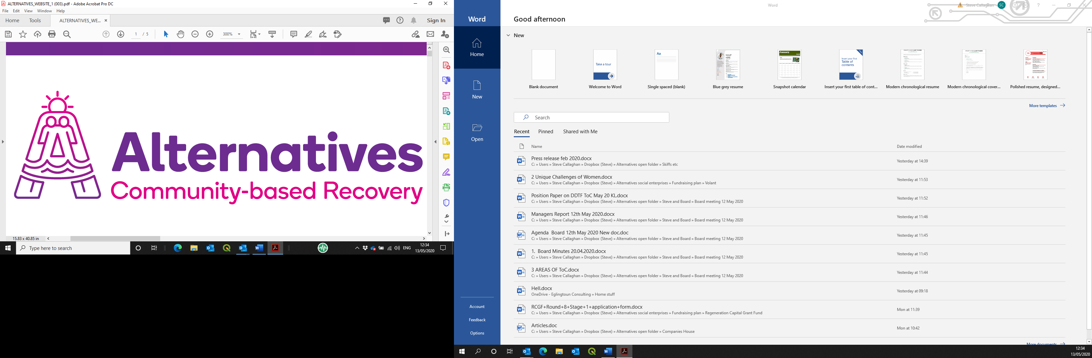

**Post of Clinical Governance Addictions Manager**

**Application pack**

*****Funded by Scottish Government National Drug Mission Fund***

Contents

Introduction and background information 3

Applying for the post on offer 3

Alternatives West Dunbartonshire Community Drug Services (Alternatives) 3

History and achievements 3

Social enterprises 3

Job description 4

Person specification 5

Application form 6

# Introduction and background information

## Applying for the post on offer

Please read this pack in its entirety, then apply using the enclosed electronic form. This should be returned by **12.00p.m. on Monday 30th May 2022**, by email to [donnie@alternativeswd.org](mailto:donnie@alternativeswd.org) .

Please add your surname to the name of the file as you save it before sending.

**LATE APPLICATIONS WILL NOT BE ACCEPTED**.

## Alternatives West Dunbartonshire Community Drug Services (Alternatives)

### History and achievements

Alternatives has been established since 1996 as a charitable company, with premises across West Dunbartonshire. Its operation base currently consists of:

* A main office in Quay Street, Dumbarton;
* A secondary office in Alexander Street, Clydebank;
* A 16-bed ‘Safe House’ in Jean Armour Drive, Clydebank;
* 8 x 2-bedroom ‘scatter flats’ in Drumry; and
* A catering operation within the Concord Community Centre, Dumbarton.
* 16 acres farm land to develop

Alternatives’ core theme and purpose is to facilitate the personal journey from chaos to wholeness for individuals who have a substance dependency, by normalising a lifestyle without such a dependency.

### Social enterprises

New social enterprises as safe, therapeutic work placement opportunities are being developed within the operational structure through 2020/21, to take in a horticulture operation, an upcycling/life skills operation and an expansion of the piloted catering operation. A heritage-based operation will also follow in due course.

# Job description

To lead the programme of corporate accountability for clinical governance and clinical performance across Alternatives including Safe As Houses.

PVG Scheme Membership is required for this post.

Alternatives operates an Equal Opportunities Policy.

**Job title**: Clinical Governance Addictions Manager

**Place of work**: All locations within Alternatives WD CDS. Homeworking may be optional from time to time

**Employer**: Alternatives West Dunbartonshire Community Drug Services (Alternatives)

**Reporting to**: General Manager of Alternatives WD CDS

**Salary**: £50,050.00, pro rata for part time (£20,020.00). There is a contributory Pension of up to 6%.

**Hours**: 2 days per week

**Key Accountabilities / Tasks**:

* Provide leadership in supporting and developing the practice of clinical governance across Alternatives /SAH
* Coordinate the review and development of clinical practice, structures and the nurses role in Alternatives /SAH
* Develop and support the role of the registered nurse(s) within Alternatives /SAH
* Develop clinical audit tools to support policy and best practice
* Undertake clinical audit visits to all services with nursing/clinical activities
* Chair, support and coordinate clinical practice related meetings
* Attend all relevant internal and external meetings which relate to governance
* Work with internal and external professional colleagues
* Achieve agreed standards of service delivery in compliance with relevant legislation and National Care Standards.
* Achieve agreed standards of clinical and nursing practice in compliance with NMC, professional standards and Alternatives /SAH requirements.
* Provide service level guidance and support to nurses and their managers
* Lead, research, develop and review all appropriate clinical policy areas and ensure that these and related procedures are understood by managers and practitioners
* Develop clinical audit tools to support policies and best practice
* Evaluate audits and advise on best practice
* Use internal systems to report and review data including electronic systems and databases.
* Report write, deliver reports if required and provide written information and guidance to the management team and audit committee
* Identify any training and development needs of nurses and other staff in relation to clinical practice and their continued registration
* Negotiate and support student nurse placements
* Recommend responses to a range of clinical issues to manage risk appropriately and ensure safe practice
* Attend all relevant committees/meetings internal and external which promote positive clinical and care delivery outcomes
* Undertake relevant learning activities to ensure professional membership of appropriate bodies.
* Keep your professional nurses qualification and membership to NMC up to date and inform your line manager of anything related to this
* Provide clinical supervision and support to nurses and performance manage when require
* Record information in line with the organisation’s Confidentiality Policy and the Data Protection Act.
* Promote the values and approach of Alternatives
* Any other duties that are reasonably requested

# Person specification

|  |  |  |  |
| --- | --- | --- | --- |
| **Specification** | **Essential** | **Desirable** | **How demonstrated** |
| **Qualifications** | Qualified and registered nurse with a well evidenced track record in delivering high quality services / health care to a range of client or patient groups  A driver with access to a car |  | Proof of qualifications |
| **Knowledge and Experience** | Clinical governance experience  Evidence of management, leadership and developing others  Experience of and understanding of a range of models and approaches to delivering services  Report writing skills  Strong professional credibility  Empathy with and experience of working with people with multiple and complex needs that can challenge services | Senior management experience  Experience of delivering on strategic work and undertaking reviews  An advanced nursing qualification | Application form; detailed in interview and references |
| **Competencies** | Ability to look at ‘the big picture’ and evaluate  Excellent communication skills  An understanding of Social Care and community based services  An ability to work with external and internal partners  Excellent understanding of the NMC, registration, revalidation, CPD and the nursing profession | An ability to undertake occasional travel and on occasion work beyond regular work hours. | Application form;  Competency based interview; references |

# Application form

|  |  |  |
| --- | --- | --- |
| **A** | **Post details** | |
| **Post Title** | | Clinical Governance Addictions Manager |
| **Employer** | | Alternatives West Dunbartonshire Community Drug Services |

|  |  |  |  |  |  |
| --- | --- | --- | --- | --- | --- |
| **B** | **Personal details** | | | | |
| **Surname:** | | **First name(s):**Click or tap here to enter text. | | **Known as:**Click or tap here to enter text. | |
| **Address and Postcode:** | | Click or tap here to enter text. | | | |
| **Telephone (home):** | | Click or tap here to enter text. | **National Insurance No:** | | Click or tap here to enter text. |
| **Telephone (mobile):** | | Click or tap here to enter text. | **Email address:** | | Click or tap here to enter text. |

|  |  |  |  |
| --- | --- | --- | --- |
| **C** | **Referees** | | |
| (we will only contact if successful at interview) | | **First reference** | **Second reference** |
| **Name:** | | Click or tap here to enter text. | Click or tap here to enter text. |
| **Role:** | | Click or tap here to enter text. | Click or tap here to enter text. |
| **Organisation/personal:** | | Click or tap here to enter text. | Click or tap here to enter text. |
| **Address:** | | Click or tap here to enter text. | Click or tap here to enter text. |
| **Postcode:** | | Click or tap here to enter text. | Click or tap here to enter text. |
| **Telephone:** | | Click or tap here to enter text. | Click or tap here to enter text. |
| **Email address:** | | Click or tap here to enter text. | Click or tap here to enter text. |

|  |  |  |
| --- | --- | --- |
| **D** | **Additional information** | |
| **Notice required by current employer:** | | Click or tap here to enter text. |
| **Are you allowed to work in the UK?** | | Click or tap here to enter text. |
| **What driving licence do you hold?** | | Click or tap here to enter text. |
| **Penalty points current:** | | Click or tap here to enter text. |

|  |  |  |  |
| --- | --- | --- | --- |
| **E** | **Education and Qualifications** | | |
| **Attainment** | | **Results obtained** | **Year** |
| Click or tap here to enter text. | | Click or tap here to enter text. | Click or tap here to enter text. |

|  |  |  |
| --- | --- | --- |
| **F** | **Other training and experience** | |
| **Description** | | **When undertaken/achieved** |
| Click or tap here to enter text. | | Click or tap here to enter text. |

|  |  |  |  |  |
| --- | --- | --- | --- | --- |
| **G** | **Membership of professional bodies** | | | |
| **Institution** | | **Class of membership** | **From** | **To** |
| Click or tap here to enter text. | | Click or tap here to enter text. | Click or tap here to enter text. | Click or tap here to enter text. |

|  |  |  |  |  |
| --- | --- | --- | --- | --- |
| **H** | **Employment history** | | | |
| **Employer (most recent first)** | | **Role held** | **Description of duties** | **Timeframe** |
| Click or tap here to enter text. | | Click or tap here to enter text. | Click or tap here to enter text. | Click or tap here to enter text. |

|  |  |
| --- | --- |
| **I** | **Health** |
| If offered employment, this will be subject to a required medical questionnaire. Please state that you will be prepared to complete such a documentClick or tap here to enter text. | |

|  |  |
| --- | --- |
| **J** | **Supporting information** |
| Please give enough information for us to assess your application against the person specification | |
| Click or tap here to enter text. | |

|  |  |  |  |  |
| --- | --- | --- | --- | --- |
| **K** | **Declaration** | | | |
| Alternatives posts are covered by the Rehabilitation of Offenders Act 1974.  Before an offer of appointment, an Enhanced Disclosure Scotland check will be carried out.   * I agree to an Enhanced Disclosure Scotland check being carried out. * I certify that all of the information I have provided is accurate and truthful; I realise that supplying incorrect or untruthful information on the form may form grounds for summary dismissal without notice. | | | | |
| **Signed:** | | Click or tap here to enter text. | **Date:** | Click or tap here to enter text. |