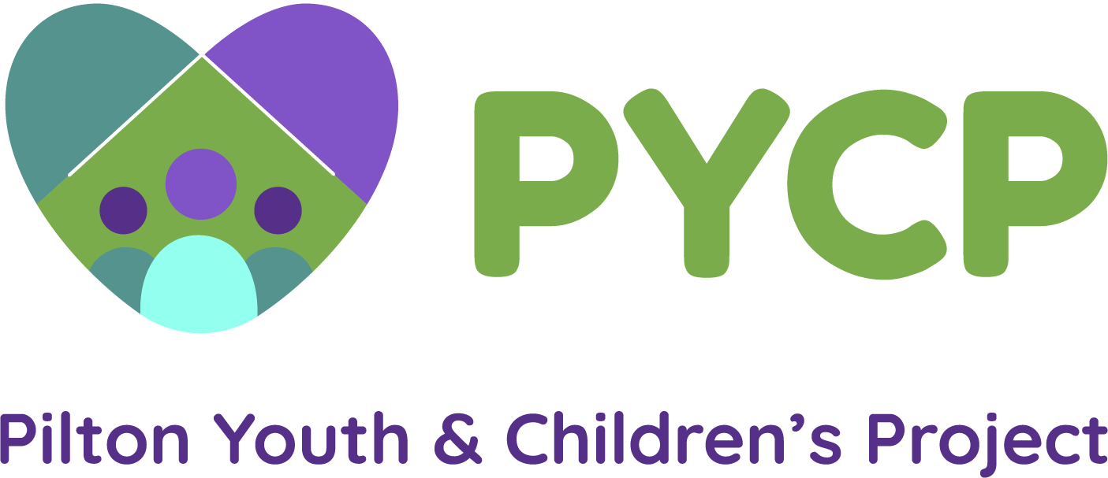

**Job Description: Volunteer Development Worker (24 hours a week)**

**Salary: £19275**

(FTE £28110 – 35hrs)

**Fixed Term for 1 year from June 2022 (with the likelihood of extension if other funding secured).**

Job Description and Person Specification

**Purpose of job:**

PYCP provides a range of open access activities for children and young people aged 5 to 18 years, as well as targeted programmes including primary to secondary transition support, holiday programmes and group work. We also offer Intensive, 1:1 support to young people in need. We promote social inclusion through supporting a positive start in the lives of children and young people, focussing on personal growth and development. We create engaging, educational experiences that broaden horizons. We ensure that our services are responsive to every-changing needs and priorities.

The Volunteer Development worker will take a lead in developing PYCP’s volunteer programme and services.

The post holder will be responsible for developing an innovative and creative programme around volunteering and support which will enable local children and young people to have a diverse experience of support and opportunity through the volunteers that come to the project and share their skills and talents.

Accountability is initially to the Project Manager, but ultimately to the Project Board of Directors.

**Main tasks:**

Particular responsibilities for the post holder will be negotiated with the Project Manager but will include:

* Develop a 10 week Programme for young volunteers aged 14+
* Raise staff’s awareness of the role and function of volunteers
* Ensure there is appropriate support and training for volunteers, by developing and implementing a volunteer training programme
* Promote volunteering internally and externally through recruitment and publicity strategies and campaigns
* Support volunteers on a day to day basis and additionally some through formal support and supervision
* Co-ordinate and manage volunteer hours and cover for absence when needed
* Interview and recruit adult volunteers and ensure they are appropriately matched and trained for the position, provide inductions and training for the volunteers
* Assist in the production of reports to funders, gathering quantitative and qualitative information
* Ensure that regular information is passed on to PYCP’s social media lead so that our work can be promoted, as well as assisting with the development of newsletters and other material
* Celebrate volunteering by nominating volunteers for awards and organise celebration events
* Offer advice and information to volunteers to support them in their role
* Assist in fundraising for activities and services to support the volunteering programme
* To actively promote equality of opportunity in all aspects of the PYCP’s work.
* To establish and ensure high standards of work practice with the volunteers who are working within PYCP
* To manage budgets and resources for volunteering within the organisation
* Keep up to date with legislation and policy related to volunteering and make any necessary modifications to accommodate changes
* Young Volunteers will participate in Youth Achievement Awards, set up a young people’s committee
* Any other duties as specified by the Project Manager and the Board of Directors

**Supervision received:**

Regular formal supervision will be with the Project Manager. The post holder will have autonomy on a day to day basis but will work as part of the wider team

All staff within PYCP will be encouraged to operate as part of a team with an emphasis on accountability, mutual support and personal development. Regular team meetings at which ongoing and ad hoc issues can be discussed.

**PERSON SPECIFICATION:**

**Education:**

A degree or diploma in Community Education, Youth Work or other relevant professions is desirable.

**SKILLS AND EXPERIENCE**

*Essential:*

* An empathy with volunteers and an understanding of their needs
* 2+ years’ experience supporting / working with volunteers
* The capacity to motivate and inspire others
* The ability to deal with information in a confidential manner and respond with sensitivity
* A flexible and non-judgemental approach to people and work
* Experience of developing volunteer programmes and services according to need
* Experience of developing and facilitating group work programmes for volunteers
* Detailed knowledge of current youth and children’s issues and volunteer programmes
* Maintain and produce records and producer clear written and oral reports
* A high level of communication and organisational skills

*Desirable:*

* Experience and interest in working in an area of deprivation.
* Experience of working in the voluntary sector.
* Experience working with children and young people, preferably in a youth work setting
* An understanding of volunteer programmes and initiatives both locally, citywide and nationally

Closing date 27th June.

Return to [Debbie@pycp.co.uk](mailto:Debbie@pycp.co.uk)