Role Profile – Marketing Manager

Reports To: Director of Marketing and Communications
Role Purpose:
The Marketing Manager leads a small team of marketing staff within the Marketing and Communications department, providing support, direction and development to team members. The post holder is responsible for developing, designing and delivering innovative marketing strategies and campaigns to attract and retain service users to the charities and to promote the brand. This is a varied role spanning across all marketing channels, ranging from TV, radio and outdoor advertising to digital channels and printed collateral. The post holder works with other department members to ensure collaboration between marketing and brand, fundraising, internal communications, media and policy, as well as working closely with staff in services on marketing campaigns.

All roles within Sight Scotland and Sight Scotland Veterans are expected to work to our values and Our Ways of Working framework:
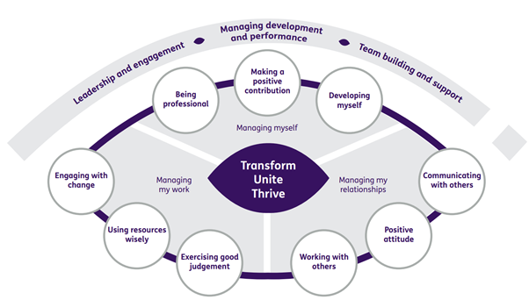
Our Ways of Working - Managing my Work
The main responsibilities and accountabilities of this role are:
- Plan and commission marketing and advertising campaigns, liaise with media buyer and design agencies, analyse and report on outcomes
- Champion the brand amongst internal and external audiences an ensure all marketing collateral meets brand guideline standards
- Commission, plan and deliver market research and analysis
- Lead on customer service delivery and standards. Work with Heads of services to design effective customer journeys, strategies and systems for potential service users
- Work with Heads of services to set targets for recruitment of new service users
- Plan and ensure delivery of marketing and communications collateral, including brochures, merchandise and communications with service users
- Oversee the development of the website and liaise with web developer
- Oversee the direction, performance and reporting of the digital marketing agency and social media campaigns relating to service user related marketing
- Line manage marketing communications staff
- Motivate and drive the team to achieve ambitious performance targets
- Set plans and KPIs for team, monitor performance and report on outcomes
- Liaise with service heads of departments to ascertain marketing needs
- Ensure GDPR compliance for service user marketing
- Manage stakeholder database and ensure it is kept up to date for marketing activities
- Carry out stakeholder mapping and target stakeholders with appropriate materials and messaging
- Lead on the organisation of high level events, including official openings, open days, visits by politicians and other dignitaries
- Oversee planning for events for service user engagement and attendance at profile raising conferences and exhibitions stands
- Manage procurement processes for marketing activities
- Oversee the production of the annual report for Sight Scotland Veterans, working in collaboration with senior management

Contribute to the work of the Marketing and Communications department
- Support cross team projects and events
- Work effectively and collaboratively with colleagues across the department
- Represent the organisation at conferences, exhibition stands and events

Our Ways of Working – Managing Myself and Managing my Relationships

To do this role, you will have:

Professional experience of:

- Working in a marketing role at a senior officer or manager level
- Developing and implementing successful customer acquisition marketing campaigns online and offline
- Producing marketing collateral
- Working with external agencies to deliver marketing activities and campaigns
- Project management and effective planning and evaluation
- Event management
- Managing websites
- Brand management

Knowledge of:

- Marketing campaign planning and analysis
- How data protection legislation impacts on marketing
- Digital marketing techniques
- Data analysis skills
- Customer service
Skills:
- Excellent grammar and a high level of written communication skills
- Ability and confidence to deliver face to face presentations
- Relationship building, both with both internal and external stakeholders, including at senior level
- Team working and interpersonal skills

Other:

- Ability to work out of hours, for which TOIL will be granted
- Full clean driving license
It is desirable that you will have:

- Experience of designing and running advertising campaigns
- Experience of line management and developing others
- Qualification in marketing
- Membership of the Chartered Institute of Marketing

On a day to day basis you will work with different people and teams, these could be:
- Staff within services and head office departments
- Service users
- Families of service users
- Senior Staff
- External stakeholders

Requirements of this role are:
- You are a member of the PVG scheme (paid for by Sight Scotland and Sight Scotland Veterans)
- You will have a 6 month probation period
- You participate in all staff training and development and maintain your own professional development
- You will wear the appropriate PPE in accordance with current guidance for the role.

What we can offer you:
- Generous annual leave entitlement
- Generous pension scheme
- Access to learning and development opportunities
- Employee Assistance Programme
- Cycle to Work scheme
- And many more, please visit our website for more information

This job profile is not exhaustive. The duties of the post holder may be reviewed from time to time and the employee may be called upon to work in other locations within Sight Scotland and Sight Scotland Veterans.

