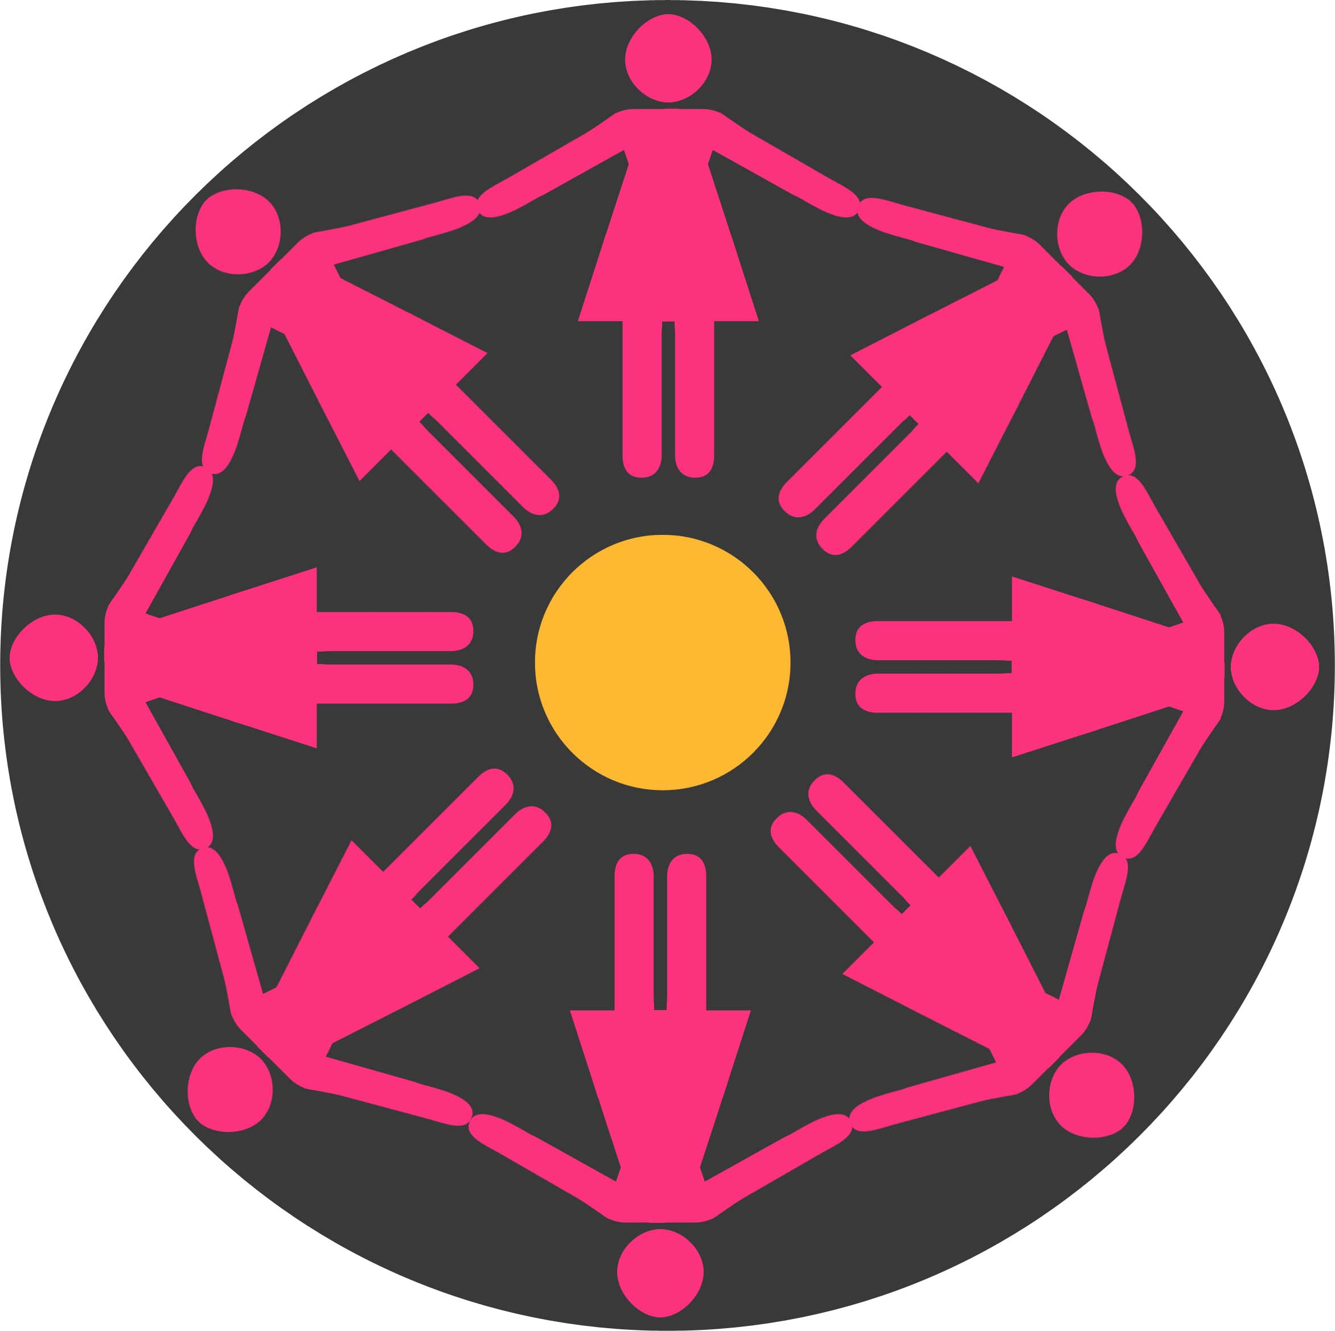
Dundee International Women's Centre
Unit 9, Manhattan Business Park,
Dundonald Street, Dundee
DD3 7PY

Background of Dundee International Women's Centre

The DIWC has been in existence over 50 years and aims to promote and create opportunities for women's social, political and economic inclusion and for the advancement of education. The Centre has developed an expertise in working with women, particularly those from black and ethnic minority communities, living in Dundee and environs and runs a programme of social, recreational and educational activities.

The DIWC reviews its aims and objectives on an annual basis, setting out clearly the work of the Centre for the forthcoming year. In order to ensure the effective implementation of these objectives each staff member is expected to contribute to the planning process and to prepare and work to an individual work plan in relation to their key areas of work.

JOB TITLE: Project Leader, Connecting Cultures

RESPONSIBLE TO: Operational and Strategic Manager

RESPONSIBLE FOR: Leading a project to develop and deliver a new comprehensive programme of educating and/training women about extremism and misinformation

LOCATION Dundee International Women's Centre
Unit 9 Manhattan Business Park,
Dundonald Street
Dundee
DD3 7PY
Working from home also required

MAIN PURPOSE: To build community resilience against misinformation and radicalism. To lead others to meet funding objective

Hours: 21 per week
Salary: FTE £30,000
Length: 1 year initially

Job Description
- To work to specific targets and instructions and adhere to all deadlines
- To implement, develop and manage the specific project(s) of the project targets, objectives and outcomes set by the funder and the organisation;
- Create a new, up to date programme of training and ensuring content and quality are assessed throughout the programme
- To demonstrate cultural competence in working in a multi ethnic/multi-disciplinary Women’s Centre.
- Liaise with our learners and staff to gain an understanding of training needs; assess training to develop and produce innovative training solutions that include web-based seminars, printed manuals, group sessions, training videos, and more
- Lead, inspire and develop the members of the team to empower and enable them to do their jobs to the best of their ability
- Present in-person and online training sessions and higher qualified personnel and create and monitor a timetable to deliver
- Review training programmes and materials to ensure that the most recent research is being adapted.
- Proven track record in meeting the formal obligations of partnership working
- Deliver multi-level training; and work with managers to address any delivery issues.
- Maintain understanding of new research and create multi-level delivery
- Manage budgets and adhere to strict deadlines
- Adhering to confidentiality and professional standards
- Organise Continuous Professional Development
- Monitor and evaluate training programme’s effectiveness
- Other relevant tasks as required

Personal Specification
- Experience in working within the field of radicalisation, extremism and/or internet misinformation
- Understanding specific barriers of engagement across communities and experience in multi-ethnic/multi-level delivery
- Proven ability to plan and manage projects in line with the demands of funders with minimum supervision
- Track record of researching and designing new materials whilst adhering to all policies and procedures
- Experience of keeping detailed and up to date records of work
- Proven experience of partnership working
- Manage and develop links to expand quantitative targets
- Ability to choose and implement effective evaluation methods to demonstrate the outcomes of the project
- Proven track record in working with up to date IT systems to create sustainable materials
- Proven experience of report writing
- Experience of working independently to lead others to meet budgets and deadlines
- Experience in adhering to professional standards and boundaries

This post is open to women only. Exempt under Schedule 9 of the Equalities Act 2010.

DIWC is a private Ltd Company No. 268081 and Scottish Charity No. SC014949

