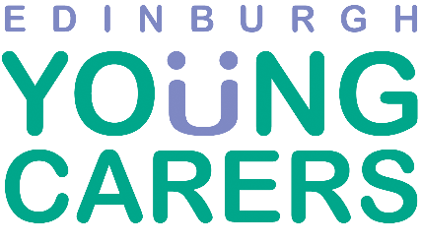
Equal Opportunities Monitoring Form

EYC is committed to being an equal opportunities employer. This means that EYC needs to know details of applicants’ sex, ethnic origin and disabilities, so that we can ensure our recruitment is fair and does not discriminate against anybody. You can help by completing this form.
Please note: This page will be separated from your application form before it is seen by the selection panel.

How would you describe your ethnic origin?
Ethnic origin is not about nationality, place of birth or citizenship. It is about the group to which you perceive you belong. Please tick the appropriate box

White
English Welsh Scottish Northern Irish Irish
British Gypsy or Irish Traveller Prefer not to say
Any other white background, please write here:

Mixed / multiple ethnic groups
White and Black Caribbean White and Black African White and Asian Prefer not to say
Any other mixed background, please write here:

Asian / Asian British
Indian Pakistani Bangladeshi Chinese Prefer not to say
Any other Asian background, please write here:

Black / African / Caribbean / Black British
African Caribbean British Prefer not to say
Any other Black/African/Caribbean background, please write here:

Other ethnic group
Arabian Prefer not to say
Any other ethnic group, please write here:

Are you:
Male Female Trans Non-binary Prefer not to say
If you prefer to use your own term, please specify here:

Disabilities and Conditions

As a Disability Symbol user, EYC is committed to interviewing any candidate with a disability or mental or physical health condition who meets the minimum criteria for appointment to this post.

Do you consider yourself to have a disability or condition? Yes No

If ‘Yes’, please tick the box(es) that best describe your disability:

Visual |  | Speech
Co-ordination, Dexterity or Mobility |  | Learning Difficulty
Mental Health |  | Hearing
Other (please specify) |  | Autism

For the purposes of this monitoring form the definition of disability is a sensory, physical, learning difficulty or mental health problem condition which is regarded as a significant disadvantage in daily life or at work.

What age group are you?

20-29 |  | 30-39
40-49 |  | 50-59
60 or over

Where did you see this post advertised?

