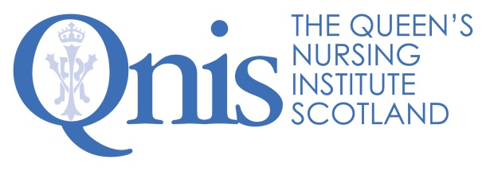
Digital Assistant Excellence Profile

Team work | - Builds and maintains a great rapport with colleagues.  - Demonstrates a ‘can do/will do’ attitude and a willingness to roll up sleeves and get involved in anything that needs doing.  - Understands the challenges and benefits of working in a small team and enjoys doing so.  - Shares knowledge, information and ideas to help us work better together.  - Is enthusiastic about the role and brings energy to the team.  - Really believes in the purpose of the Queen’s Nursing Institute Scotland (QNIS).  - Has the confidence to ask others for support and looks for ways to support them as well.  - Takes time to celebrate after working hard to achieve goals.  - Balances the urgent and important and enjoys working flexibly.  - Thrives in a dynamic and rapidly changing environment, embracing change.  - Brings a sense of fun to the office.

Relationship management | - Provides friendly and courteous first point of contact on the phone and in person to office visitors.  - Builds positive relationships with our networks and external providers.  - Builds trust through delivering on actions agreed and exceeding the expectations of others.  - Has the confidence to clarify details to ensure understanding of important information.  - Works alongside our stakeholders to provide jointly branded output.  - Engages positively with community nurses to develop news and web content leaving them feeling valued.

Outputs and productivity | - Supports the development of daily original content for Twitter to attract followers and build the brand.  - Supports the general running of the office with a cheery efficiency.  - Confidently answering office calls and recording communications on the digital database.  - Supports the development of high-quality images, videos, podcasts, and GIFs.  - Coordinates high quality printing in house or liaising with external printers and organisation of printed material in the office.  - Brings a great blend of creativity, innovation and attention to detail to all aspects of work.  - Prioritises work, sifting the important and the urgent and constantly looking at ways to do things more effectively.

Technical know how | - Uses excellent written English skills to communicate in a range of media using clear, professional and appropriate language which enhance our brand.  - Uses content management skills to keep webpages up to date, working with the team to develop new content ensuring the website is refreshed regularly so the website is always fresh and engaging.  - Great telephone manner, so all our stakeholders look forward to getting in touch.  - Skilled in editing digital images with text which inspire and encourage community nurses.  - Skilled in recording and editing sound and video files so people love engaging with our outputs.  - Demonstrates agility between formats and audiences.  - Uses a range of social media in a highly impactful way to promote the brand and provide updates for followers so more people are inspired by what we do.  - Brings tech support skills to providing streamlined online events for QNIS.

QNIS 2022

