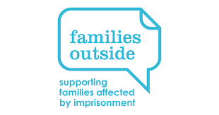
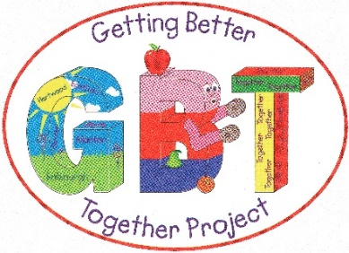


Job title: Key Worker – HMP Shotts Visitor Centre & Family Time Project

Salary: £23,000 (Post Funded for 1 year with possible extension)

Hours of Work: 35 hours per week (evening and weekend work expected)

Location/Base: HMP Shotts, Canthill Road, Shotts, ML7 4LE

Head Office: Getting Better Together Ltd, Shotts Healthy Living Centre, Kirk Rd, Shotts, ML7 5ET

Reporting to: Development Worker HMP Shotts Visitors Centre & Family Time Project

Managed by: Executive Manager

Main Purpose:

To work as part of the Getting Better Together Early Years and Youth Team, employed to support the development and implementation of the Visitor Centre and Family Time work plan. Visitor Centre staff are committed to working with families, community, and voluntary sector partners to maintain meaningful contact between prisoners and their families throughout the period of imprisonment.

We provide advice and information about the prison and how it works. We offer a safe space, a listening ear, and activities for children. We also engage in health promotion activities.

You will work with the Development Worker and the Early Years and Youth Team to deliver, monitor, and evaluate set outcomes within the project and its success in relation to the outcomes of the programme. The project requires a hard-working individual with a sound understanding of the needs of families and young children, who have been affected by the detention of a family member. You will be experienced in delivering early years programmes. The role requires exceptional organisational and communication skills as well as the ability to work on your own initiative as well as working in a team.

The keyworker role is an integral part of the service and supports a larger team and you will be required to support Early Years and Youth activities at the Healthy Living Centre when required.

Conditions of Service

- The successful candidate must be a current member of the PVG scheme or willing to become a member.

Key Responsibilities

- To support the Visitors Centre at HMP Shotts and assist in the delivery of weekly programmes within the Work plan outcomes as directed.
- To plan, participate in, assist leading and/or lead a range of indoor based activities for the children.
- To plan, design, implement and evaluate programmes as directed.
- To safely operate the organisations assets.
- To deliver Solihull and Dads Plus programmes, once trained.
- To work with partner agencies to ensure a multi-agency approach is being achieved within all aspects of the projects work.
- To suitably monitor project outcomes, which clearly demonstrate the projects effectiveness to funders, users and partner organisations. Providing regular monitoring and evaluation reports and updates to the Early Years Team.
- To attend staff training, staff meetings and undertake training courses where required and directed by the organisation.
- To ensure that all activities and workshops comply with Health and Safety, Risk assessments, Standard Operating Procedures and Child Protection requirements.
- To comply with emergency response procedures.
- To undertake any other tasks suitable to the level and nature of the post as deemed appropriate by the Executive Manager.

Occasional Responsibilities

- To attend meetings of the Family Strategy Group, Families Outside Groups and contribute to progress reports when required
- To participate in training and qualifications considered relevant by the Executive Manager
- To promote the project at one off events

This Job description is not definitive and may be changed in relation to professional development and the needs of Getting Better Together Ltd.

Person Specification

Essential
- Qualified to Degree Level or similar or have relevant experience.
- Experience of Early years work.
- Relevant qualification Understanding of working in the voluntary and charitable sector.
- Excellent organisational skills and an ability to communicate at all levels both orally and in writing.
- Excellent time management skills.
- Ability to inspire and relate to challenging client groups.
- Have or willing to work towards a First Aid Qualification

Desirable
- Experience in delivering or assisting the delivery of a wide range of support programmes for families and early years.
- Ability to demonstrate knowledge/awareness of local and national priorities in relation to families and early years work

