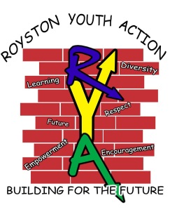
ROYSTON YOUTH ACTION
JOB DESCRIPTION: CHILDREN, YOUNG PEOPLE
AND FAMILY WORKER (37.5 hrs)

Job Title: RYA Community Worker.
Location: Royston Youth Action, Royston, Glasgow and surrounding local areas.
Responsible to: Project Manager.
Start date: As soon as possible.
Hours of work: 37.5 hours per week, with hours worked varying over days, nights and weekend duties.
Salary: £25,128 per annum. (Salary scale AP3)
Main purpose and duties: To assist in the delivery of a range of clubs and activities for the children, young people and families attending Royston Youth Action project.
Main duties will include working within a range of children and young people clubs and also delivering family projects. You will also be responsible for working at trips and residentials.
There will also be the remit of devising and implementing new projects and clubs as guided by funding requirements and service user’s needs. You will have the responsibility of helping with fundraising drives and initiatives. You will work in partnership with local organisations and schools and build up strong positive community links. You will work to enhance the lives of local families by ensuring activities are provided to develop their mental, emotional, physical and social well-being. You will also be committed to ongoing personal development and undertake training or other professional development activities as required.
All other reasonable duties will be required to be undertaken as and when required and agreed with the Project Manager.
Applications: Please request an application form by phoning Frances March on 0141 572 0984, or emailing to request one, frances@roystonyouthaction.co.uk. Completed application forms should then be emailed to info@roystonyouthaction.co.uk or posted to Royston Youth Action, 325 Royston Road, Glasgow, G21 2BS by the closing date of Monday 6th June at 5pm.

