
Role Profile – Senior Administrator
Reports to: Operations Support Manager, Sight Scotland Veterans
Role Purpose:
- To oversee the smooth running of the current SPECS system and day to day operations support activity
- To prepare the data within the SPECS system for transition to the new CRM system
- To provide project management support within the new CRM system and other departmental project teams
- Line manage Sight Scotland Veterans Administration Assistants
- Support and work closely with all the Sight Scotland Veterans Management Team

All roles within Sight Scotland Veterans are expected to work to our values and Our Ways of Working framework:
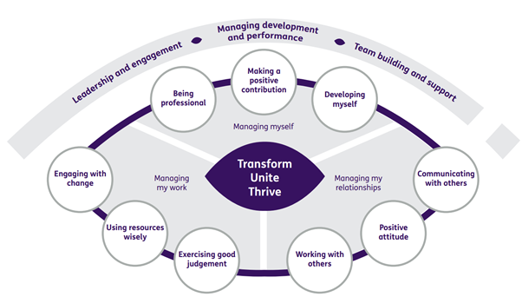

Our Ways of Working - Managing my Work
The main responsibilities and accountabilities of this role are to:
- To maintain and monitor existing systems and processes, always ensuring effectiveness and efficiency. Where appropriate, identifying, recommending, and establishing new processes to increase efficiency in service delivery
- Undertake regular quality checks and data cleansing and resolve inconsistencies
- To provide a high-quality client focused information and systems support service for the Sight Scotland Veterans Service Management team, including database management and reporting, diary management, meeting facilitation and action tracking
- To create and update reports, project trackers, process documents and how to guides, participate in user testing, arrange meetings for stakeholders
- To co-ordinate issuing of communications and documents for process improvement and project work
- To support with process, procedures and risk assessments for events
- To oversee the effective and timely completion of work by the Administration support team
- To provide support as needed to the Administration Assistants in relation to referrals and the defined processes
- To ensure mail in shared mailboxes is managed effectively and efficiently, supporting as needed to help with prioritising and planning tasks in line with team timelines and deadlines
- To ensure financial procedures are followed and ensure compliance with audit processes
- To maintain a working knowledge and awareness of information governance requirements to ensure compliance with information governance regulations in all aspects of the role.
- To maintain records and archives in line with GDPR requirements and audit all processes and systems in line with data retention policies
- To provide input into the design of the new CRM system for data sets and reports as required
- To build and maintain effective internal and external working relationships
- Act as an ambassador for sight loss and be able to articulate this to internal and external contacts.

Our Ways of Working – Managing Myself and Managing my Relationships

To do this role you will:

- Have experience of delegating and prioritising workload for others
- Have experience of database management, data analysis and reporting
- Have experience of using Microsoft Office suite and other IT packages, e.g. TEAMS, Visio, Sharepoint, Microsoft FORMS, Excel and Word
- Have excellent attention to detail with the ability to identify and rectify errors without prompting within own area of responsibility
- Have experience of supporting meetings through note taking and reporting
- Be proactive, positive and self-motivated and be able to work on your own initiative
- Have experience of handling sensitive information and working to GDPR guidelines and audit procedures
- Have experience of documenting processes and drafting how to guides
- Be able to develop and maintain good working relationships and effective communication with internal and external stakeholders
- Have planning and organisational skills to organise time effectively, prioritising workload and meeting deadlines
- Have experience of customer service and ability to manage multiple mailboxes
- Have problem-solving and creative skills
- Be enthusiastic, committed and able to remain calm under pressure
- Be able to support occasional events outwith normal office hours.
On a day to day basis you will work with different people and teams, these could be:
- Operations Support Manager
- CRM Project Team Members
- Administration Assistants and Centre Administrators
- Colleagues across Sight Scotland Veterans and Sight Scotland
- Veterans and their families
- External Agencies
- Suppliers

Requirements of this role are:
- You are/become a member of the PVG scheme (paid for by Sight Scotland Veterans)
- You will have a 6 month probation period
- That you participate in all staff training and development and maintain your own professional development
- You will follow Sight Scotland’s guidance, policies and procedures relating to your own health and safety and that of colleagues and service users at all times
- You will uphold the principles of Sight Scotland’s Dignity at Work and Equal Opportunities policies at all times, working in a way which supports an inclusive work environment that is respectful of differences

What we can offer you:
- Generous annual leave entitlement which increases after 4 years’ service
- Generous pension scheme
- Access to learning and development opportunities
- Employee Perks through the Employee Assistance Programme
- Cycle to Work scheme
- And many more, please visit our intranet for more information
This job profile is not exhaustive. The duties of the post holder may be reviewed from time to time and the employee may be called upon to work in other locations within Sight Scotland.

