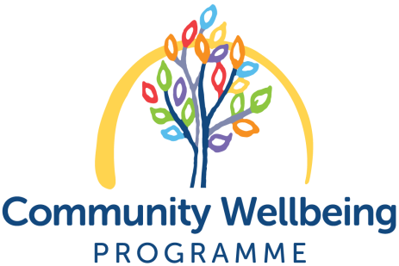

Development Worker
Community Wellbeing Programme

Job Description and Person Specification

Post Development Worker
Salary £26,676 to £29,528
Pension PCHP makes a 6% pension contribution matched by
a 6% employee contribution
Hours 35 hours per week, flexible
Holidays 25 days annual leave, 10 public holidays and 2 extra days for office closures
Responsible to Development Manager
Responsible for Development, co-ordination, delivery and reporting for the PCHP Community Wellbeing Programme food related activities and managing sessional workers and volunteers from time to time

Job Purpose

To plan, deliver and evaluate a range of community-led food work with local people to complement, add value and contribute to the culture of community wellbeing and food activities offered by PCHP and local partners.

This key role will work with Community Wellbeing Programme colleagues to support local people affected by health inequalities, with a focus on reducing food insecurity, the impacts of the rising cost of living, and the long term effects of the pandemic on local people’s lives.

You will create, adapt and deliver accessible, dignified food activities, events and groups within your own and other Community Wellbeing Programme work streams. This includes exploring wider food matters like food growing, food systems, reducing waste, cooking, budgeting and nutrition support.

Main duties and responsibilities

- Ensure the food activities meet the wellbeing needs of the people and families in the local area and delivers the work plan and outcomes agreed with our funders and donors

- To work with local people, colleagues, partners and volunteers to develop and deliver regular food-related wellbeing activities including cook and share groups, community meals, and barrier free food sharing opportunities

- To work collaboratively with colleagues and volunteers to develop strengths-based approaches to ensure local people have access to opportunities and networks to enhance their wellbeing

- To ensure that all activities are in line with the PCHP values and policies, meet our objectives and are focussed on enhancing the lives of local people and their families

- To collect data for reporting, monitoring and evaluation and draft reports as required

- To deliver a project work plan and manage a budget

- To facilitate, network and represent PCHP and its work as appropriate, at local, city and national level

- To contribute to PCHP staff meetings, conferences and training as part of continuing professional development

- To undertake any administrative tasks required to ensure the smooth running of your own work, the Community Wellbeing Programme and PCHP overall and to follow agreed policies and procedures

- To establish and maintain an effective working relationship with the PCHP staff team and support colleagues to achieve their goals

- To work flexibly and responsively, including occasional evening and weekend work.

- Other duties as required

Support and Supervision
You will receive regular support and supervision from your line manager, and have the opportunity to participate in regular team meetings, and training and development events.

Additional information
Membership of the PVG Scheme is required and this post is subject to a six month probationary period.

Employee and Volunteer Wellbeing
All workers and volunteers have access to our Employee Assistance Programme including a Wellbeing Portal and a 24 hour helpline, 365 days a year.

Place of work and Flexibility
We provide a base at Pilton Community Health Project. We are developing Hybrid and Flexible Working protocols with all our workers and we are keen to support family/caring responsibilities work patterns where possible.

Pilton Community Health Project – Development Worker
Person Specification
Qualifications and Experience
Essential | Desirable
Relevant qualification or equivalent experience  Experience of working with people using a social model of health  Experience of delivering practical activities to groups | Experience of community food initiatives (paid or voluntary experience)  Experience of managing sessional workers or volunteers  Experience of project planning and budget management  Working with groups  Developing and leading learning  Experience of organising community events  REHIS Elementary Food Hygiene certificate
Knowledge
Essential | Desirable
An understanding of the social model of health and health inequalities  A good understanding of nutrition, food and health, local food issues and wider policies on food  Understanding of community development competencies  Knowledge, understanding and sensitivity to the needs of people who may be isolated, have long term health conditions, experience poor mental and physical health and are living with the impacts of deprivation | Understanding of personal and professional boundaries and confidentiality  Understanding of relevant national and local  Managing social media content  Understanding of behaviour change and experience supporting people to make a positive change for health and wellbeing  Understanding of monitoring and evaluation  Understanding of community and voluntary sector
Skills
Essential | Desirable
Able to work on your own and as part of the team  Strong communication and listening skills, including the ability and sensitivity to work with people who may be vulnerable  Able to communicate with a wide range of individuals and organisations  Able to work collaboratively  IT skills including the use of Microsoft Office  Ability to plan, organise and prioritise work, meeting deadlines when required | Excellent report writing skills  Experience of using of databases  Working within set budgets
Personal Qualities
A positive attitude and commitment to improving wellbeing
A commitment to working in a kind, non-discriminatory way
Highly motivated, responsive, flexible and able to take the initiative
Able to listen to people and support community voice
A commitment to continuous personal and professional learning and development

