

**Organisational overview**:

The Vale of Leven Trust (VOLT) attained charity status in 2017 and our charity is based in West Dunbartonshire. The Vale of Leven encompasses Alexandria, Tullichewan, Levenvale, Haldane, Jamestown, Dalmonach, Bonhill and Balloch. Balloch is known as ‘the Gateway to Loch Lomond’. Alexandria Town Centre is the main shopping area for the Vale of Leven and is known as ‘the Heart of the Vale’.

VOLT is a local charity run by local people who have witnessed a gradual deterioration of a town centre and area in general that was once economically prosperous but has seen all our industry and large companies leave to countries overseas. We have become a commuter town which results in many residents not routinely being part of the community or visiting our town centre, resulting in reduced footfall and leading to market failure in terms of variety and scale of locally accessible services and economy. The Vale of Leven is less than 2 miles from the shores of Loch Lomond yet does not benefit economically from the high volume of tourists that visit.

The Vale of Leven has a range of social and health issues which place it in many of the lower reaches of Scottish Index of Multiple Deprivation (SIMD) 2020.

Our General Target Outcomes are:

* Improving the economy of the town of Alexandria
* Improving the physical environment of Vale of Leven
* Investigating how the economy / footfall can be increased within the Town Centre
* Investigating how the lives of residents can be improved against the current more negative outcomes noted in the WDC SIMD (2016 & 2020).

Our work has been informed by previous consultations the most prominent being our Place Standard Report undertaken in 2019. <https://bit.ly/VOLTplacestandard>

**Context to the Role**

The Scottish Government’s ‘***Strengthening Communities Programme****’* award has enabled VOLT to create this exciting job role for you to bring your experience, knowledge and management skills to lead this young charity forward in developing the above projects which are in varying stages of development.

The Vale of Leven Trust has to date:

- set up of an Active Travel Hub temporarily located in Alexandria town centre.

- secured funding to create and run a regular outdoor market in the town

- begun the early stages of a weekend activity calendar of events for local people and visitors.

**Current Structure**

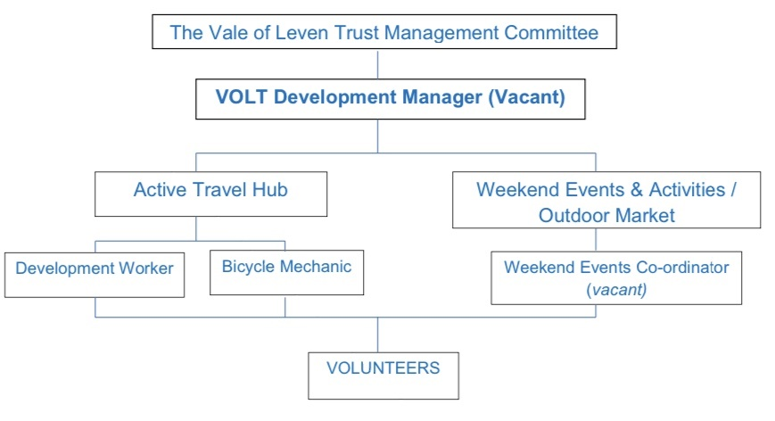

**Interested in the Post:**

You are welcome to visit and participate in any of our activities which are posted on different social media sites to get a feel for what we do. No requirement to tell us you are interested in the post although we do take personal details to comply with the health and safety remits of our activities.

** Like us *@valeofleventrust*     Follow us *@VOLTrust*     Follow us @Vale of Leven Trust**

View our current website which is not fully operational as of yet, but contains some information at [www.valeofleventrust.com](http://www.valeofleventrust.com)

We can be contacted at:

The Vale of Leven Trust,

9 Mitchell Way,

Alexandria,

G83 0LW or Telephone: 01389 752629.