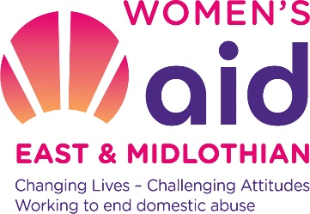
29a Eskbank Road
Dalkeith
Midlothian
EH22 1HJ

Tel: 0131 663 9827

Dear Applicant

Thank you for your interest in the position of (Family Support Worker) with Women’s Aid East & Midlothian Limited

Please find enclosed:-
- Covering Letter
- Info for job applicants
- Job description and person specification
- Application form
- Equal opportunities monitoring form

Please ensure that you read the recruitment guidelines before completing the application form.

Closing date for all applicants is Friday 28th of June, Interviews via Zoom will take place on Wednesday 13th of July 2022

Download the application pack at www.womensaideml.org or email for an electronic copy nancy@womensaideml.org.

Only applicants that are being called to interview will receive any further communication from us.

We would like to thank you for your interest in working with WAEML and wish you the best of luck with your application.

