Recruitment Pack digital INCLUSION COMMUNICATIONS officer

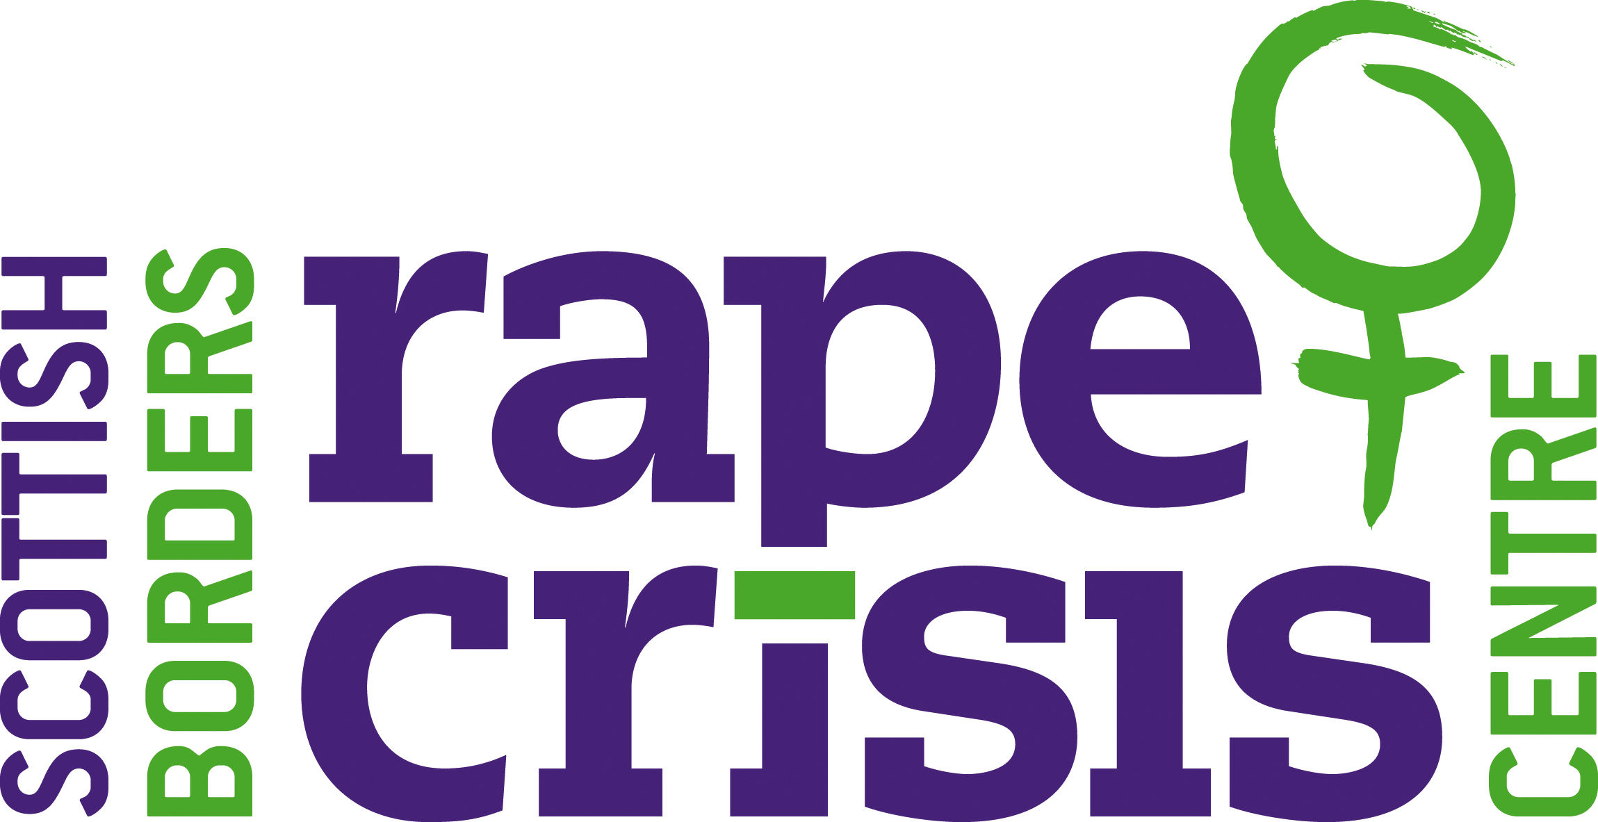

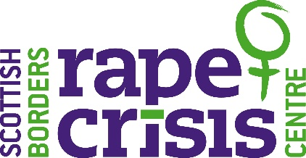

June 2022

Dear Applicant,

**Vacancy: Digital Inclusion Communications Officer**

Thank you very much for your interest in working with Scottish Borders Rape Crisis Centre (SBRCC).

Please find enclosed:

* Background information
* Job description
* Person specification
* Tips on completing your application form
* Application form

Further information about our organisation’s work is available on our website, [**www.scottishbordersrapecrisis.org.uk**](http://www.scottishbordersrapecrisis.org.uk)

Please note that the deadline for completed applications is **6pm on Wednesday 13th July 2022.** Interviews will be held via Zoom on **Thursday 28th July, Wednesday 3rd and Thursday 4th August 2022.**  Due to our limited resources, we will only contact you if you have been shortlisted for interview. All shortlisted candidates will be contacted **by Monday 25th July.**

Please note that we do not accept CVs. The full **application form** should be completed and **emailed** to [recruitment@sbrcc.org.uk](mailto:recruitment@sbrcc.org.uk)

We look forward to receiving your application. In the meantime, if you have any questions, please do not hesitate to contact me on **07584 149390** or email me at [susie@sbrcc.org.uk](mailto:susie@sbrcc.org.uk)

Best wishes,



Susie Stein

Chief Executive Officer

**Background Information**

Scottish Borders Rape Crisis Centre (SBRCC) provides a safe, non-threatening environment where survivors can talk freely and in confidence. We support all self-identifying females aged 18+ and all young people of any gender/gender identity aged between 12 and 18, who have experienced rape or any form of sexual violence, either recently or in the past. We work in partnership with others towards the elimination of violence against women.

We are an all-women organisation, believing that this allows us to offer the most appropriate and secure support to women and young people affected by rape and other forms of sexual violence. While we acknowledge that men experience rape and sexual violence, we also know that most incidents are committed against women by men, and it is to women that our efforts are primarily directed. Rape and sexual violence are crimes of violence against women and girls which reflect inequality in our society: redressing this inequality defines our work with women and girls who have experienced rape and other forms sexual violence.

We aim:

* To enable survivors to take their own steps towards reclaiming control of their lives;
* To support them through information, listening, and acceptance as they make choices for themselves; and
* To embody the principles of equality and empowerment in all we do.

Our services are free of charge and consist of:

**Sunrise**

Emotional and practical, support, information and advocacy for self-identifying female survivors aged 18+, who have experienced any form of sexual violence at any time in their lives.

* One to one (face-to-face) support sessions at the Centre or in safe outreach venues across the Scottish Borders. We offer an introductory session followed by 12 support sessions. Support sessions can be extended to 20 if the survivor has complex and/or multiple needs.
* Telephone/Email/Text/Virtual support for survivors, this can be informal to help survivors access the service or can be structured and used as their preferred method of support.

**Unity**

Emotional and practical, support, information and advocacy for all young people of any gender/gender identity aged between 12 and 18, who have experienced any form of sexual violence at any time in their lives.

* One to one (face-to-face) support sessions at the Centre or in safe outreach venues across the Scottish Borders. We offer an introductory session followed by 12 support sessions. Support sessions can be extended to 20 if the survivor has complex and/or multiple needs.
* Telephone/Email/Text/Virtual support for survivors, this can be informal to help survivors access the service or can be structured and used as their preferred method of support.

**Support for friends, families and non-offending partners.**

* One off, one to one support session. The session will be provided by a worker who is not supporting the survivor, this is to maintain the survivor’s confidentiality.

**Support & Advocacy**

For survivors who have engaged or are considering engaging with the criminal justice system following a sexual crime. This service is available to survivors who have experienced recent and historical sexual violence. A key role of the advocacy worker is to provide information to survivors who are considering reporting a sexual crime and to support them in their decision to report or not. The advocacy worker can be the one point of contact for the survivor throughout the criminal justice process as it can take a long time to reach a conclusion.

**Groupwork**

**Butterfly Project – 4-week programme, for self-identifying female survivors aged 18+**

Survivors can progress to groupwork when their individual support comes to an end, allowing them to continue their recovery journey and to work on issues which they may still be struggling with. The Butterfly Project is aimed at helping women move forward from simply “surviving” to “thriving” and covers topics such as

increasing self-esteem, becoming more confident, setting new achievable

goals, developing healthy relationships and personal growth. The group offers a safe environment where survivors are able to offer and experience mutual support.

We also offer short course such as managing anxiety, assertiveness, wellbeing and self-care and relationships and intimacy.

**Covid-19 support**

Throughout the pandemic we provided support remotely and virtually by phone, text, email, by Zoom and MS Teams. We have fully resumed centre based and outreach support. Staff have allocated centre based and home working days.

**Survivor Feedback/Evaluation**

We monitor the uptake, effectiveness, and efficiency of all of our services and adjust and develop our services in light of feedback from survivors and partner agencies.

**Funding**

The post is funded by the Scottish Government until March 2025.

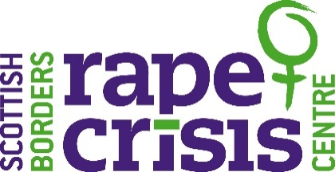 **Job Description**

**Position Title:** **Digital Inclusion Communications Officer**

**Salary:** £22,735 (Pro-rata) & 3% pension contribution

**Hours:** 18 hours per week

**Funded by**: The Scottish Government until 31st March 2025

**Location:** Centre based in Galashiels & Home Working

**Annual Leave Entitlement**: 28 days plus 9 Scottish public holidays (Pro-rata)

**Responsible to:** Service Coordinator

**Job Purpose**

* To promote the services of SBRCC, to develop partnership engagement work, increasing stakeholder engagement and building relationships with local and national organisations. Assist in SBRCC’s external communications including creating social media and website content and maintaining our website. This post will specifically focus and bring expertise and knowledge to further our intersectional approach. The role aims to increase our reach and engage survivors specifically within rural and remote communities, LGBTQI, BME, children & young people, disability, older women and survivors with learning difficulties.

**Key Responsibilities:**

* In conjunction with the management team (Chief Executive officer and Service Coordinator) Implement a partnership and stakeholder engagement plan.
* Coordinate SBRCC’s communications.
* Develop plans to reach new stakeholders, with a focus on diverse and intersectional communities and organisations.
* Deepen work with existing partners and identify and engage with new partners.
* Explore the options for developing and maintaining a membership base.
* In conjunction with the management team explore and develop plans to generate income focusing on community fundraising, individual giving and corporate sponsorship.

**Main duties**

* Coordinating SBRCC’s social media presence to ensure we have an effective and accessible online presence.
* Support the development of our communications channels to increase awareness and reach new audiences.
* Creating content for our social media channels to showcase our work, recruit team members, engage with networks and raise awareness of SBRCC in keeping with our established branding.
* Support the development of online and digital communications materials and resources connected to SBRCC’s work and policy.
* Oversee and updating and development of SBRCC’s website
* Produce a newsletter to be shared with internal and external stakeholders.
* Assist with the development of publications and associated materials.
* Support local and national campaigns across our channels to achieve wider strategic aims.
* Photographing and videoing events and services to document our work, provide content for social media and publications and contributing to the growth of an image library.
* Completing research around new printed materials or communication systems to address internal and external needs.
* Liaising with external suppliers and printers to identify the best quotes for printed materials.
* To act as a digital campion for SBRCC.

**General duties**

* Acting in accordance with SBRCC policies and procedures
* Working in a manner which positively promotes the aims and objectives of the organisation.
* Positively upholding and promoting SBRCC’s feminist ethos and commitment to equality, diversity and anti-discriminatory practices.
* Taking reasonable care of personal safety and that of other persons and resources whilst at work.
* Attending and participating in regular training when required.
* Attending and participating in regular internal and external support and supervision, staff and other meetings as necessary.
* Carrying out your own administrative duties.
* Participating in training to partner agencies and stakeholders
* Undertaking any duties consistent with the post as may be reasonably requested by your line manager

**Pre-Employment Checks**

* Confirmation of Right to Work in the UK
* Enhanced/PVG Registration Disclosure Check
* References
* **Only women need apply under Schedule 9, Part 1 of the Equality Act 2010.**

**Desired**

* **Full valid driver licence and access to a vehicle on a daily basis.**



**Person Specification: Digital Inclusion Communications Officer**

|  |  |  |
| --- | --- | --- |
| **Criteria** | **Essential** | **Desirable** |
| **Knowledge & Understanding** | A firm understanding of a gender analysis of violence, current gender issues and intersectionality. |  |
| **Experience** | Strong experience of delivering communication work at local and/or national level to achieve objectives.  Experience of coordinating and creating social media content (ie. Facebook, Instagram, TikTok, website and email) |  |
| **Skills & Abilities** | Excellent interpersonal and communication skills, with proven experience of working collaboratively with internal and external stakeholders.  An understanding of different drivers of engagement and the varied approaches required for different audiences.  The ability to effectively manage and prioritise a busy and varied workload.  Excellent organisational and administrative skills.  Ability to communicate confidently and persuasively with a variety of groups, organisations and agencies.  Creative with the ability to share ideas and work collaboratively. | Monitoring, data analysis and evaluation skills  Experience of service user involvement/participation.  Report writing skills |
| **Qualifications** |  | Rape Crisis, Violence Against Women or Gender Based Violence training.  Relevant CPD in communications or marketing. |
| **Other** | Commitment to equality & diversity and anti-discriminatory practice.  Occasionally to work flexibly and to do evening /weekend work as required.  Commitment to undertake relevant training.  Act with integrity and respect when working with internal and external stakeholders. | Full Driver Licence with access to a car. |

**Tips on Completing your application form**

As part of SBRCC’s commitment to equal opportunities, candidates for each post are treated equally. Application forms are the only basis on which the first selection is made to decide whom to call for interview. Therefore, only information which appears on the form (and continuation pages), can be considered. It is **very** important that your completed form contains both the information we want about your skills and experience and the information you want to give us. These tips are intended to help you to complete your form effectively.

* Read all the information provided especially the job description and person specification. These outline the duties you would be expected to carry out in this post and lists the skills, knowledge and abilities that the short listing/interview panel will be looking for.
* The application form should be completed in black ink or typed.
* Section 5 asks you to note down your general experience and is the most important part of your application. **This is your chance to explain why you are suitable for the job.** It is not enough to say you have the experience – you must demonstrate experience and skills with specific examples. Relevant experience may be from your current or previous jobs or from out with formal employment.
* Should you need to use an additional sheet of paper, please indicate the name of the post on the top of the sheet. **Do not send your CV in addition to or in place of a completed application form as it will not be considered by the short-listing panel.**
* Completing the Equal Opportunities Monitoring Form (survey monkey link in section 9) is optional but the information requested here is useful as it allows us to monitor the effectiveness of our policy of equal opportunities in employment.
* All applicants must complete all parts of the application form.
* Application forms must arrive on time, forms arriving late will not be considered.

**General Data Protection Regulation (GDPR)**

**Collection of data**

SBRCC will collect personal information about candidates through the application and recruitment process from candidates directly and from third parties including former employers and Disclosure Scotland.

The information you or a third party provides to us will be stored securely and will be treated as restricted information.

**Retention of data**

If you are successful in your application, your application form and additional recruitment information will form part of your personnel record and will be retained for 6 years after your employment ceases.

If you are unsuccessful in your application, the information you provide to SBRCC will be retained for 6 months.

**Destruction of Personal Information**

Once the above retention times have passed your personal information will be securely destroyed. We contract the services of a secure destruction company – SHRED-IT. When a personal record has been securely disposed of, we are given a certificate of destruction.

**Digital Inclusion Communications Officer - Application Form**

**To be emailed to:** [recruitment@sbrcc.org.uk](mailto:recruitment@sbrcc.org.uk)

**by:** 6pm on Wednesday 13th July 2022

|  |  |
| --- | --- |
| **Section 1: Personal details** | |
| First Name: | Surname: |
| Address: | Tel (home) |
| Tel (mobile): |
| Postcode: | Email: |

|  |  |  |  |  |  |  |
| --- | --- | --- | --- | --- | --- | --- |
| **Section 2: Qualifications and training**  **(only enter those qualifications and/or training necessary or relevant to the job)** | | | | | | |
| Qualification and/or training | | | Subject | | Date | |
|  | | |  | |  | |
|  | | |  | |  | |
|  | | |  | |  | |
|  | | |  | |  | |
|  | | |  | |  | |
|  | | |  | |  | |
|  | | |  | |  | |
|  | | |  | |  | |
|  | | |  | |  | |
|  | | |  | |  | |
|  | | |  | |  | |
|  | | |  | |  | |
|  | | |  | |  | |
|  | | |  | |  | |
|  | | |  | |  | |
|  | | |  | |  | |
|  | | |  | |  | |
|  | | |  | |  | |
|  | | |  | |  | |
| **Section 3: Present employer** | | | | | | |
| Name & address of employer: | | | | Date commenced employment: | | |
| Job title: | | | | Notice required: | | Current salary: |
| Brief description of your main duties and responsibilities, with an emphasis, where possible, on those areas most relevant to this role. | | | | | | |
| **Section 4: Previous employment (list in order, with most recent employer first)** | | | | | | |
| Please list **all** your previous employment, detailing any gaps between employments with reasons (insert an additional page if necessary). | | | | | | |
| Dates | | Name and address of employer | | Job title and nature of work | | Reason for leaving |
| From  DD/MM/YY | To  DD/MM/YY |
|  |  |  | |  | |  |
|  |  |  | |  | |  |
|  |  |  | |  | |  |
|  |  |  | |  | |  |
|  |  |  | |  | |  |
|  |  |  | |  | |  |
|  |  |  | |  | |  |
|  |  |  | |  | |  |
|  |  |  | |  | |  |

|  |  |  |
| --- | --- | --- |
| **Section 5: Relevant skills, experience and abilities** | | |
| Taking close account of the job description and person specification, please outline how your work experience, (including unpaid work) skills and abilities would enable you to carry out the duties of this post. Please include any information which you feel is relevant. | | |
|  | | |
| **Section 6: References** | | |
| SBRCC requires a minimum of 2 employment references to cover a three-year period – if necessary, please provide further referees covering the last 3 years. | | |
| **Reference 1: Current / most recent employer** | | |
| Name: | Position: |  |
| Email: | Tel No. |  |
| Company name: | Address: | |
| May we, with discretion, contact your employer to discuss this reference: |
| **Reference 2: Previous employer / supervisor** | | |
| Name: | Position: |  |
| Email: | Tel No. |  |
| Company name: | Address: | |
| May we, with discretion, contact your previous employer to discuss this reference: |
| **Reference 3: Previous employer / supervisor** | | |
| Name: | Position: |  |
| Email: | Tel No: |  |
| Company name: | Address: | |
| May we, with discretion, contact your previous employer to discuss this reference: |

|  |
| --- |
| **Section 7: Declaration** |
| I certify that all the information contained in this form and any attachments is true and correct to the best of my knowledge. I realise that false information or omissions may lead to dismissal without notice.  Signature:  Date: |

|  |
| --- |
| **Section 8: Interview availability** |
| If you are shortlisted for interview, please indicate your availability to attend, interviews will be held via Zoom. We will try our best to accommodate personal preferences but this may not be possible.   |  |  |  | | --- | --- | --- | | **Thursday 28th July** | **Wednesday 3rd August** | **Thursday 4th August** | | Morning  Afternoon | Morning  Afternoon  Evening | Morning  Afternoon  Evening | |

|  |
| --- |
| **Section 9. Equality & Diversity Monitoring Form (Optional)** |
| SBRCC is committed to promoting diversity and inclusion in hiring and service provision. To assist us to monitor the effectiveness of our equality and diversity practices we would encourage you to complete this monitoring form. Please note completion of our Equality & Diversity form is optional and does not form part of your application.  If you are happy to complete this form, please use the link below:  <https://www.surveymonkey.co.uk/r/9G5T8PN> |

Completed applications should be emailed to [recruitment@sbrcc.org.uk](mailto:recruitment@sbrcc.org.uk), handwritten applications should be posted to:

F.A.O Susie Stein, Chief Executive Officer

Scottish Borders Rape Crisis Centre

1A Wilderhuagh

Galashiels

TD1 1PW