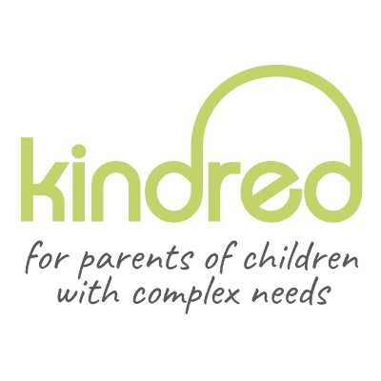

Equalities Monitoring
Questionnaire

Why are we monitoring?
Kindred recognises that equalities monitoring is an important way of assessing our service to families and our recruitment process.
What will we do with the information?

Your response will be treated anonymously and we ensure confidentiality. Funders sometimes require us to provide data on our recruitment process.
Completion of this form is voluntary. Non-completion of this form will not affect recruitment opportunities.

1. What is your gender? Please tick the appropriate box:

Female Male prefer not to say

2. What is your age? Please tick the appropriate box:

17-25 yrs 26-44 yrs 45-64 yrs 65 yrs+ prefer not to say

3. Do you consider yourself to be a disabled person? Please tick the appropriate box:
Under the Equality Act 2005 a person is considered to have a disability if he/she has a physical or mental impairment or illness, such as HIV, cancer, diabetes, heart condition, multiple sclerosis, which has sustained and substantial long term adverse effect on your ability to carry out normal day-to-day activities.

Yes No prefer not to say

4. How would you describe your ethnic group? Please tick one category:

White
Scottish/English/Welsh/Northern Irish/UK
Irish
Gypsy/Irish Traveller

Any other White ethnic group

please specify:___________________

Asian/Asian UK

Chinese
Bangladeshi
Indian
Pakistani

Any other Asian group
please specify:___________________

PTO

Black/African/Caribbean/Black UK

African
Caribbean

Any other Black/African/Caribbean group

please specify:___________________

Mixed or multiple ethnic groups

Any mixed or multiple ethnic groups please specify:___________________

_______________________________

Other ethnic group

Arab
Any other ethnic group
please specify:___________________

5. Your religion or belief – please tick the appropriate box:
No religion
Buddhist
Christian
Hindu
Jewish
Muslim
Sikh
Other, please specify:________________________________________________

6. Your sexual orientation – please tick the appropriate box:
Heterosexual Lesbian/gay men/bisexual prefer not to say

May 2022

