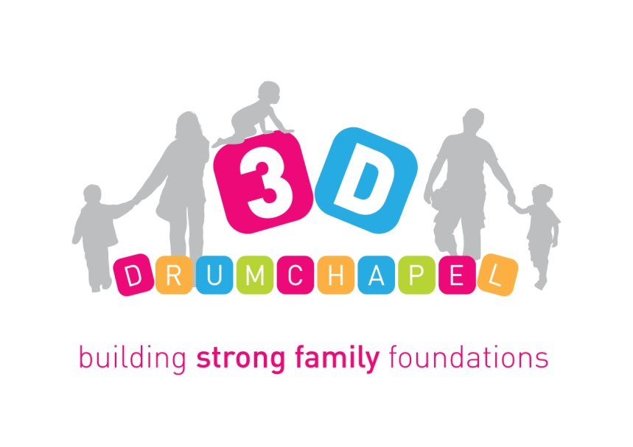
AIM
To make a difference in the lives of children and families in Drumchapel by providing support, strengthening relationships and empowering families to make positive change.

MAIN OBJECTIVES
In seeking to achieve this vision, the work of the organisation is underpinned by the following objectives:
Objective 1 - Continue to work with families across Drumchapel and surrounding areas, to offer support and enable the development of good relationships within the home; and offer a range of opportunities for parents to increase confidence and self-esteem, develop skills that support positive parenting and to address barriers and move towards positive destinations, and to effectively participate within the local community.
Objective 2 – Continue to explore the opportunity to deliver a range of services for children within Drumchapel and surrounding areas, in order to promote their overall learning, social and emotional development.
Objective 3 – Continue to strengthen, expand and develop joint working and partnership arrangements with other agencies within Drumchapel and across Glasgow, in order to ensure a cohesive approach to service delivery, and to broaden the range of opportunities available for families and the organisation as a whole.
Objective 4 – Continue to support the long-term development and sustainability of the organisation through ongoing fundraising activity, and by ensuring that priorities and service activity is responsive and flexible to meet emerging policy objectives and local needs.

CHRISTIAN ETHOS STATEMENT
Our motivation is rooted in our relationship with God whose love for individuals and communities is compassionate and transforming. We aim to integrate our Christian faith with the way we work. We strive to reflect Christ’s life of love, trust, justice, generosity and forgiveness in the internal practice and external expression of our organisation.

BACKGROUND
3D Drumchapel was established in 1997 with the aim of delivering a range of services and support for children and families residing within the Drumchapel area of Glasgow. 3D Drumchapel operates as a Company Limited by Guarantee and is a Registered Charity. Over the years, the organisation has continued to grow and expand its service provision across the local area. The organisation currently delivers a dedicated Family Support Programme that focuses on the health and wellbeing of local families.

The work of 3D Drumchapel has been continually strengthened and developed in response to local needs. The organisation delivers a range of activity that focuses on developing parenting skills, promoting health and well-being, and continued personal and social development.

ACTIVITIES & SERVICES
3D Drumchapel has developed a robust model of family engagement delivered in a locality and seeks to prevent against Adverse Childhood Experiences as well as support parents to mitigate against the impact of them. Activities include parent and child activities, learning and development workshops, issue-based workshops, parenting programmes, perinatal support programme, baby massage, Mums nights, peer support groups, one-to-one support, family trips and residentials, outdoor play, home visits, support plans, family support in schools and nurseries, Dads' work, children's programmes, play initiatives and volunteer development. Our parents and volunteers facilitate a clothing and goods bank for 0-5 years and we drive and facilitate the Drumchapel Children & Families Network which is for any professional working with the children & families in Drumchapel. We have 15 staff, 12 Board members and 20 volunteers.

We offer both targeted and universal sessions to children and families from pre-birth to 12 years. Access to our targeted programmes is via a direct referral from a partner agency or through our own 1:1 needs assessment process. Our universal programmes are open to any family living with Drumchapel, Knightswood or Yoker.

VOLUNTEER DEVELOPMENT
We rely very much on Volunteers to support many of our activities including crèches, children’s Clubs and family activities. The time given by volunteers to the project is invaluable. The opportunities provided to volunteers also provide a valuable tool to gain confidence, learn new skills and gain experience to move onto College and further learning or employment.

PARTNERSHIP WORKING
We work in partnership with Social Work, Health, Education, Glasgow Life, Housing and other Third Sector organisations to ensure we receive referrals for those most in need of our services and support. Additionally, we continue to work in partnership with different local organisations and we continue to forge new relationships with different organisations to increase the effectiveness of service delivery at 3D and also to encourage referrals for those who could benefit in engaging in our services. We facilitate the Drumchapel Children & Families Network which brings together professionals working with early years from Education, Health, Social Work, Third Sector, Glasgow Life, Housing & Police.

FUNDING
We benefit from the support of a wide variety of funders. Funding we receive to date has mostly been from Trusts & Foundations with some funding from Glasgow City Council, and a small number of dedicated donors. We also continue to develop our fundraising strategy.

FUTURE DEVELOPMENTS
3D Drumchapel never seems to stand still. It is an exciting time as we increase the work and breadth of the team with other new ventures on the horizon. This is an exciting time to be part of this innovative and dynamic organisation.

June 2022

