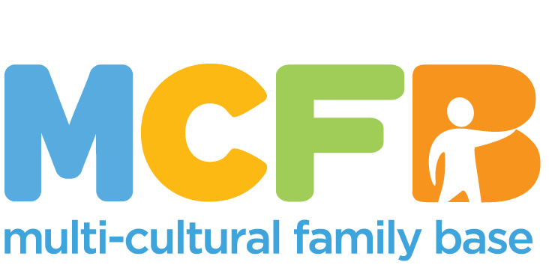

PERSON SPECIFICATION

Job Title: Project Worker Bright Choices

Function: To develop group work and provide practical and emotional support for people affected by Honour Based Violence

Date Prepared:

ATTRIBUTES | ESSENTIAL | DESIRABLE | ASSESSMENT METHOD
Education and qualifications | Secondary Level Education (HNC, HNQ, SVQ or equivalent)  Relevant professional qualification e.g. social work/community work/community education | S.V.Q. Level 4 (in Mediation) or equivalent standard  Degree level Education  Registration with appropriate professional body | - Application form
Experience and knowledge | Knowledge and understanding of the nature and impact of FGM/HBV  Knowledge and understanding of Gender Based Violence  Gendered understanding of domestic abuse and HBV  Relevant experience in working with BAME communities/groups in a community setting  Knowledge and understanding of the specific issues facing individuals and children from BAME communities in Edinburgh  Experience facilitating group work with young people and adults  Experience of supporting other workers/volunteers/students | Experience of working within the field of Honour Based Violence, Gender Based Violence or FGM  Knowledge of current legal and policy status of FGM  Knowledge and understanding of child protection procedures  Training in public protection, child protection (level 2), domestic abuse and/or coercive control or related  Experience of interagency/partnership working | - Application form/interview/references
Skills and Abilities | Excellent communication skills (both written and verbal, including report writing)  Confident user of IT  Ability to communicate with young people and adults and build trusting relationships  Ability to carry HBV case work on a one to one basis  Group facilitation skills  Ability to evaluate outcomes and report-writing skills  Ability to work effectively with relevant professionals (education, social work, police, health)  Proven ability to organise own workload  Excellent team working skills  Ability to maintain highest levels of confidentiality and maintain work records up-to-date | Ability to speak a relevant community language  Ability to maintain a professional attitude in challenging and emotive circumstances  Full, clean UK driver’s license and access to own vehicle  Ability to recognise, risk of FGM/HBV and willingness to provide intervention to manage this risk  Creative and forward-thinking approach  Ability to present publicly to a range of different audiences. | - Application form/interview/references
Personal Qualities and Attitudes | Strong ethical commitment to the aims and values of MCFB  Commitment to anti-racist practice  Commitment to working with empathy, impartially and in a confidential manner  Willing to travel as required in order to deliver the service within the community |  | - Application form/interview/references

