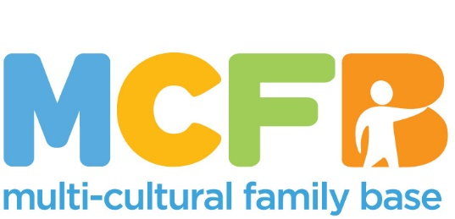

Equality Monitoring Form

Multi-Cultural Family Base is committed to developing positive practice, promoting equality of opportunity and preventing unlawful discrimination. The information provided on this form will be used strictly for monitoring purposes to ensure our Equality and Diversity policy is being implemented. It will play no part in the selection process.

Please return the completed form by email to: eleanor.mcknight@mcfb.org.uk
Gender: Male  Female 
Other (any non-binary identity please state)  ………………………………….
Prefer not to say 

Do you identify, or have you ever identified, as a trans person? (Trans is an umbrella term to describe people whose gender is not the same as the sex they were assigned at birth)
Yes  No  Prefer not to say 

Age: 16-24  25-29  30-34  35-39  40-44 
45-49  50-54  55-59  60-64  Prefer not to say 

Ethnicity: (Scottish Census categories are used)

White
Scottish  Other British  Irish  Gypsy/Traveller 

Polish  Other White background, please state: ………………………………….

Mixed
Mixed background/ethnicity, please state: ………………………………

Asian, Asian Scottish or Asian British
Indian  Pakistani  Bangladeshi  Chinese 

Other Asian background, please state: ……………………………….

Black, Black Scottish or Black British
African  Caribbean 

Other Black background, please state: …………………………………

Other
Arab (including Scottish or British Arab)  Other, please state: ………………………….

Prefer not to say (to any of above) 

Disability: (do you consider yourself to have a physical or mental impairment that has a substantial long-term effect on your ability to undertake day to day tasks)?

Yes  No  Prefer not to say 

Sexual orientation:

Straight (heterosexual)  Gay man  Lesbian/gay woman  Bisexual  Prefer not to say 

Religion or belief: (Scottish Census categories are used)

No religion or belief  Church of Scotland  Roman Catholic 
Hindu  Jewish  Buddhist  Muslim  Sikh 
Other, please state: ……………………………………. Prefer not to say 

What is your preferred working pattern?

None  Flexi-time  Staggered hours  Term-time hours  Annualised hours  Job-share  Flexible shifts  Compressed hours 
Homeworking 
If other, please state: ………………………….….. Prefer not to say 
Do you have caring responsibilities? If yes, please tick all that apply:

None 
Primary carer of a child/children (under 18) 
Primary carer of disabled child/children 
Primary carer of disabled adult (18 and over) 
Primary carer of older person 
Secondary carer (another person carries out the main caring role) 
Prefer not to say 

Thank you for completing this form

