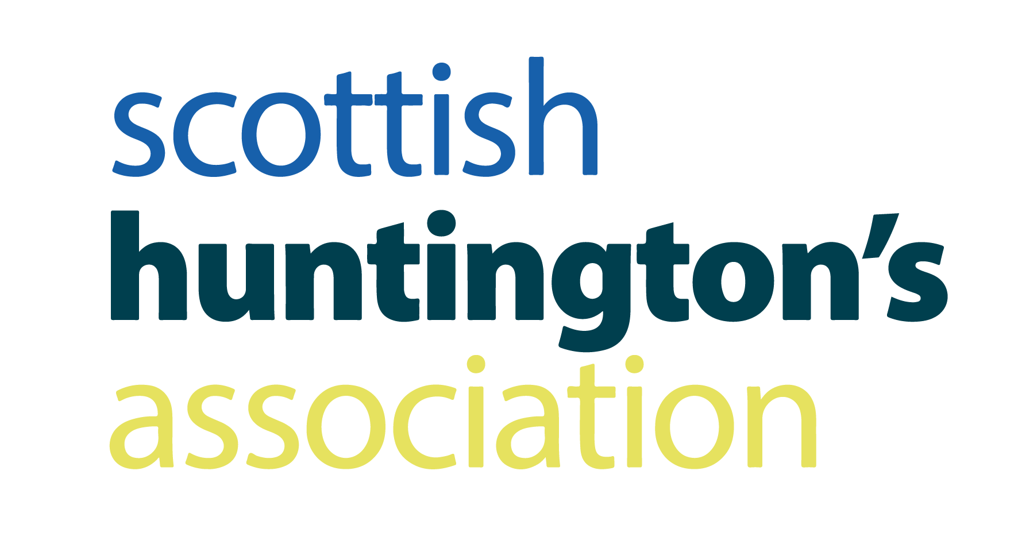

JOB DESCRIPTION

Job title: Financial Wellbeing Officer

Location: North Scotland

Salary: £30,408

Duration: Permanent

Accountable to: SHA Board of Directors via the Chief Executive

Reporting to: Financial Wellbeing Service Lead

Purpose of role:

You will work as part of the Scottish Huntington’s Association (SHA) Financial Wellbeing Service to significantly improve the financial outcomes of families by delivering a holistic advice service. The role involves working directly with vulnerable families in the North of Scotland, providing information, advice and guidance to those referred to the service. You will work in an integrated way with a range of Scottish Huntington’s Association staff including the adult clinical team, youth advisors, volunteers and professional staff from a number of external organisations to improve the quality of life of people living with Huntington’s disease. You will also provide education and training where appropriate and participate in the development of literature to meet the needs of the families.

The range of services provided includes advice focusing on four key areas – welfare rights; debt, energy and future planning. You will be expected to have considerable expertise in delivering a high quality service. Training will be offered in any areas for which additional experience is required.

The successful candidate should be able to work flexibly and autonomously using their own initiative. Good listening, communication and interpersonal qualities are essential, as is excellent attention to detail in addition to organisational and caseload management skills. The post holder will be also be expected to help promote an awareness of the issues affecting families in the Huntington’s disease community as widely as possible.

PERSON SPECIFICATION

KNOWLEDGE AND EXPERIENCE

- Relevant Training programmes will have been completed such as Wiseradviser; CPAG training; City & Guilds Level 3 Energy Awareness; or equivalent.
- At least at three years’ experience delivering advice in a welfare rights, money advice or energy advice capacity.
- Experience and training should include at least two out of our four main advice areas – welfare rights; debt advice; energy advice; future planning.
- Up to date knowledge of the benefit and tax credit system.
- Experience of appeals to tribunal level.
- Experience of working with people with long term health conditions.
- Experience of working with carers.
- Experience of working autonomously.
- Experience of delivering training and presentations.
- Computer literacy including Word, Excel, PowerPoint, Outlook, Teams
- Experience of using information systems such as AdviserNet, Rightnet, CPAG Handbook, Lisson Grove Benefit Programme.
- Experience of using client database systems such as AdvicePro.

SKILLS, ABILITIES AND DISPOSITION

- Excellent communication and interpersonal skills.
- Flexibility of working practice.
- Attention to detail.
- Excellent literacy and numeracy skills.
- Confidence in negotiation and advocacy.
- Highly self-motivated.
- Able to work as part of a team.
- Highly organised.
- Ability to manage a busy caseload.

NB Hybrid working means a lot of our staff are working partially from home. While the post holder will have access to an office base, it is essential that some home working is possible. Interview and induction processes for successful candidates will take place in part via Microsoft Teams.

Further information and an application pack can be obtained from:

David McNiven, Admin Officer, sha-admin@hdscotland.org

Scottish Huntington’s Association, Business First, Burnbrae Road, Paisley, PA1 2FB

Closing date for applications: 8 July 2022

Interview dates: To be confirmed

The SHA is a registered charity and is committed to promoting equal opportunities in employment

www.hdscotland.org

Charity No. SC010895

