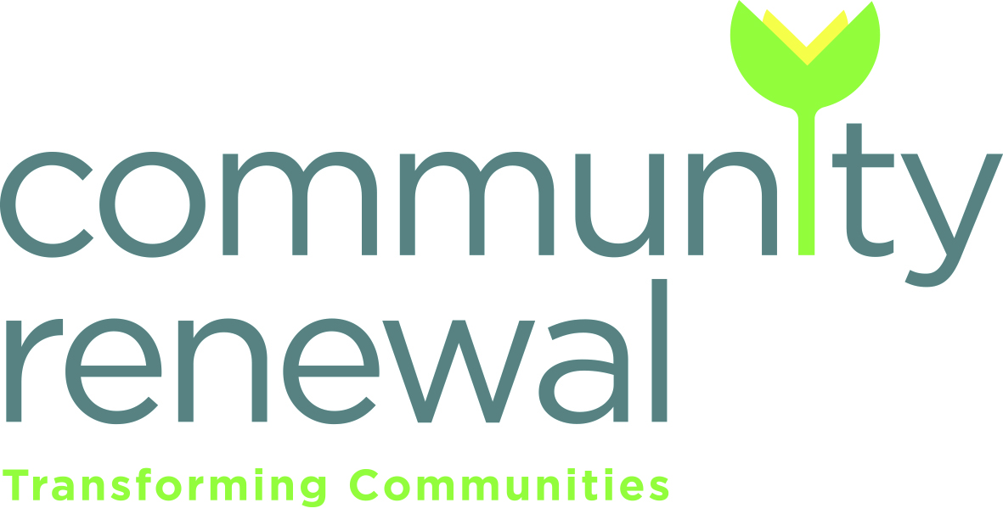

Job Title: Community Link Worker – 2 posts
Salary range: £26471-£28393 (pro rata) plus 6% pension contribution
Hours: variable 14, 21 or 28 hours per week
Responsible to: Community Renewal Trust Regional Director - East
Closing date: Monday 4 July(9am)
Interview date: pm on the 12 & 13 July

Job Description
Overall purpose of the job:
The Community Link Worker programme is funded by EVOC and Edinburgh Health & Social Care Partnership. The principle aim is to support people to live well through strengthening connections between community resources and primary care.
The Community Link Workers (CLW) will be employed by Community Renewal Trust,
The success of this post is dependent on effective joint work between Community Renewal Trust, Edinburgh Health & Social Care Partnership and EVOC. The post holder will be supervised by Community Renewal Trust’s Regional Director - East with support from the Community Link Worker Network Area Lead, who will work together to ensure that the post holder is on track to meet outcomes prescribed by the Scottish Government and Edinburgh Integrated Joint Board.
The two CLWs will work across three practices including Muirhouse Medical Practice, Parkgrove Medical Practice and Ladywell Medical Centre East. The CLW will provide a person-centered service that is responsive to the needs and interests of the GP practice population. They will support patients referred by medical practice staff to: Identify issues affecting their ability to live well; Identify personal outcomes and priorities; Provide support to overcome barriers to achieving personal goals; Link people to local and national services and agencies.
The CLW will support the practice team to have increased knowledge and understanding of local and national resources available to their patients. ​They will also build relationships and processes between the GP practice and community resources, statutory organisations, other health services and voluntary organisations.

Main Duties and Responsibilities
- Provide, through good conversations, a specialist and professional service to GP patients who may benefit from services based on a social model of health and build non-dependent relationships and trust with them.

- Enable people to identify personal outcomes and priorities to improve their health and well-being, to overcome any barriers to addressing these and, where appropriate, to link people to relevant local and national support services and activities.

- Implement effective pathways for accessing the Community Link Worker service to ensure people face minimal barriers and are offered a 1:1 appointment within an appropriate timescale.

- Build excellent working relationships and develop effective pathways to a range of service providers within the statutory/public and 3​rd​ sector.

- Develop and maintain knowledge of other local and national service providers, sharing this information with practice staff and other colleagues.

- Develop excellent working relationships with all staff within the GP practice and become embedded within the practice team, ensuring that the service takes account of local demographics and particular circumstances of each practice.

- Attend regular practice meetings to discuss and caseloads & issues of concern.

- To work with the Community Link Worker Network Manager and the Community Link Worker Network Lead for North Edinburgh to ensure that agreed operational procedures and guidelines are adhered to.

- Attend CLW network meetings; case review sessions and continued professional development for CLWs as required.

- Provide appropriate feedback to the medical practice, 3​rd​ sector organisations and other stakeholders on the challenges and achievements of the service, raising awareness of gaps in services and/or excessive demand on services.

- Enable and support the GP practice team to build their understanding of community orientated approaches to best support their patients.

- Maintain accurate and consistent records on each client through a quality assured case management system. This will include recording an agreed minimum core data set required for on-going monitoring and evaluation of the national Community Link Worker programme.

- Work closely with monitoring and evaluation colleagues to ensure local data is effectively used for on-going monitoring and evaluation of the national Community Link Worker programme.

- Develop and deliver reports in an agreed timely manner to enable evaluation and further learning.

- To participate in the work of Community Renewal Trust as required.

- To participate in community events run by Community Renewal Trust.

- To attend Community Renewal Trust team meetings, team building and training as required.

Additional Information

- This post is a fixed term contract, initially until 31st March 2023. It is anticipated that further funding would be sought.

- This post is subject to a PVG Check.

- Annual leave entitlement: 25 days, 10 public holidays and 2 extra days during the Christmas/New Year break (Total – 37 days) pro rata.

- This post is subject to a 6-month probationary period. Place of work: based at Community Renewal Trust’s Muirhouse office, working with patients and staff in Muirhouse Medical Centre and other community settings in the Muirhouse area of Edinburgh.

Community Renewal Trust – Community Link Worker
Person Specification
Qualifications and Experience
Essential | Desirable
- Extensive experience of working with vulnerable people using a social model of health  - Experience of working with people with complex health and social needs  - Ability to work autonomously, plan workloads, meet deadlines etc | - Experience in working with individuals with mental health issues.  - Educated to degree level in a relevant field e.g. health sciences/health & social care/public health  - Experience of partnership work across the sectors
Knowledge
Essential | Desirable
- Demonstrable interest in health inequalities, health improvement and well-being.  - Ability to produce written reports and maintain client records.  - Knowledge of the third sector and/or primary care.  - Understanding of the impact of social and economic inequalities on communities and individuals  - Understanding of behavior change and experience of supporting people to make positive change for health and wellbeing  - Good understanding and creative approach to evaluation | - Understanding issues that affect women and families affected by gender based violence.
Skills
Essential | Desirable
- Ability to work on own and as part of a team.  - Ability to plan, organise and prioritise work; meeting deadlines when required.  - Skills in presenting information clearly and concisely to a variety of audiences.  - Ability to support individuals in psychological distress calmly, safely and sympathetically  - Ability to listen, support and motivate individuals  - Understanding of professional boundaries and confidentiality  - IT skills including the use of databases, word and excel  - Positive outlook, self-motivated and flexible | - Understanding/experience of motivational interviewing  - Understanding/experience of coaching

