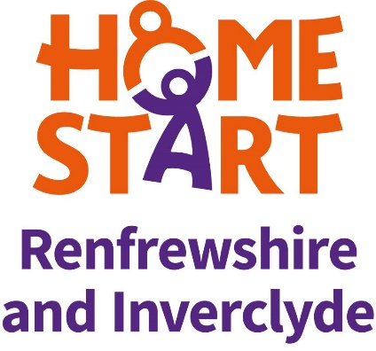**Person Specification – Wellbeing Support Worker**

This form also indicates how the different requirements may be assessed during the selection process:

A = Application Form, I = Interview, E = Exercise

| **Person Specification – Wellbeing Support Worker** | | | |
| --- | --- | --- | --- |
| **ESSENTIAL** | **Method of Assessment** | | |
|  | **A** | **I** | **E** |
| **Education and qualifications** |  |  |  |
| Good standard of education : Degree, HNC Social Care/SVQ Level 3 or equivalent qualification working with children and families | ✓ |  |  |
|  |  |  |  |
| **Employment History** |  |  |  |
| Relevant previous or current employment or voluntary work | ✓ | ✓ |  |
| Experience of direct work with adults, children, young people and families | ✓ | ✓ |  |
|  |  |  |  |
| **Managing the scheme** |  |  |  |
| Knowledge of the voluntary sector and the roles and responsibilities of voluntary management committees | ✓ | ✓ |  |
| Ability to process and collate information | ✓ |  | ✓ |
| Ability to prepare reports and statistical information | ✓ |  | ✓ |
|  |  |  |  |
| **Supporting families** |  |  |  |
| Understanding of the needs of families with young children | ✓ | ✓ |  |
| Knowledge of child development | ✓ | ✓ |  |
| Awareness of factors impacting on issues facing vulnerable children, young people and their families | ✓ | ✓ | ✓ |
| Parenting experience and/or significant care experience | ✓ | ✓ |  |
| Experience of applying safeguarding and child protection policies and other relevant policies and procedures | ✓ | ✓ |  |
|  |  |  |  |
| **Working in partnership and in the wider context** |  |  |  |
| Knowledge of the roles of agencies providing services for parents, children and families | ✓ | ✓ |  |
| Promotional skills | ✓ | ✓ | ✓ |
| Presentation skills | ✓ | ✓ | ✓ |
|  |  |  |  |
| **Self management/personal attributes** |  |  |  |
| Interpersonal skills | ✓ | ✓ | ✓ |
| A compassionate and caring approach | ✓ | ✓ | ✓ |
| A positive and creative approach to tackling tasks | ✓ | ✓ | ✓ |
| Knowledge of and commitment to equal opportunities and anti-discriminatory practice | ✓ | ✓ |  |
| Understanding of the need for professional confidentiality | ✓ | ✓ |  |
| Good written and verbal communication skills | ✓ | ✓ | ✓ |
| Negotiating skills | ✓ | ✓ | ✓ |
| Good IT skills and knowledge – familiarity with Microsoft Office suite, social media platforms, data bases, the internet and electronic communications. | ✓ | ✓ | ✓ |
|  |  |  |  |
| **Special requirements** |  |  |  |
| Able to work flexibly, some evening or weekend work | ✓ | ✓ |  |
| Willingness to access training opportunities | ✓ | ✓ |  |
| Car Driver with access to a car | ✓ |  |  |
| Eligibility to work in the UK | ✓ |  |  |
|  |  |  |  |
| **DESIRABLE** |  |  |  |
| Experience of group work | ✓ | ✓ |  |
| Experience of providing wellbeing and/or mental health support to adults | ✓ | ✓ |  |
| Knowledge of the local area and community supports | ✓ | ✓ |  |
| Relevant professional training, for example, Family Support Worker, Health Visitor, Teacher, Social Worker, Child Carer | ✓ | ✓ |  |
| Experience of work in the voluntary sector or as a volunteer | ✓ | ✓ |  |